

Big Hole River Watershed TMDL Implementation Evaluation

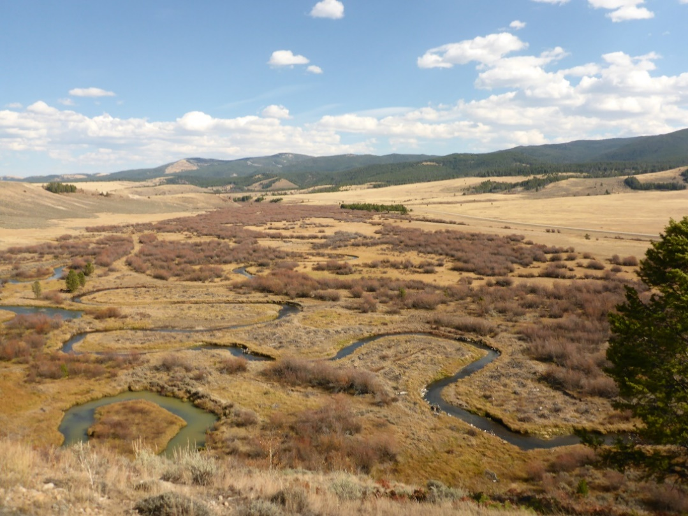

October 2026



Greg Gianforte, Governor
Sonja Nowakowski, Director DEQ
This page intentionally left blank.

The latest controlled version of this document is located on the DEQ website (https://deq.mt.gov/water/Programs/tmdl). Printed copies are not controlled. Document users are responsible for ensuring printed copies are valid prior to use.

Prepared by:
Water Quality Planning Bureau
TMDL Section

Contributors:
Water Quality Planning Bureau
TMDL Section
Kyle Milke, Project Manager
Heather Henry, Previous Project Manager

Cover Photo:
French Creek, Big Hole Watershed, MT
Photo by: Kyle Milke, Montana Department of Environmental Quality

Montana Department of Environmental Quality
Water Quality Planning Bureau
1520 E. Sixth Avenue
P.O. Box 200901
Helena, MT 59620-0901

Suggested citation: Montana DEQ. 2026. Big Hole River Watershed TMDL Implementation Evaluation. Helena, MT: Montana Dept. of Environmental Quality.
Acknowledgements
DEQ would like to acknowledge and thank the following entities for their contributions to the development of this total maximum daily load (TMDL) implementation evaluation. The Big Hole Watershed Committee and the Montana Bureau of Land Management provided significant amounts of data related to planning, restoration, and monitoring projects that was instrumental to the evaluation of progress in the Big Hole River watershed since TMDL development.

DEQ would also like to thank the following staff; Joe Vanderwall for technical review of long-term temperature trends and Steve Carpenedo and Abbie Ebert for their extensive knowledge of restoration projects and monitoring in the Big Hole watershed.

A draft version of the document was sent to stakeholders for review and input. The involvement of all reviewers led to improvements in this document and is greatly appreciated.

Table of Contents
List of Tables iii
List of Figures iii
Acronyms and Units of Measure vi
Document Summary DS-1
1.0 Purpose of a TMDL Implementation Evaluation 1
2.0 Description of the Big Hole River Watershed 1
3.0 Impairments Addressed in This Document 2
4.0 TMDL Document-Recommended Activities 13
5.0 Indicators of Progress 16
5.1 Planning Progress 16
5.1.1 Big Hole Watershed Committee Planning Efforts 17
5.1.2 Montana Fish, Wildlife & Parks Planning Efforts 17
5.1.3 Big Hole River Foundation (Save Wild Trout) Planning Efforts 18
5.1.4 United States Forest Service – Beaverhead-Deerlodge National Forest Planning Efforts 18
5.1.5 Bureau of Land Management – Dillon and Butte Field Offices Planning Efforts 19
5.2 Implementation/Restoration Progress 19
5.2.1 Big Hole Watershed Committee Projects 19
5.2.2 United States Forest Service – Beaverhead-Deerlodge National Forest Projects 20
5.2.3 Montana Fish, Wildlife & Parks Projects 20
5.2.4 Bureau of Land Management Dillon Field Office 24
5.2.5 Montana Department of Environmental Quality §319 Funded Projects 25
5.3 Monitoring Progress 27
5.3.1 Temperature Monitoring 27
5.3.2 Sediment Monitoring 29
5.3.3 Nutrient Monitoring 30
5.3.4 Metals Monitoring 30
5.3.5 §319 Project Effectiveness Reviews 31
5.3.6 NRDP Performance Monitoring Compliance Reports 31
5.4 Data Evaluation 32
5.4.1 Temperature Data Evaluation 32
5.4.2 Sediment Data Evaluation 34
5.4.3 Nutrients Data Evaluation 38
5.4.4 Metals Data Evaluation 38
5.4.5 §319 Project Effectiveness Review Data Evaluation 39
6.0 Conclusions and Recommendations 40
6.1 Temperature 41
6.2 Sediment 41
6.3 Nutrients 43
6.4 Metals 43
6.5 §319 Project Effectiveness Reviews 44
7.0 Information Sources 44
7.1 Communication Sources 44
7.2 Document References 45
Appendix A – Conclusions Summary Table A-1
Appendix B – Data B-1
Appendix C – Watershed Contacts C-1
Appendix D – Maps D-1

List of Tables
Table DS-1. Waterbodies, TMDLs, and pollutant groups addressed by this TMDL implementation evaluation DS-2
Table DS-2. Activities summary for the Big Hole River watershed DS-10
Table 3-1. TMDLs and impairments in the Big Hole River watershed 3
Table 4-1. Upper & North Fork Big Hole River and Middle & Lower Big Hole TMDLs recommended restoration and monitoring activities 14
Table 5-1. Activities summary for the Big Hole River watershed 16
Table 5-2. USFS planned projects in the Big Hole watershed 18
Table 5-3. Summary of FFIP and CCAA projects. 20
Table 5-4. BLM restoration projects summary. 24
Table 5-6. Summary of USGS and DNRC Big Hole watershed gage stations measuring temperature 27
Table 5-7. Number of times hoot-owl fishing restriction requirements met 33
Table 5-8. Number of times discharge trigger requirements were met 33
Table 5-9, 2018, 2022, and 2025 Camp Creek BLM MIM monitoring results 37
Table 5-10. 2022 BLM Dillon RA Riparian Inventory on Camp Creek 37
Table 5-11. Summary of Elkhorn Creek pre-restoration monitoring results. 38
Table 5-12. §319 PER project ratings. 40
Table 7-1. Big Hole watershed contacts 44
Table A-1. Conclusions summary A-2
Table B-1. USFS PIBO data B-19
Table B-2. French Gulch and Moose Creek riparian greenline assessment B-20
Table B-3. 2021 French Creek drainage sediment site data post-restoration B-21
Table B-4. 2017 French Gulch and Moose Creek post-restoration monitoring data B-21
Table C-1. Big Hole River watershed contacts C-2

List of Figures
Figure B-1. Daily mean discharge at USGS gage #06024450 B-2
Figure B-2. Daily mean discharge at DNRC gage #41D 08000 B-3
Figure B-3. Daily mean discharge at USGS gage #06025250 B-4
Figure B-4. Daily mean discharge at USGS gage #06026210 B-5
Figure B-5. Daily mean discharge at USGS gage #06025500 B-6
Figure B-6. Daily mean discharge at USGS gage #06026420 B-7
Figure B-7. Daily maximum temperatures at USGS gage #06024450. B-8
Figure B-8. Daily maximum temperatures at DNRC gage #41D 08000. B-8
Figure B-9. Daily maximum temperatures at USGS gage #06025250 B-9
Figure B-10. Daily maximum temperatures at USGS gage #06026210 B-9
Figure B-11. Daily maximum temperatures at USGS gage #06025500. B-10
Figure B-12. Daily maximum temperatures at USGS gage #06026420 B-10
Figure B-13. Annual Spring weekly average temperature trends (1996-2024) B-11
Figure B-14. Annual Summer weekly average temperature trends (1996-2024) B-11
Figure B-15. Annual Spring discharge trends (1924-2024) B-12
Figure B-16. Annual Summer discharge trends (1924-2024). B-12
Figure B-17. Annual Fall discharge trends (1923-2023) B-13
Figure B-18. Palmer Hydrological Drought Index for southwestern Montana (2005-2026). B-13
Figure B-19. Big Hole at Jackson nutrient concentrations compared to TMDL targets B-14
Figure B-20. Big Hole at Kalsta Bridge nutrient concentrations compared to TMDL targets B-14
Figure B-21. Big Hole at Maiden Rock nutrient concentrations compared to TMDL targets B-15
Figure B-22. Big Hole at Mudd Creek Bridge nutrient concentrations compared to TMDL targets B-15
Figure B-23. Big Hole at Skinner Meadows nutrient concentrations compared to TMDL targets B-16
Figure B-24. Big Hole at Wisdom nutrient concentrations compared to TMDL targets B-16
Figure B-25. Big Hole near Twin Bridges nutrient concentrations compared to TMDL targets B-17
Figure B-26. Deep Creek on BLM land nutrient concentrations compared to TMDL targets B-17
Figure B-27. North Fork Big Hole near Wisdom nutrient concentrations compared to TMDL targets B-18
Figure B-28. Wise River near confluence nutrient concentrations compared to TMDL targets B-18
Figure B-29. California Creek pre- (2015) and post-restoration (2017) photos B-22
Figure B-30. California Creek pre- (2015) and post-restoration (2017) photos B-22
Figure B-31. French Gulch and Moose Creek pre- (2016) and post-restoration (2017) photos B-22
Figure B-32. French Creek pre- (2019) and post-restoration (2020) photos B-23
Figure B-33. Oregon Creek Uplands pre- and post-restoration photos B-23
Figure B-34. 2019-2024 California Creek arsenic monitoring results. B-24
Figure B-35. 2019-2024 California Creek copper monitoring results. B-24
Figure D-1. Road systems in the Big Hole River watershed. D-2
Figure D-2. Grazing allotments in the Big Hole River watershed. D-3
Figure D-3. Abandoned in the Big Hole River watershed. D-4
Figure D-4. Irrigation systems and types in the Big Hole River watershed. D-5

This page intentionally left blank.

Acronyms and Units of Measure
°C degrees Celsius
°F degrees Fahrenheit
AFS American Fisheries Society (Montana Chapter)
AU Assessment Unit
BCD Beaverhead Conservation District
BDNF Beaverhead-Deerlodge National Forest
BLM United States Bureau of Land Management
BMP Best Management Practices
BHRF Big Hole River Foundation
BHWC Big Hole Watershed Committee
CCAA Candidate Conservation Agreement with Assurances
cfs cubic feet per second
CWA Clean Water Act
DEQ Department of Environmental Quality (Montana)
DLVCD Deer Lodge Valley Conservation District
DMP Drought Management Plan
DNRC Department of Natural Resources and Conservation (Montana)
FFIP Future Fisheries Improvement Program
FLBS-MMW Flathead Lake Bio Station – Monitoring Montana Waters
FWP Fish, Wildlife & Parks (Montana)
GGTU George Grant Chapter of Trout Unlimited
HUC hydrologic unit code
LRMP Land and Resource Management Plan
MCA Montana Code Annotated
MCC Montana Conservation Corps
mg/L milligrams per liter
MIM Multiple Indicator Monitoring
MTF Montana Trout Foundation
NFWF National Fish and Wildlife Foundation
NPSW Nonpoint Source and Wetlands
NRCS Natural Resources Conservation Service
NRDP Natural Resource Damage Program (Montana)
PIBO PacFish/InFish Biological Opinion
RA Resource Area
RRA Remediation and Restoration Areas
SMSP Southwest Montana Sagebrush Partnership
TIE TMDL Implementation Evaluation
TMDL total maximum daily load
TNC The Nature Conservancy
TPA TMDL Planning Area
TSF Trought and Salmon Foundation
TU Trout Unlimited
USFS United States Forest Service
USGS United States Geological Survey
WCS Wildlife Conservation Society
WET Water & Environmental Technologies
WRP Watershed Restoration Plan
YEP Youth Employment Program

This page intentionally left blank.

Document Summary
As required by Montana state law and the federal Clean Water Act (CWA), the Montana Department of Environmental Quality (DEQ) develops total maximum daily loads (TMDLs) for waterbodies impaired by a pollutant. TMDLs provide water quality goals and criteria for impaired waterbodies to attain water quality standards. In the 2006 list of impaired waters, or 303(d) list, DEQ determined that streams in the Big Hole River watershed did not support one or more of their aquatic life beneficial uses, cold-water fisheries, drinking water, primary contact recreation, and agriculture beneficial uses. In 2009, the “Upper and North Fork Big Hole River Planning Area TMDLs and Framework Water Quality Restoration Approach” and the “Middle and Lower Big Hole River Planning Area TMDLs and Water Quality Improvement Plan” documents were published and provide TMDLs for the impaired waterbodies listed in Table DS-1 (DEQ 2009a, 2009b). This TMDL implementation evaluation (TIE) document covers all TMDLs provided in the TMDL documents which include temperature, sediment, metals, and nutrients pollutant groups for the 3 segments of the Big Hole River mainstem and 43 of its tributaries.

The Big Hole River watershed (hydrologic unit code [HUC] 10020004) encompasses approximately 1,786,146 acres (2,791 square miles) in Beaverhead, Deer Lodge, Silver Bow, and Madison counties in southwest Montana. The mainstem of the Big Hole River flows through the towns of Wisdom, Fishtrap, Dewey, Divide, Melrose, and Glen, Montana. Land use in the watershed consists of agricultural operations, several small communities, silviculture, historical mining activities, and remediation of historical mining practices.

In watersheds with approved TMDL documents, DEQ periodically reviews the progress of restoration efforts, the progress toward meeting TMDL water quality goals, and documents the results in what is called a TIE document. This Big Hole TIE provides information as well as recommendations for potential next steps to address water quality impairments.

Table DS-1. Waterbodies, TMDLs, and pollutant groups addressed by this TMDL implementation evaluation
TMDL Document | Waterbody | Assessment Unit ID | TMDL(s) | Pollutant Group(s) | Non-pollutant(s)¹
Middle and Lower Big Hole³ | Big Hole River, Divide Creek to mouth (Jefferson River) | MT41D001_010 | Temperature | Temperature | N/A
Middle and Lower Big Hole³ | Big Hole River, Pintlar Creek to Divide Creek | MT41D001_020 | Temperature, Sediment, Copper, Lead | Temperature, Sediment, Metals | Alteration in stream-side or littoral vegetative covers^{1a}, Physical substrate habitat alterations^{1a}
Upper and North Fork Big Hole² | Big Hole River, headwaters to Pintlar Creek | MT41D001_030 | Temperature, Sediment | Temperature, Sediment | Alteration in stream-side or littoral vegetative cover^{1a}, Flow regime modification^{1b}
 | Birch Creek, headwaters to National Forest Boundary | MT41D002_090 | Sediment | Sediment | Alteration in stream-side or littoral vegetative covers^{1a}, Physical substrate habitat alterations^{1a}
 | Birch Creek, National Forest Boundary to mouth (Big Hole River) | MT41D002_100 | Sediment | Sediment | Alteration in stream-side or littoral vegetative covers, Physical substrate habitat alterations^{1a}, Other anthropogenic substrate alterations^{1a}
 | California Creek, headwaters to mouth (French Creek-Deep Creek) | MT41D003_070 | Sediment, Arsenic, Copper | Sediment, Metals | Turbidity^{1a}, Alteration in stream-side or littoral vegetative covers^{1a}, Other anthropogenic substrate alterations^{1a}, Physical substrate habitat alterations^{1a}
 | Camp Creek, headwaters to mouth (Big Hole River) | MT41D002_020 | Sediment, Total Nitrogen, Total Phosphorus | Sediment, Nutrients | Alteration in stream-side or littoral vegetative covers^{1a}
 | Corral Creek, headwaters to mouth (Deep Creek) | MT41D003_130 | Sediment | Sediment | Alteration in stream-side or littoral vegetative covers^{1a}, Physical substrate habitat alterations^{1a}
 | Deep Creek, headwaters to mouth (Big Hole River) | MT41D003_040 | Sediment | Sediment | Alteration in stream-side or littoral vegetative covers^{1a}
 | Delano Creek, headwaters to mouth (Jerry Creek) | MT41D003_030 | Sediment | Sediment | Alteration in stream-side or littoral vegetative covers^{1a}
 | Divide Creek, headwaters to mouth (Big Hole River) | MT41D002_040 | Temperature, Sediment, Total Nitrogen, Total Phosphorus | Temperature, Sediment, Nutrients | Alteration in stream-side or littoral vegetative covers^{1a}, Total Kjeldahl Nitrogen (TKN)^{1c}
Upper and North Fork Big Hole² | Doolittle Creek, headwaters to mouth (Big Hole River) | MT41D004_220 | Sediment | Sediment | Alterations in stream-side or littoral vegetative covers^{1a}
Middle and Lower Big Hole³ | Elkhorn Creek, headwaters to mouth (Jacobson Creek) | MT41D003_220 | Sediment, Arsenic, Cadmium, Copper, Lead, Zinc | Sediment, Metals | N/A
Middle and Lower Big Hole³ | Fishtrap Creek, confluence of West & Middle Forks to mouth (Big Hole River) | MT41D003_160 | Sediment | Sediment | Alteration in stream-side or littoral vegetative covers^{1a}
Upper and North Fork Big Hole² | Fox Creek, headwaters to mouth (Governor Creek) | MT41D004_170 | Sediment | Sediment | N/A
Upper and North Fork Big Hole² | Francis Creek, headwaters to mouth (Steel Creek) | MT41D004_200 | Sediment, Total Nitrogen, Total Phosphorus | Sediment, Nutrients | Alteration in stream-side or littoral vegetative covers^{1a}
Middle and Lower Big Hole³ | French Creek, headwaters to mouth (Deep Creek) | MT41D003_050 | Sediment, Arsenic, Copper | Sediment, Metals | N/A
Middle and Lower Big Hole³ | Gold Creek, headwaters to mouth (Wise River) | MT41D003_230 | Sediment | Sediment | Alteration in stream-side or littoral vegetative covers^{1a}
Upper and North Fork Big Hole² | Governor Creek, headwaters to mouth (Warm Springs Creek) | MT41D004_150 | Sediment | Sediment | Physical substrate habitat alterations^{1a}, Other anthropogenic substrate alterations^{1a}
Middle and Lower Big Hole³ | Grose Creek, headwaters to mouth (Big Hole River) | MT41D002_060 | Sediment, Total Nitrogen, Total Phosphorus | Sediment, Nutrients | Alteration in stream-side or littoral vegetative covers^{1a}
Middle and Lower Big Hole³ | Jerry Creek, headwaters to mouth (Big Hole River) | MT41D003_020 | Sediment, Copper | Sediment, Metals | Alteration in stream-side or littoral vegetative covers^{1a}, Physical substrate habitat alterations^{1a}
Upper and North Fork Big Hole² | Johnson Creek, headwaters to mouth (North Fork Big Hole River) | MT41D004_030 | Sediment | Sediment | Alteration in stream-side or littoral vegetative covers^{1a}
Upper and North Fork Big Hole² | Joseph Creek, headwaters to mouth (Trail Creek) | MT41D004_090 | Sediment | Sediment | Physical substrate habitat alterations^{1a}
Middle and Lower Big Hole³ | Lost Creek, headwaters to mouth (Lost Creek Canal/Ditch), T4S R9W S15 | MT41D002_180 | Sediment, Arsenic, Total Nitrogen, Total Phosphorus | Sediment, Metals, Nutrients | Alteration in stream-side or littoral vegetative covers^{1a}
Upper and North Fork Big Hole² | McVey Creek, headwaters to mouth (Big Hole River) | MT41D004_210 | Sediment | Sediment | Alteration in stream-side or littoral vegetative covers^{1a}
Upper and North Fork Big Hole² | Miner Creek, headwaters to mouth (Big Hole River) | MT41D004_140 | Sediment | Sediment | N/A
Middle and Lower Big Hole³ | Moose Creek, headwaters to mouth (Big Hole River at Maiden Rock) | MT41D002_050 | Sediment | Sediment | N/A
Upper and North Fork Big Hole² | Mussigbrod Creek, headwaters to mouth (North Fork Big Hole River) | MT41D004_020 | Sediment | Sediment | Alteration in stream-side or littoral vegetative covers^{1a}, Physical substrate habitat alterations^{1a}, Other anthropogenic substrate alterations^{1a}
Upper and North Fork Big Hole² | North Fork Big Hole River, headwaters to mouth (Big Hole River) | MT41D004_010 | Sediment | Sediment | Alteration in stream-side or littoral vegetative covers^{1a}
Middle and Lower Big Hole³ | Oregon Creek, headwaters to mouth (California Creek-French Creek-Deep Creek) | MT41D003_080 | Sediment, Arsenic, Copper | Sediment, Metals | Alteration in stream-side or littoral vegetative covers^{1a}, Physical substrate habitat alterations^{1a}, Other anthropogenic substrate alterations^{1a}
Middle and Lower Big Hole³ | Pattengail Creek, headwaters to mouth (Wise River) | MT41D003_210 | Sediment | Sediment | Alteration in stream-side or littoral vegetative covers^{1a}, Physical substrate habitat alterations^{1a}
Upper and North Fork Big Hole² | Pine Creek, headwaters to mouth (Andrus Creek) | MT41D004_160 | Sediment | Sediment | Alteration in stream-side or littoral vegetative covers^{1a}
Middle and Lower Big Hole³ | Rochester Creek, headwaters to mouth (Big Hole River), T3S R6W S29 | MT41D002_160 | Sediment, Arsenic, Copper, Lead, Mercury | Sediment, Metals | Physical substrate habitat alterations^{1a}
Upper and North Fork Big Hole² | Rock Creek, headwaters to mouth (Big Hole River) | MT41D004_120 | Sediment | Sediment | Alteration in stream-side or littoral vegetative covers^{1a}, Physical substrate habitat alterations^{1a}
Upper and North Fork Big Hole² | Ruby Creek, headwaters to mouth (North Fork Big Hole River) | MT41D004_100 | Sediment | Sediment | Alteration in stream-side or littoral vegetative covers^{1a}, Physical substrate habitat alterations^{1a}
Middle and Lower Big Hole³ | Sawlog Creek, headwaters to mouth (Big Hole River) | MT41D004_230 | Sediment | Sediment | Alteration in stream-side or littoral vegetative covers^{1a}
Middle and Lower Big Hole³ | Sevenmile Creek, headwaters to mouth (Deep Creek) | MT41D003_110 | Sediment | Sediment | Alteration in stream-side or littoral vegetative covers^{1a}
Middle and Lower Big Hole³ | Sixmile Creek, headwaters to mouth (California Creek) | MT41D003_090 | Sediment | Sediment | Physical substrate habitat alterations^{1a}
Middle and Lower Big Hole³ | Soap Creek, headwaters to mouth (Big Hole River), T2S R9W S10 | MT41D002_140 | Sediment, Total Nitrogen, Total Phosphorus | Sediment, Nutrients | Alteration in stream-side or littoral vegetative covers^{1a}
Upper and North Fork Big Hole² | Steel Creek, headwaters to mouth (Big Hole River) | MT41D004_190 | Sediment, Total Nitrogen, Total Phosphorus | Sediment, Nutrients | Alteration in stream-side or littoral vegetative covers^{1a}, Physical substrate habitat alterations^{1a}, Other anthropogenic substrate alterations^{1a}
Upper and North Fork Big Hole² | Swamp Creek, headwaters to mouth (Big Hole River) | MT41D004_110 | Sediment | Sediment | Alteration in stream-side or littoral vegetative covers^{1a}
Upper and North Fork Big Hole² | Tie Creek, headwaters to mouth (North Fork Big Hole River) | MT41D004_060 | Sediment | Sediment | Physical substrate habitat alterations^{1a}
Upper and North Fork Big Hole² | Trail Creek, headwaters to Joseph Creek | MT41D004_070 | Sediment | Sediment | Physical substrate habitat alterations^{1a}
Upper and North Fork Big Hole² | Trail Creek, Joseph Creek to mouth (North Fork Big Hole River) | MT41D004_080 | Sediment | Sediment | Physical substrate habitat alterations^{1a}
Middle and Lower Big Hole³ | Trapper Creek, headwaters to mouth (Big Hole River) | MT41D002_010 | Sediment, Arsenic, Cadmium, Copper, Lead, Zinc | Sediment, Metals | Alteration in stream-side or littoral vegetative covers^{1a}, Physical substrate habitat alterations^{1a}
Middle and Lower Big Hole³ | Wickiup Creek, headwaters to mouth (Camp Creek), T2S R8W S1 | MT41D002_120 | Copper | Metals | N/A
Middle and Lower Big Hole³ | Wise River, headwaters to mouth (Big Hole River) | MT41D003_200 | Sediment, Cadmium, Copper, Lead | Sediment, Metals | Alteration in stream-side or littoral vegetative covers^{1a}, Physical substrate habitat alterations^{1a}
¹ Indicates an impairment cause is a “non-pollutant” which has been addressed by a TMDL.
^{1a}Addressed by sediment TMDL.
^{1b}Addressed by temperature TMDL.
^{1c}Addressed by total nitrogen TMDL.
² Upper and North Fork Big Hole River Planning Area TMDLs and Framework Water Quality Restoration Approach
³ Middle and Lower Big Hole River Planning Area TMDLs and Water Quality Improvement Plan
Conservation groups and local, state, and federal agencies have implemented reasonable land, soil, and water conservation practices called for in the Upper and North Fork Big Hole River and Middle and Lower Big Hole River TMDL documents. These organizations have developed DEQ approved Watershed Restoration Plans, conducted watershed assessments, and pre-restoration planning and study activities; implemented riparian and channel restoration, irrigation improvement, and culvert-to-bridge conversion projects; and conducted water quality monitoring since TMDL publication. See Table DS-2 for an estimate of activities that have occurred within the TMDL planning areas (TPAs).

Table DS-2. Activities summary for the Big Hole River watershed
Waterbodies/Segments with TMDLs Where: | Total¹
Planning has occurred | 47
Outreach and education have taken place | 47
Monitoring has occurred | 21
On-the-ground restoration work has occurred | 23
No activity has taken place | 0
Fish habitat/passage improvements have been made² | 13
Additional impacts have been observed | 0
¹Due to the large amount of stakeholder involvement, project information provided, and its completeness, these totals reflect an estimate of what has been completed within the watershed. For an accurate reporting of activities that have been completed, readers should review all reports referenced in this document.
²While fish habitat/passage restoration work is important for the many fish populations in the Big Hole watershed, these projects do not directly impact water quality, nor the pollutants being evaluated in this TIE, so they have been tallied separately.

This page intentionally left blank.

1.0 Purpose of a TMDL Implementation Evaluation
In watersheds with approved TMDL documents, DEQ periodically reviews the progress of restoration efforts, the progress toward meeting TMDL water quality goals, and documents the results in what is called a TMDL implementation evaluation (TIE) document. TIEs provide specific recommendations for the waters subject to the TMDL that identify needed restoration projects, monitoring, or recommended reassessment.

This TIE is an evaluation of the progress toward meeting the water quality goals of the Upper and North Fork Big Hole River Planning Area and Framework Water Quality Restoration Approach and the Middle and Lower Big Hole Planning Area TMDLs and Water Quality Improvement Plan, as well as an evaluation of the success of on-the-ground efforts to address the water quality impairments and DEQ’s recommendations for potential next steps for addressing those impairments (DEQ 2009a, DEQ 2009b).

The purpose of a TIE is to document the following:
- Progress made toward restoring water quality to the applicable water quality standards.
- Status of the TMDL’s recommended reasonable land, soil, and water conservation practices.
- Suggest additional monitoring to help evaluate progress toward attainment of beneficial uses and/or establish existing water quality conditions.
- Constructive feedback to those pursuing water quality improvements:
  - Acknowledge water quality restoration activities that have or are taking place
  - Identify water quality success stories in Montana
  - Provide additional guidance or suggestions for best management practices (BMP) implementation and extent of activities necessary to meet one or more TMDLs
- Suggest TMDL document update requirements and/or other TMDL document improvement recommendations, if necessary.

Conclusions of a TIE should be one of the three specific conclusions identified in §75-5-703(9), MCA:
- The implementation of a new or improved phase of voluntary reasonable land, soil, and water conservation practices is necessary.
- Water quality is improving but a specified time is needed for compliance with water quality standards.
- Revisions to the TMDL are necessary to achieve applicable water quality standards.

2.0 Description of the Big Hole River Watershed
The Big Hole River watershed (HUC 10020004) encompasses approximately 1,786,146 acres (2,791 square miles) in Beaverhead, Deer Lodge, Silver Bow, and Madison counties in southwest Montana. The watershed is comprised of four TMDL Planning Areas (TPAs): the North Fork Big Hole, Upper Big Hole, Middle Big Hole, and Lower Big Hole, Figure D-1. The mainstem of the Big Hole River flows through the towns of Wisdom, Fishtrap, Dewey, Divide, Melrose, and Glen, Montana. Land use in the watershed consists of agricultural operations, several small communities, silviculture, historical mining activities, and remediation of historical mining practices. Land ownership consists of federal, private, and state lands. Approximately 58.6% of the land is managed by the Beaverhead-Deerlodge National Forest (BDNF), 26.3% is privately owned, 9.4% is managed by the Bureau of Land Management (BLM), 3.4% is managed by the state of Montana, and 2.2% is managed by Montana Fish, Wildlife & Parks (FWP). Land cover in the northern, western, and central extent is primarily conifer-dominated forest and woodland (xeric-mesic) with some mining and resource extraction. The dominant land cover in the eastern extent is sagebrush steppe with some agriculture lands. The northern and western extents are separated from the central extent by a mix of agriculture, wet meadow, and sagebrush steppe.

3.0 Impairments Addressed in This Document
A total of 91 TMDLs were written addressing 93 pollutant impairments and 62 non pollutant impairments for 47 waterbody segments in the Big Hole watershed. The main pollutant sources include:
- Sedimentation from upland erosion, unpaved roads, road traction sanding, and streambank erosion resulting in altering aquatic insect communities, reducing fish spawning success, filling pool habitat, and increasing levels of turbidity, Figure D-1.
- Nutrients from accelerated bank erosion from livestock, reduced riparian filtering from livestock grazing and browsing, fertilizer applications, and areas of upland vegetation reduction from livestock grazing resulting in excess algae growth, Figure D-2.
- Metals from historic mining activities, including abandoned mines and fallout from the Anaconda Smelter, resulting in potentially toxic, carcinogenic, or bioconcentrating effects on biota and chronic and acute effects in animals and humans, Figure D-3.
- Thermal impacts from sparse riparian cover, channel widening, and reduced flow due to irrigation withdrawals, drought conditions, and plant uptake causing stress to fish during warm summer days, Figure D-4.

TMDLs have been developed for the Big Hole River watershed for various pollutant-waterbody combinations. The impairments, pollutant sources, and the associated TMDLs are listed in Table 3-1. As each pollutant is linked to a source(s), each significant source may need to be addressed before waterbodies can achieve water quality standards. Some sources will be left unaddressed due to complicating factors such as land ownership, lack of funding, lack of interest, etc.

Table 3-1. TMDLs and impairments in the Big Hole River watershed
TMDL Document | Waterbody | Assessment Unit ID | TMDL(s) | Impairments Addressed by TMDL(s) | Sources
Middle and Lower Big Hole³ | Big Hole River, Divide Creek to mouth (Jefferson River) | MT41D001_010 | Temperature | Thermal Impacts | Lack of riparian vegetation shade; Inefficient irrigation during summertime; Wide stream channels
Middle and Lower Big Hole³ | Big Hole River, Pintlar Creek to Divide Creek | MT41D001_020 | Temperature | Thermal Impacts | Reduced stream bank canopy; Inefficient irrigation during summertime; Wide stream channels
Middle and Lower Big Hole³ | Big Hole River, Pintlar Creek to Divide Creek | MT41D001_020 | Sediment | Sedimentation/siltation, Habitat Alterations¹ | Eroding banks needing sustainable riparian zone vegetative condition; Upland sediment from grazing; Unpaved roads
Middle and Lower Big Hole³ | Big Hole River, Pintlar Creek to Divide Creek | MT41D001_020 | Copper, Lead | Cu, Pb | Abandoned mines; Placer mining; Atmospheric deposition from Anaconda smelter via watersheds in the French Creek drainage
Upper and North Fork Big Hole² | Big Hole River, headwaters to Pintlar Creek | MT41D001_030 | Temperature | Thermal Impacts, Flow Alterations¹ | Lack of riparian vegetation shade; Lower summertime stream flow; Overly wide and less complex stream channel
Upper and North Fork Big Hole² | Big Hole River, headwaters to Pintlar Creek | MT41D001_030 | Sediment | Sedimentation/siltation, Habitat Alterations¹ | Eroding banks needing sustainable riparian zone vegetative condition; Upland sediment; Unpaved roads
Middle and Lower Big Hole³ | Birch Creek, headwaters to National Forest Boundary | MT41D002_090 | Sediment | Sedimentation/siltation, Habitat Alterations¹ | Upland sediment from grazing; Unpaved roads
Middle and Lower Big Hole³ | Birch Creek, National Forest Boundary to mouth (Big Hole River) | MT41D002_100 | Sediment | Sedimentation/siltation, Habitat Alterations¹ | Upland sediment from grazing; Eroding banks needing sustainable riparian zone vegetative condition; Unpaved roads
Middle and Lower Big Hole³ | California Creek, headwaters to mouth (French Creek-Deep Creek) | MT41D003_070 | Sediment | Sedimentation/siltation, Habitat Alterations¹, Other (Turbidity)¹ | Upland sediment from grazing; Upland sediment from Anaconda smelter fallout; Eroding banks needing sustainable riparian zone vegetative condition; Unpaved roads
Middle and Lower Big Hole³ |  | MT41D003_070 | Arsenic, Copper | As, Cu | Placer mining; Atmospheric deposition from Anaconda smelter
Middle and Lower Big Hole³ | Camp Creek, headwaters to mouth (Big Hole River) | MT41D002_020 | Sediment | Sedimentation/siltation, Habitat Alterations¹ | Upland sediment from grazing; Eroding banks needing sustainable riparian zone vegetative condition; Unpaved roads
Middle and Lower Big Hole³ | Camp Creek, headwaters to mouth (Big Hole River) | MT41D002_020 | Total Nitrogen, Total Phosphorus | TN, TP | Rangeland grazing; Domestic animal waste; Upland forest areas; Bank erosion; Irrigated hay and pastureland
Middle and Lower Big Hole³ | Corral Creek, headwaters to mouth (Deep Creek) | MT41D003_130 | Sediment | Sedimentation/siltation, Habitat Alterations¹ | Upland sediment from grazing; Eroding banks needing sustainable riparian zone vegetative condition; Unpaved roads
Middle and Lower Big Hole³ | Deep Creek, headwaters to mouth (Big Hole River) | MT41D003_040 | Sediment | Sedimentation/siltation, Habitat Alterations¹ | Upland sediment from grazing; Eroding banks needing sustainable riparian zone vegetative condition; Unpaved roads
Middle and Lower Big Hole³ | Delano Creek, headwaters to mouth (Jerry Creek) | MT41D003_030 | Sediment | Sedimentation/siltation, Habitat Alterations¹ | Upland sediment from grazing; Eroding banks needing sustainable riparian zone vegetative condition; Unpaved roads
Middle and Lower Big Hole³ | Divide Creek, headwaters to mouth (Big Hole River) | MT41D002_040 | Temperature | Thermal Impacts | Lack of riparian vegetation shade
Middle and Lower Big Hole³ | Divide Creek, headwaters to mouth (Big Hole River) | MT41D002_040 | Sediment | Sedimentation/siltation, Habitat Alterations¹ | Eroding banks needing sustainable riparian zone vegetative condition; Upland sediment from grazing; Unpaved roads
Middle and Lower Big Hole³ | Divide Creek, headwaters to mouth (Big Hole River) | MT41D002_040 | Total Nitrogen, Total Phosphorus | TN, TP | Rangeland grazing; Domestic animal waste; Upland forest areas; Bank erosion; Irrigated hay and pastureland
Upper and North Fork Big Hole² | Doolittle Creek, headwaters to mouth (Big Hole River) | MT41D004_220 | Sediment | Sedimentation/siltation, Habitat Alterations¹ | Eroding banks needing sustainable riparian zone vegetative condition; Upland sediment from grazing
Middle and Lower Big Hole³ | Elkhorn Creek, headwaters to mouth (Jacobson Creek) | MT41D003_220 | Sediment | Sedimentation/siltation | Upland sediment from grazing; Eroding banks needing sustainable riparian zone vegetative condition; Unpaved roads
Middle and Lower Big Hole³ | Elkhorn Creek, headwaters to mouth (Jacobson Creek) | MT41D003_220 | Arsenic, Cadmium, Copper, Lead, Zinc | As, Cd, Cu, Pb, Zn | Abandoned mines
Middle and Lower Big Hole³ | Fishtrap Creek, confluence of West & Middle Forks to mouth (Big Hole River) | MT41D003_160 | Sediment | Sedimentation/siltation, Habitat Alterations¹ | Upland sediment from grazing; Eroding banks needing sustainable riparian zone vegetative condition; Unpaved roads
Upper and North Fork Big Hole² | Fox Creek, headwaters to mouth (Governor Creek) | MT41D004_170 | Sediment | Sedimentation/siltation | Eroding banks needing sustainable riparian zone vegetative condition; Upland sediment from grazing
Upper and North Fork Big Hole² | Francis Creek, headwaters to mouth (Steel Creek) | MT41D004_200 | Sediment | Sedimentation/siltation, Habitat Alterations¹ | Eroding banks needing sustainable riparian zone vegetative condition; Upland sediment from grazing; Unpaved roads
Upper and North Fork Big Hole² | Francis Creek, headwaters to mouth (Steel Creek) | MT41D004_200 | Total Nitrogen, Total Phosphorus | TN, TP | Upland forest areas; Upland livestock grazing; Eroding banks; Irrigated hay and pastureland
Middle and Lower Big Hole³ | French Creek, headwaters to mouth (Deep Creek) | MT41D003_050 | Sediment | Sedimentation/siltation | Upland sediment from grazing; Eroding banks needing sustainable riparian zone vegetative condition; Unpaved roads
Middle and Lower Big Hole³ | French Creek, headwaters to mouth (Deep Creek) | MT41D003_050 | Arsenic, Copper | As, Cu | Abandoned mines; Placer mining; Atmospheric deposition from Anaconda smelter
Middle and Lower Big Hole³ | Gold Creek, headwaters to mouth (Wise River) | MT41D003_230 | Sediment | Sedimentation/siltation, Habitat Alterations¹ | Upland sediment from grazing; Eroding banks needing sustainable riparian zone vegetative condition
Upper and North Fork Big Hole² | Governor Creek, headwaters to mouth (Warm Springs Creek) | MT41D004_150 | Sediment | Sedimentation/siltation, Habitat Alterations¹ | Eroding banks needing sustainable riparian zone vegetative condition; Upland sediment from grazing; Unpaved roads
Middle and Lower Big Hole³ | Grose Creek, headwaters to mouth (Big Hole River) | MT41D002_060 | Sediment | Sedimentation/siltation, Habitat Alterations¹ | Eroding banks needing sustainable riparian zone vegetative condition; Upland sediment from grazing; Unpaved roads
Middle and Lower Big Hole³ | Grose Creek, headwaters to mouth (Big Hole River) | MT41D002_060 | Total Nitrogen, Total Phosphorus | TN, TP | Rangeland grazing; Domestic animal waste; Upland forest areas; Bank erosion; Irrigated hay and pastureland
Middle and Lower Big Hole³ | Jerry Creek, headwaters to mouth (Big Hole River) | MT41D003_020 | Sediment | Sedimentation/siltation, Habitat Alterations¹ | Upland sediment from grazing; Eroding banks needing sustainable riparian zone vegetative condition; Unpaved roads
Middle and Lower Big Hole³ | Jerry Creek, headwaters to mouth (Big Hole River) | MT41D003_020 | Copper | Cu | Abandoned mines
Upper and North Fork Big Hole² | Johnson Creek, headwaters to mouth (North Fork Big Hole River) | MT41D004_030 | Sediment | Sedimentation/siltation, Habitat Alterations¹ | Eroding banks needing sustainable riparian zone vegetative condition; Upland sediment from grazing
Upper and North Fork Big Hole² | Joseph Creek, headwaters to mouth (Trail Creek) | MT41D004_090 | Sediment | Sedimentation/siltation, Habitat Alterations¹ | Eroding banks needing sustainable riparian zone vegetative condition
Middle and Lower Big Hole³ | Lost Creek, headwaters to mouth (Lost Creek Canal/Ditch), T4S R9W S15 | MT41D002_180 | Sediment | Sedimentation/siltation, Habitat Alterations¹ | Upland sediment from grazing; Eroding banks needing sustainable riparian zone vegetative condition; Unpaved roads
Middle and Lower Big Hole³ |  | MT41D002_180 | Total Nitrogen, Total Phosphorus | TN, TP | Rangeland grazing; Domestic animal waste; Upland forest areas; Bank erosion; Irrigated hay and pastureland
Middle and Lower Big Hole³ |  | MT41D002_180 | Arsenic | As | Abandoned mines
Upper and North Fork Big Hole² | McVey Creek, headwaters to mouth (Big Hole River) | MT41D004_210 | Sediment | Sedimentation/siltation, Habitat Alterations¹ | Eroding banks needing sustainable riparian zone vegetative condition; Upland sediment from grazing
Upper and North Fork Big Hole² | Miner Creek, headwaters to mouth (Big Hole River) | MT41D004_140 | Sediment | Sedimentation/siltation | Upland sediment from grazing
Middle and Lower Big Hole³ | Moose Creek, headwaters to mouth (Big Hole River at Maiden Rock) | MT41D002_050 | Sediment | Sedimentation/siltation | Upland sediment from grazing; Eroding banks needing sustainable riparian zone vegetative condition; Unpaved roads
Upper and North Fork Big Hole² | Mussigbrod Creek, headwaters to mouth (North Fork Big Hole River) | MT41D004_020 | Sediment | Sedimentation/siltation, Habitat Alterations¹ | Eroding banks needing sustainable riparian zone vegetative condition; Upland sediment from grazing
Upper and North Fork Big Hole² | North Fork Big Hole River, headwaters to mouth (Big Hole River) | MT41D004_010 | Sediment | Sedimentation/siltation, Habitat Alterations¹ | Eroding banks needing sustainable riparian zone vegetative condition; Upland sediment from grazing; Unpaved roads
Middle and Lower Big Hole³ | Oregon Creek, headwaters to mouth (California Creek-French Creek-Deep Creek) | MT41D003_080 | Sediment | Sedimentation/siltation, Habitat Alterations¹ | Upland sediment from grazing; Eroding banks needing sustainable riparian zone vegetative condition; Unpaved roads
Middle and Lower Big Hole³ |  | MT41D003_080 | Arsenic, Copper | As, Cu | Placer mining; Atmospheric deposition from Anaconda smelter
Middle and Lower Big Hole³ | Pattengail Creek, headwaters to mouth (Wise River) | MT41D003_210 | Sediment | Sedimentation/siltation, Habitat Alterations¹ | Upland sediment from grazing; Eroding banks needing sustainable riparian zone vegetative condition; Unpaved roads
Upper and North Fork Big Hole² | Pine Creek, headwaters to mouth (Andrus Creek) | MT41D004_160 | Sediment | Sedimentation/siltation, Habitat Alterations¹ | Eroding banks needing sustainable riparian zone vegetative condition; Upland sediment from grazing
Middle and Lower Big Hole³ | Rochester Creek, headwaters to mouth (Big Hole River), T3S R6W S29 | MT41D002_160 | Sediment | Sedimentation/siltation, Habitat Alterations¹ | Upland sediment from grazing; Eroding banks needing sustainable riparian zone vegetative condition; Unpaved roads
Middle and Lower Big Hole³ |  | MT41D002_160 | Arsenic, Copper, Lead, Mercury | As, Cu, Pb, Hg | Abandoned mines
Upper and North Fork Big Hole² | Rock Creek, headwaters to mouth (Big Hole River) | MT41D004_120 | Sediment | Sedimentation/siltation, Habitat Alterations¹ | Eroding banks needing sustainable riparian zone vegetative condition; Upland sediment from grazing; Unpaved roads
Upper and North Fork Big Hole² | Ruby Creek, headwaters to mouth (North Fork Big Hole River) | MT41D004_100 | Sediment | Sedimentation/siltation, Habitat Alterations¹ | Eroding banks needing sustainable riparian zone vegetative condition; Upland sediment from grazing
Middle and Lower Big Hole³ | Sawlog Creek, headwaters to mouth (Big Hole River) | MT41D004_230 | Sediment | Sedimentation/siltation, Habitat Alterations¹ | Upland sediment from grazing; Eroding banks needing sustainable riparian zone vegetative condition; Unpaved roads
Middle and Lower Big Hole³ | Sevenmile Creek, headwaters to mouth (Deep Creek) | MT41D003_110 | Sediment | Sedimentation/siltation, Habitat Alterations¹ | Upland sediment from grazing; Eroding banks needing sustainable riparian zone vegetative condition; Unpaved roads
Middle and Lower Big Hole³ | Sixmile Creek, headwaters to mouth (California Creek) | MT41D003_090 | Sediment | Sedimentation/siltation, Habitat Alterations¹ | Upland sediment from grazing; Eroding banks needing sustainable riparian zone vegetative condition; Unpaved roads
Middle and Lower Big Hole³ | Soap Creek, headwaters to mouth (Big Hole River), T2S R9W S10 | MT41D002_140 | Sediment | Sedimentation/siltation, Habitat Alterations¹ | Upland sediment from grazing; Eroding banks needing sustainable riparian zone vegetative condition; Unpaved roads
Middle and Lower Big Hole³ |  | MT41D002_140 | Total Nitrogen, Total Phosphorus | TN, TP | Rangeland grazing; Domestic animal waste; Upland forest areas; Bank erosion; Irrigated hay and pastureland
Upper and North Fork Big Hole² | Steel Creek, headwaters to mouth (Big Hole River) | MT41D004_190 | Sediment | Sedimentation/siltation, Habitat Alterations¹ | Eroding banks needing sustainable riparian zone vegetative condition; Upland sediment from grazing
Upper and North Fork Big Hole² | Steel Creek, headwaters to mouth (Big Hole River) | MT41D004_190 | Total Nitrogen, Total Phosphorus | TN, TP | Upland forest areas; Upland livestock grazing; Eroding banks; Irrigated hay and pastureland
Upper and North Fork Big Hole² | Swamp Creek, headwaters to mouth (Big Hole River) | MT41D004_110 | Sediment | Sedimentation/siltation, Habitat Alterations¹ | Eroding banks needing sustainable riparian zone vegetative condition; Upland sediment from grazing
Upper and North Fork Big Hole² | Tie Creek, headwaters to mouth (North Fork Big Hole River) | MT41D004_060 | Sediment | Sedimentation/siltation, Habitat Alterations¹ | Eroding banks needing sustainable riparian zone vegetative condition; Upland sediment from grazing
Upper and North Fork Big Hole² | Trail Creek, headwaters to Joseph Creek | MT41D004_070 | Sediment | Sedimentation/siltation, Habitat Alterations¹ | Eroding banks needing sustainable riparian zone vegetative condition
Upper and North Fork Big Hole² | Trail Creek, Joseph Creek to mouth (North Fork Big Hole River) | MT41D004_080 | Sediment | Sedimentation/siltation, Habitat Alterations¹ | Eroding banks needing sustainable riparian zone vegetative condition; Upland sediment from grazing; Unpaved roads
Middle and Lower Big Hole³ | Trapper Creek, headwaters to mouth (Big Hole River) | MT41D002_010 | Sediment | Sedimentation/siltation, Habitat Alterations¹ | Upland sediment from grazing; Eroding banks needing sustainable riparian zone vegetative condition; Unpaved roads
Middle and Lower Big Hole³ | Trapper Creek, headwaters to mouth (Big Hole River) | MT41D002_010 | Arsenic, Cadmium, Copper, Lead, Zinc | As, Cd, Cu, Pb, Zn | Abandoned mines
Middle and Lower Big Hole³ | Wickiup Creek, headwaters to mouth (Camp Creek), T2S R8W S1 | MT41D002_120 | Copper | Cu | Abandoned mines
Middle and Lower Big Hole³ | Wise River, headwaters to mouth (Big Hole River) | MT41D003_200 | Sediment | Sedimentation/siltation, Habitat Alterations¹ | Upland sediment from grazing; Eroding banks needing sustainable riparian zone vegetative condition; Unpaved roads
Middle and Lower Big Hole³ | Wise River, headwaters to mouth (Big Hole River) | MT41D003_200 | Cadmium, Copper, Lead | Cd, Cu, Pb | Abandoned mines
¹ Indicates an impairment cause is a “non-pollutant” which has been addressed by a TMDL.
²Upper and North Fork Big Hole River Planning Area TMDLs and Framework Water Quality Restoration Approach
³Middle and Lower Big Hole River Planning Area TMDLs and Water Quality Improvement Plan

4.0 TMDL Document-Recommended Activities
The Upper & North Fork Big Hole River and Middle & Lower Big Hole River TMDL documents outline some of the actions that may be necessary to reduce pollution to acceptable levels (see Section 10.3 of the Upper & North Fork TMDL document; Section 9.4 and 10.3 of the Middle & Lower TMDL document). Specific restoration and monitoring activities recommended within the Upper & North Fork Big Hole River and Middle & Lower Big Hole River TMDL documents are summarized in Table 4-1. The documents note that streamside riparian restoration and long-term riparian zone management are key to sediment, thermal, and nutrient load reductions in the Big Hole watershed.

Table 4-1. Upper & North Fork Big Hole River and Middle & Lower Big Hole TMDLs recommended restoration and monitoring activities
TMDL Pollutant Group | Recommended Restoration Activity | Recommended Monitoring Activity
Temperature | - Achievement of stream channel and streamside vegetation conditions equaling reference area conditions.  - Improve streamside grazing management to promote native shrub growth.  - Irrigation efficiency projects (reducing irrigation diversions by 15%), and stock water management to promote instream flows during summer months. | - In-stream temperature, percent shade cover, stream bank vegetation measures, streamflow, and irrigation water use monitoring
Sediment | - Streamside riparian vegetation and channel restoration.  - Long-term riparian zone vegetation management.  - Livestock grazing management, vegetation planting, and livestock fencing in riparian zones.  - Unpaved road erosion control near streams. | Monitoring of Grazing BMPs  - Seasonal monitoring during grazing season using riparian grazing use indicators (e.g., streambank alteration, riparian browse, and riparian stubble height at bank and “key area”)  - Photo point monitoring of stream conditions  - Vegetation surveys and greenline method  - Channel cross-section survey with pebble count and sediment core samples  - Aquatic macroinvertebrate sampling  - Pool quality (i.e., spawning habitat)  - EMAP/Riparian assessment  Monitoring of Road BMPs  - Rapid inventory to document improvements and condition  - Fish passage and culvert condition inventory  - Monitor streambed fine sediment and sediment routing to stream (silt traps) below specific problem areas
Metals | - Revegetation and limited shrub planting in affected soils.  - Prevent waste rock and tailings materials/sediment from migrating into adjacent surface waters.  - Reduce or eliminate runoff and discharges of sediment and/or heavy metals contamination to adjacent surface and ground waters.  - Identify, prioritize, and select response and restoration actions based on a comprehensive source assessment and streamlined risk analysis of mine sites. | - Monitoring for heavy metals, pH, and TSS in water column at high and low flow above and below mine sites. Monitoring should include periphyton and macroinvertebrates at low flow on a regular interval.  - Greenline survey, including bank stability, shrub regeneration, and bare ground every 3 years.
Nutrients | - Improve streamside grazing management practices to promote native shrub growth.  - Develop off-stream watering for livestock.  - Improve management of irrigation systems and fertilizer applications to reduce nutrient inputs to surface and ground water.  - Incorporate streamside vegetation buffers to irrigated croplands and confined animal feeding areas.  - Reduction of sediment delivery from eroding streambanks and unpaved roads paralleling streams. | Monitoring of Grazing BMPs  - Seasonal monitoring during grazing season using riparian grazing use indicators (e.g., streambank alteration, riparian browse, and riparian stubble height at bank and “key area”)  - Photo point monitoring of stream conditions  - Vegetation surveys and greenline method  - Channel cross-section survey with pebble count and sediment core samples  - Aquatic macroinvertebrate sampling  - Pool quality (i.e., spawning habitat)  - EMAP/Riparian assessment  Monitoring of Road BMPs  - Rapid inventory to document improvements and condition  - Fish passage and culvert condition inventory  - Monitor streambed fine sediment and sediment routing to stream (silt traps) below specific problem areas

5.0 Indicators of Progress
Addressing water quality impairments requires planning, outreach and education, and on-the-ground projects, guided by monitoring as identified in the TMDL documents. In preparing the Big Hole TIE, DEQ staff reached out to a wide variety of local, state, and federal entities known to be involved in these efforts. From these contacts, DEQ compiled indicators of progress towards achieving Upper & North Fork Big Hole River and Middle & Lower Big Hole River TMDL targets which generally fall into one of three major categories:
- Planning
- TMDL implementation/restoration
- Monitoring

The Big Hole River watershed has an extensive history of grassroots efforts to protect and restore water quality in the mainstem Big Hole River and its tributaries. This section provides an overview of activities that have occurred since both Big Hole TMDL documents were published in 2009. Many projects have been funded by multiple sources over multiple funding years which made it difficult to determine a definitive count of activities. It is important to also note, however, that these indicators did not account for the many decisions that watershed residents have made on their own, without public recognition, to implement practices that reduce temperature, sediment, nutrient, and metals pollution. An activities summary for the Big Hole River watershed is provided in Table 5-1 below. The remainder of this document section is organized by the three indicators of progress categories for the Big Hole River watershed.

Table 5-1. Activities summary for the Big Hole River watershed
Waterbodies/Segments with TMDLs Where: | Total¹
Planning has occurred | 47
Outreach and education have taken place | 47
Monitoring has occurred | 21
On-the-ground restoration work has occurred | 23
No activity has taken place | 0
Fish habitat/passage improvements have been made² | 13
Additional impacts have been observed | 0
¹Due to the large amount of stakeholder involvement, project information provided, and its completeness, these totals reflect an estimate of what has been completed within the watershed. For an accurate reporting of activities that have been completed, readers should review all reports referenced in this document.
²While fish habitat/passage restoration work is important for the many fish populations in the Big Hole watershed, these projects do not directly impact water quality, nor the pollutants being evaluated in this TIE, so they have been tallied separately.

5.1 Planning Progress
There are many plans and programs in place that address water quality improvements in the Big Hole River watershed and TMDL planning areas. It is important to note that planning efforts in the Big Hole TMDL planning areas were initiated prior to publication of the TMDL documents in 2009 to address drought conditions and cold-water fisheries concerns. These efforts included formation of the Big Hole Watershed Committee (BHWC) in 1995 and the Big Hole River Foundation (Save Wild Trout as of 2025) in 1988, development of the Big Hole River Drought Management Plan in 1997 by Montana Fish, Wildlife & Parks, Montana Department of Natural Resources and Conservation, and the United States Fish and Wildlife Service – Montana Partners for Fish and Wildlife (BHWC 2024), implementation of the Statewide Fisheries Management Plan developed by Montana Fish, Wildlife & Parks in 2013 (FWP 2023b), the implementation of the Candidate Conservation Agreement with Assurances in 2006 for the protection of Arctic Grayling, and the Future Fisheries Improvement Program enacted in 1995 by FWP. All of these planning efforts will be further discussed in the subsections below.

5.1.1 Big Hole Watershed Committee Planning Efforts
The BHWC is a watershed group dedicated to the conservation of the Big Hole River and surrounding watershed that fosters sustainability through education, management, and restoration. The BHWC manages multiple plans for water quality improvement in the Big Hole River watershed.

One type of these plans is known as a Watershed Restoration Plan (WRP). A WRP is a document that identifies opportunities throughout a watershed to reach management objectives and obtain improved water quality for the watershed. Watershed Restoration Plans can help communities identify its natural resource management goals and will focus on streams that have been identified by DEQ as impaired or those that can be protected (Kunard 2017).

Plans include:
- Big Hole River, Montana Watershed Restoration Plan, Part I: Upper & North Fork Big Hole Watershed (BHWC 2012). Accepted by DEQ December 2012.
- Big Hole River, Montana Watershed Restoration Plan, Part II: Middle & Lower Big Hole Watershed (BHWC 2013). Accepted by DEQ September 2013.
- Big Hole River Drought Management Plan (BHWC 2024). Latest version published in 2024, first developed in 1997.
- Big Hole Watershed Drought Resilience Plan (BHWC 2019). Published in 2019.

The BHWC received a WaterSMART grant in 2024 through the Bureau of Reclamation Cooperative Watershed Management Program to update their watershed restoration plan. The BHWC will be focusing on the 13 HUC-10 watersheds and combining the Big Hole River, Montana Watershed Restoration Plans Part I and Part II as part of this effort.

The BHWC in conjunction with FWP has also undertaken numerous resource management/planning efforts throughout the Big Hole watershed. Many of these efforts are related to drought management, water quantity, and fish habitat and passage.

5.1.2 Montana Fish, Wildlife & Parks Planning Efforts
Montana FWP manages two programs that impact the Big Hole River watershed and implement projects that overlap with TMDL recommendations:
- The Future Fisheries Improvement Program (FFIP) supports the Statewide Fisheries Management Plan by providing grants for the “enhancement of spawning streams and other habitat, and to improve the natural reproduction and growth of wild fish populations.” Projects funded by FFIP must accomplish one or more goals of the program for funding and include effectiveness monitoring requirements (FWP 2022).
- The Candidate Conservation Agreement with Assurances (CCAA) is an agreement between the U.S. Fish and Wildlife Service and FWP for the protection of Arctic Grayling (Thymallus arcticus) in the Missouri River Basin upstream of Great Falls, MT (FWP 2023a). The agreements are site-specific and provide for the development of conservation strategies on private land, including monitoring plans. Landowners located along the Big Hole River headwaters to just upstream of Dickie Bridge are eligible to enroll.

5.1.3 Big Hole River Foundation (Save Wild Trout) Planning Efforts
The Big Hole River Foundation (BHRF), founded in 1988, is a science-based organization that works to protect the Big Hole River watershed through water quality monitoring, education outreach, and advocacy. Their mission is to protect, conserve, and enhance the free-flowing Big Hole River and its unique culture, fisheries, and wildlife. In 2025, the Big Hole River Foundation became Save Wild Trout.

The BHRF established a long-term water quality monitoring program in 2020. They are part of DEQ’s Volunteer Monitoring Lab Analysis Support Program and are working to evaluate current nutrient and sediment conditions throughout the Big Hole watershed and develop a baseline for future water quality work. They have a DEQ approved sampling and analysis plan for their water quality monitoring program that covers the Big Hole River, Deep Creek, Wise River, and North Fork Big Hole River (BHRF 2024).

5.1.4 United States Forest Service – Beaverhead-Deerlodge National Forest Planning Efforts
The United States Forest Service (USFS) Beaverhead-Deerlodge National Forest (BDNF) periodically revises the Beaverhead-Deerlodge National Forest Land and Resource Management Plan (LRMP) (USFS 2009b) which includes actions for the protection and improvement of water quality in the Big Hole River watershed and identified priority watersheds. The LRMP was first published in 1986 and the latest revision was published in 2009. The BDNF has published multiple watershed assessments in support of the LRMP findings that serve to guide restoration projects in the watershed. Watershed assessments are produced at the (third-code HUC) HUC 6 scale and publications of relevance to this TIE are the Seymour, Sullivan, and Deep Creeks Watershed Assessment (USFS 2012), Fleecer Mountains Watershed Assessment (USFS 2009a), and Birch Creek, Willow Creek, and Lost Creek Watershed Assessment (USFS 2008).

The USFS also has numerous projects planned for 2025, 2026, and 2027, as described in Table 5-2.

Table 5-2. USFS planned projects in the Big Hole watershed
Year Planned | Location | Project Type
2025 | Springs that feed Van Houten Lake | Riparian fencing
2025 | Saginaw Creek | Beaver dam analog installation
2025 | Englebaugh Creek | Beaver dam analog installation
2025 | Tributaries to Governor Creek | Beaver dam analog installation
2025 | Trail Creek | Beaver dam analog installation
2025 | Pintler Creek in Pintler Meadows | Low tech stream restoration
2025 | Doolittle Creek | Pipe replacement
2025 | Pintler Creek to Tenmile Creek | Road decommissioning
2025 | Grouse Creek | Best management practice work for fire scars
2025 | Moose Creek drainage | Large scale beaver dam analog projects
2025 | Cherry Creek | Trail restoration
2026 | Skinner Meadows | Road removal
2026 | Dark Horse Creek | Replace road crossing
2026 | Ruby Creek | Bridge replacement
2027 | Skinner Meadows | Move road

5.1.5 Bureau of Land Management – Dillon and Butte Field Offices Planning Efforts
The Bureau of Land Management (BLM) Dillon and Butte Field Offices conduct watershed assessments for BLM holdings in the Big Hole River watershed and provide recommendations for improvement and monitoring plans in alignment with TMDL recommendations. These assessments evaluate land for conformance to rangeland health standards and document opportunities for more efficient administration and management of BLM lands. The Dillon Field Office has published the Upper Big Hole Watershed Assessment (BLM 2009, BLM 2026), East Pioneers Watershed Assessment (BLM 2019a), Beaverhead West Watershed Assessment (BLM 2007), Rochester Watershed Environmental Assessment (BLM 2019b), and the Southwest Highlands Watershed Environmental Assessment (BLM 2014). The Butte Field Office also develops more site-specific assessments, Land Health Evaluation Reports, which are focused on specific BLM allotments. Land Health Evaluation Reports have been published for the following allotments that have TMDLs: Deep Creek, Jerry Creek, Moose Creek AMP (Big Hole River), Moose Creek non-AMP (Big Hole River), Charcoal Mountain (Big Hole River), Dickie (Big Hole River), and East Pioneer (Birch, Willow, and Lost Creeks) (BHWC 2013). BLM’s ePlanning website (https://eplanning.blm.gov/) provides access to ongoing land use planning and National Environmental Policy Act documents.

The BLM Dillon Field Office has plans to cut conifers along 0.5 miles of Lost Creek to promote riparian plant communities within the riparian area which improves bank stability and reduces sediment input over time. Additionally, the Dillon Field Office is also planning continued riparian cutting along approximately one mile of a tributary to Trapper Creek.

5.2 Implementation/Restoration Progress
Below is a summary of the significant implementation and restoration activities that have occurred since publication of the TMDLs in 2009. Due to numerous entities involved in single projects, projects that span funding cycles and sources, and differing project names across entities, it was difficult to get an accurate count of individual projects. In some cases, multiple projects have been grouped as single projects as the available information indicates they may be related or can be generalized for simplicity.

5.2.1 Big Hole Watershed Committee Projects
The BHWC and partners have implemented several large restoration projects in the Big Hole River watershed to address sediment, temperature, and metal TMDLs:
- Placer mining reclamation activities on French Creek-French Gulch-Moose Creek, California Creek, Oregon Creek implementing channel restoration and revegetation. These were extensive projects involving BHWC, NRCS, DEQ, DNRC, George Grant Chapter of Trout Unlimited, Trout Unlimited, FWP, Deer Lodge Valley Conservation District, Wildlife Conservation Society, Patagonia World Trout Initiative, Montana Trout Foundation, American Fisheries Society Montana Chapter, and Natural Resource Damage Program.
- Eastern Pioneers low-tech process-based restoration on Trapper Creek and Browns Gulch involving BHWC, The Nature Conservancy (TNC), Southwest Montana Sagebrush Partnership (SMSP), National Fish and Wildlife Foundation, BLM, and Youth Employment Program - Dillon
- Sage Springs wetland restoration involving BHWC, SMSP, FWP, Trout and Salmon Foundation and private landowners

BHWC has also completed numerous smaller projects involving streambank/sedimentation, wetlands/mesic restoration, irrigation and stockwater, and fish passage projects.

5.2.2 United States Forest Service – Beaverhead-Deerlodge National Forest Projects
The USFS has completed five projects related to road obliteration, closure, and decommissioning in restoration key watersheds on Greenhorn Creek, Cottonwood Creek, Middle Fork Rock Creek, and Warm Springs Creek. Of these, Rock Creek and Warm Springs Creek are the only ones impaired for sediment. For a more detailed list of work performed in these restoration key watersheds see the 2021 Biennial Monitoring Evaluation Report for the Beaverhead-Deerlodge National Forest, Table 17 (USFS 2021).

5.2.3 Montana Fish, Wildlife & Parks Projects
In 2020, the French Creek Streambank Restoration Project was completed by FWP within the Mount Haggin Wildlife Management Area. The project restored 21 streambanks with excessive lateral erosion. This project was designed to enhance the aquatic habitat for Arctic grayling and Westslope cutthroat trout and facilitate the expansion of wildlife riparian habitat.

There has also been an abundance of restoration projects implemented through the FFFIP and CCAA programs. These projects primarily address temperature and sediment TMDLs as they are geared towards protection of cold-water fisheries and include riparian restoration and fencing, channel restoration, irrigation efficiencies, and culvert to bridge conversion projects. Table 5-3 provides the approximate count of these projects implemented since 2009 for the identified waterbodies.

Table 5-3. Summary of FFIP and CCAA projects.
Waterbody & AU ID | Project Type | FFIP Project Count^{1,2} | CCAA Project Count^{1,2}
Big Hole River, Divide Creek to mouth (Jefferson River)  MT41D001_010 | Riparian Fencing | 1 | ND
 | Channel Restoration | (1) | ND
 | Irrigation Efficiencies | 1 | ND
 | Off-Channel Stockwater | 1 | ND
 | Restoration | 1 | ND
Big Hole River, Pintlar Creek to Divide Creek  MT41D001_020 | Riparian Fencing | (1) | (2)
Big Hole River, Pintlar Creek to Divide Creek  MT41D001_020 | Channel Restoration | ND | (1)
Big Hole River, Pintlar Creek to Divide Creek  MT41D001_020 | Culvert to Bridge | ND | (1)
Big Hole River, Pintlar Creek to Divide Creek  MT41D001_020 | Irrigation Efficiencies | ND | (9)
Big Hole River, Pintlar Creek to Divide Creek  MT41D001_020 | Off-Channel Stockwater | ND | (1)
Big Hole River, Pintlar Creek to Divide Creek  MT41D001_020 | Riparian Restoration | 1 | ND
Big Hole River, headwaters to Pintlar Creek  MT41D001_030 | Riparian Restoration | 2 | ND
Big Hole River, headwaters to Pintlar Creek  MT41D001_030 | Irrigation Efficiencies | 1 (2) | 22
Big Hole River, headwaters to Pintlar Creek  MT41D001_030 | Channel Restoration | ND | 22 (1)
Big Hole River, headwaters to Pintlar Creek  MT41D001_030 | Riparian Fencing | 2 | 13 (3)
Big Hole River, headwaters to Pintlar Creek  MT41D001_030 | Off-Channel Stockwater | 1 | 15 (3)
Big Hole River, headwaters to Pintlar Creek  MT41D001_030 | Culvert to Bridge | ND | 2 (3)
Big Hole River, headwaters to Pintlar Creek  MT41D001_030 | Streambank Restoration | 1 | ND
Big Hole River, headwaters to Pintlar Creek  MT41D001_030 | Flow Enhancement | 2 | ND
Moose Creek, headwaters to mouth (Big Hole River at Maiden Rock)  MT41D002_050 | Riparian Fencing | 2 | ND
Deep Creek, headwaters to mouth (Big Hole River)  MT41D003_040 | Riparian Fencing | 1 | 1 (1)
 | Irrigation Efficiencies | ND | 1
 | Off-Channel Stockwater | 2 | 1
 | Channel Restoration | 1 | ND
French Creek, headwaters to mouth (Deep Creek)  MT41D003_050 | Riparian Fencing | 1 | 1
French Creek, headwaters to mouth (Deep Creek)  MT41D003_050 | Riparian Restoration | 2 | ND
French Creek, headwaters to mouth (Deep Creek)  MT41D003_050 | Channel Restoration | 5 | 1
French Creek, headwaters to mouth (Deep Creek)  MT41D003_050 | Off-Channel Stockwater | ND | 1
Fishtrap Creek, confluence of West & Middle Forks to mouth (Big Hole River)  MT41D003_160 | Irrigation Efficiencies | ND | 6 (4)
 | Riparian Fencing | ND | (3)
 | Off-Channel Stockwater | 1 | ND
 | Pool Habitat Enhancement | 1 | ND
Fishtrap Creek, confluence of West & Middle Forks to mouth (Big Hole River)  MT41D003_160  North Fork Big Hole River, headwaters to mouth (Big Hole River)  MT41D004_010 | Culvert to Bridge | ND | 1
 | Irrigation Efficiencies | ND | 1 (1)
 | Channel Restoration | ND | 2 (2)
Fishtrap Creek, confluence of West & Middle Forks to mouth (Big Hole River)  MT41D003_160  North Fork Big Hole River, headwaters to mouth (Big Hole River)  MT41D004_010  Ruby Creek, headwaters to mouth (North Fork Big Hole River)  MT41D004_100  Swamp Creek, headwaters to mouth (Big Hole River)  MT41D004_110 | Riparian Fencing | ND | 2 (1)
 | Off-Channel Stockwater | ND | (1)
 | Irrigation Efficiencies | ND | 1
 | Off-Channel Stockwater | ND | 1
Ruby Creek, headwaters to mouth (North Fork Big Hole River)  MT41D004_100 | Irrigation Efficiencies | 1 | 12
 | Riparian Fencing | ND | 4
North Fork Big Hole River, headwaters to mouth (Big Hole River)  MT41D004_010  Swamp Creek, headwaters to mouth (Big Hole River)  MT41D004_110  Ruby Creek, headwaters to mouth (North Fork Big Hole River)  MT41D004_100  Rock Creek, headwaters to mouth (Big Hole River)  MT41Doo4_120  Miner Creek, headwaters to mouth (Big Hole River)  MT41D004_140 | Off-Channel Stockwater | ND | 9
 | Culvert to Bridge | ND | 4
 | Channel Restoration | 1 | 2
 | Riparian Fencing | ND | 4
Ruby Creek, headwaters to mouth (North Fork Big Hole River)  MT41D004_100  Rock Creek, headwaters to mouth (Big Hole River)  MT41D004_120 | Irrigation Efficiencies | ND | 15
 | Off-Channel Stockwater | ND | 6
Swamp Creek, headwaters to mouth (Big Hole River)  MT41D004_110  Miner Creek, headwaters to mouth (Big Hole River)  MT41D004_140  Rock Creek, headwaters to mouth (Big Hole River)  MT41D004_120 | Riparian Fencing | ND | 2 (3)
 | Irrigation Efficiencies | ND | 5
 | Channel Restoration | ND | 2
 | Off-Channel Stockwater | ND | 1 (1)
Rock Creek, headwaters to mouth (Big Hole River)  MT41D004_120  Governor Creek, headwaters to mouth (Warm Springs Creek)  MT41D004_150  Warm Springs Creek, headwaters to mouth (Big Hole River)  MT41D004_180 | Culvert to Bridge | ND | 2 (4)
 | Riparian Fencing | ND | 1 (2)
 | Culvert to Bridge | ND | 2
 | Riparian Fencing | ND | 4
Governor Creek, headwaters to mouth (Warm Springs Creek)  MT41D004_150  Warm Springs Creek, headwaters to mouth (Big Hole River)  MT41D004_180  Steel Creek, headwaters to mouth (Big Hole River)  MT41D004_190  McVey Creek, headwaters to mouth (Big Hole River)  MT41D004_210 | Irrigation Efficiencies | ND | 1
 | Off-Channel Stockwater | ND | 3
 | Riparian Fencing | ND | 2
 | Channel Restoration | ND | 4
 | Irrigation Efficiencies | ND | 3 (1)
Steel Creek, headwaters to mouth (Big Hole River) | Off-Channel Stockwater | ND | 3
Steel Creek, headwaters to mouth (Big Hole River) | Riparian Fencing | 1 | 1
Steel Creek, headwaters to mouth (Big Hole River) | Culvert to Bridge | 1 | ND
Steel Creek, headwaters to mouth (Big Hole River) | Irrigation Efficiencies | ND | 2
¹ND: None documented.
²() Indicates number of project(s) that occurred on unassessed or unimpaired tributary(ies) to the listed waterbody and may provide positive impacts to the listed waterbody.

5.2.4 Bureau of Land Management Dillon Field Office
The BLM Dillon Field Office has conducted numerous restoration projects in conjunction with various entities such as the BHWC, FWP, TNC, SMSP, the Montana Conservation Corps (MCC), the Dillon Youth Employment Program (YEP), and USFS. These efforts included conifer reduction, prescribed fire treatments, stream and riparian restoration, modified grazing plans and associated infrastructure improvements, and native fisheries projects. Many of these projects are captured in Sections 5.2.1, 5.2.2, and 5.2.3. Other projects conducted by BLM are summarized in Table 5-4.

Table 5-4. BLM restoration projects summary.
Waterbody & AU ID | Year(s) | Project Type | Project Description
Camp Creek,  headwaters to mouth (Big Hole River)  MT41D002_020 | pre-2016 | Prescribed burns¹ | Prescribed burns were conducted along the mainstem of Camp Creek.
Lost Creek, headwaters to mouth (Lost Creek Canal/Ditch), T4S R9W S15  MT41D002_180 | 2021 | Stream crossing improvement | Culvert installation at an unimproved ford crossing to reduce sediment delivery from vehicles and livestock use.
Rock Creek,  headwaters to mouth (Big Hole River)  MT41D004_120 | 2023-2026 | Prescribed burns¹ | Prescribed burns were conducted in the East Pioneers units (Rock/Brown, Rock/Cherry, and Cherry/Trapper Creeks areas).
Soap Creek, headwaters to mouth (Big Hole River), T2S R9W S10  MT41D002_140 | 2021 | Offsite water and riparian fencing | Provided offsite watering source by installing a pipeline and stock tank in the uplands along with several sections of fencing to reduce grazing impacts to riparian areas along Soap Creek.
Trapper Creek², headwaters to mouth (Big Hole River)  MT41D002_010 | 2025-2026 | Prescribed burns¹ | Conifer cutting and prescribed burns were used to help improve upland habitats.
 | 2025 | Riparian conifer cutting | Conifer cutting in riparian habitat along 1.2 miles of stream was performed to promote deciduous and herbaceous plant communities within the riparian area which improves bank stability and reduces sediment input over time.  Additionally, approximately 50 low-tech stream structures (beaver dam analogs and post-assisted log structures) were installed to trap bedload and begin aggrading the channel.
¹Prescribed burns promote sagebrush and grassland habitats which increase infiltration and reduce overland flow, therefore decreasing sediment delivery into riparian zones and surface waters over time.
²Projects were completed on a tributary to Trapper Creek.

5.2.5 Montana Department of Environmental Quality §319 Funded Projects
Section 319 of the Clean Water Act provides federal funding to address nonpoint source pollution. Under §319, states and tribes receive grant money to support locally led voluntary activities to reduce nonpoint source water pollution. Table 5-5 identifies projects that received §319 funding in the Big Hole River watershed.

Table 5-5. Federal 319 Grants awarded in the Big Hole River watershed
319 Contract Number | Project Name | Project Sponsor | Funding Year | Project Description | Feet of Stream Channel Restored /Wetland Acres
209061 | Big Hole Restoration, Planning and Education | Big Hole Watershed Committee | 2009 | Culvert replacements on Governor Creek | N/A
210109 | Big Hole Restoration, Planning and Education | Big Hole Watershed Committee | 2010 | Irrigation diversion improvement project on Wise River tributary | N/A
211081 | Big Hole Restoration, Planning and Education | Big Hole Watershed Committee | 2011 | Irrigation diversion improvement project on Wise River tributary | N/A
214009 | California Creek Restoration Project | Big Hole Watershed Committee | 2014 | Restoration of California Creek | 8,000/8
216003 | French and Moose Creek Restoration | Big Hole Watershed Committee | 2015 | Placer mining reclamation and restoration of French and Moose Creeks | 13,665/15
218018 | French Creek Restoration | Big Hole Watershed Committee | 2018 | Placer mining reclamation and restoration of French Creek | 4,000/7
219015 | Oregon Creek Sediment Catchment and Wetland Creation | Big Hole Watershed Committee | 2019 | Stream restoration of Oregon Creek | 1,400/4
221022 | Upper Oregon Creek Restoration | Big Hole Watershed Committee | 2021 | Stream restoration of Oregon Creek | 600/11
223002 | Smith Sage Springs Restoration Project | Big Hole Watershed Committee | 2022 | Smith Sage Springs wetland restoration, floodplain reconnection, and increasing baseflow to North Fork Big Hole River | 450/4.5
225008² | Elkhorn Ranch Revegetation and Fencing Project | Big Hole Watershed Committee | 2025 | Installed 4,977 feet of willow trenches and created riparian area setbacks. | N/A
211075 | Corder Ditch Abandonment | Craighead Institute | 2011 | Corder Ditch abandonment removing 2.5 miles of irrigation ditch along the Big Hole River. | N/A
N/A = Not applicable
¹A video on this restoration and its effects titled “Restoring the Headwaters” is available at https://bhwc.org/feature-films/.
²Project is still in progress.

5.3 Monitoring Progress
Monitoring in the Big Hole River watershed has been conducted as required by contract requirements associated with project funding, such as Section 319 grants; part of USFS, BLM, NRCS, and other agency watershed plans and assessments; and by volunteer organizations such as the BHRF. Monitoring efforts and various studies pertinent to the TMDLs addressed in this document will be discussed.

5.3.1 Temperature Monitoring
Temperature TMDLs were developed for the Lower, Middle, and Upper Big Hole River and Divide Creek (Table 3-1). Since TMDL recommendations included reducing stream temperatures on tributaries to the impaired streams, monitoring on tributaries will be included in this discussion.

Temperature related monitoring has been occurring as part of the Big Hole River Drought Management Plan since the 1990s. In this effort, temperature and stream flow data has been collected on the mainstem Big Hole River United States Geological Survey (USGS) gages (https://waterdata.usgs.gov/mt/nwis/rt) and DNRC gages (https://gis.dnrc.mt.gov/apps/stage/gage-report) (Table 5-6), data is available through their respective websites.

Table 5-6. Summary of USGS and DNRC Big Hole watershed gage stations measuring temperature
Waterbody | Assessment Unit ID | Gage Name | Gage Number
Big Hole River, Divide Creek to mouth (Jefferson River) | MT41D001_010 | Big Hole River @ Maiden Rock near Divide, MT | USGS 06025250
Big Hole River, Divide Creek to mouth (Jefferson River) | MT41D001_010 | Big Hole River near Melrose, MT | USGS 06025500
Big Hole River, Divide Creek to mouth (Jefferson River) | MT41D001_010 | Big Hole River near Glen, MT | USGS 06026210
Big Hole River, Divide Creek to mouth (Jefferson River) | MT41D001_010 | Big Hole River below Hamilton Ditch near Twin Bridges, MT | USGS 06026420
Big Hole River, Pintlar Creek to Divide Creek | MT41D001_020 | Big Hole River below Mudd Creek near Wisdom, MT | USGS 06024540
Big Hole River, Pintlar Creek to Divide Creek | MT41D001_020 | Big Hole River near Wise River, MT | USGS 06024580¹
Big Hole River, Pintlar Creek to Divide Creek | MT41D001_020 | Big Hole River near Wise River, MT | DNRC 41D 08000
Big Hole River, Pintlar Creek to Divide Creek | MT41D001_020 | Big Hole River below Big Lake Creek at Wisdom, MT | USGS 06024450
Big Hole River, Pintlar Creek to Divide Creek | MT41D001_020 | Big Hole River above Jackson, MT | DNRC 41D 01000
Big Hole River, Pintlar Creek to Divide Creek | MT41D001_020 | Big Hole River above Spring Creek near Jackson, MT | DNRC 41D 02000
Big Hole River, Pintlar Creek to Divide Creek | MT41D001_020 | Big Hole River at Miner Creek near Jackson, MT | DNRC 41D 05000
Deep Creek, headwaters to mouth (Big Hole River) | MT41D003_040 | Deep Creek near Wise River, MT | DNRC 41D 07700
Wise River, headwaters to mouth (Big Hole River) | MT41D003_200 | Wise River near mouth | DNRC 41D 07900
Wise River, headwaters to mouth (Big Hole River) | MT41D003_200 | Wise River below Pattengail Creek confluence | DNRC 41D 07850¹
¹Gage is no longer active.

Montana FWP has also collected water temperature data in the Big Hole watershed annually since 2007 at 10 monitoring locations along both the mainstem and tributaries of the Big Hole River (FWP 2006). Mainstem sites included Saginaw Bridge, Miner Lakes Road at the confluence with Miner Creek, Wisdom Bridge, and Dickie Bridge. Tributary sites included Governor Creek, Miner Creek, Rock Creek, Steel Creek, and Deep Creek. Stream temperature data was collected at 60-minute intervals from May through October.

The USFS PacFish/InFish Biological Opinion (PIBO) monitoring program evaluates stream and riparian habitat status to evaluate effectiveness of conservation strategies identified by the USFS. The USFS has 82 PIBO sites within the watershed, six of these are on the North Fork Big Hole River and 12 are on impaired tributaries to the Big Hole River. Temperature was monitored at PIBO sites intermittently from 2006 through 2018. The PIBO temperature data is a summary of hourly stream temperature data from July 15 through August 31 with a max value of 48 days.

In 2020, the BHRF established an annual long-term water quality monitoring program at seven sites spanning the length of the Big Hole River and three sites on major tributaries from April to October (BHRF 2024). Of these sites, five are located within assessment units with temperature TMDLs; Big Hole near Twin Bridges, Big Hole at Kalsta Bridge, Big Hole at Maiden Rock, Big Hole at Mudd Creek Bridge, and Big Hole at Wisdom. As part of this data collection effort, field parameters, including temperature were measured. Data was submitted to the Water Quality Portal (found at: https://www.waterqualitydata.us/) as part of DEQ’s Volunteer Monitoring Lab Analysis Support Program.

5.3.2 Sediment Monitoring
In 2019, Montana Natural Resource Damage Program (NRDP) contracted Water & Environmental Technologies (WET) to conduct UAV (drone) restoration progress monitoring within the Mount Haggin Remediation and Restoration Areas (WET 2020). While sediment parameters were not directly measured, this aerial monitoring was designed to help quantify and qualify the effectiveness of restoration activities and their ability to reduce copper and heavy metal mobilization. Ground control surveys, upland vegetation flights, and gully flights were compared against 2018 baseline topography and land cover models to quantify restoration progress to date. Additionally, WET quantified sediment captured in dozer basins (depressions and berms created during surface shaping) and gully structures between 2018 and 2019 (WET 2020).

After several restoration projects, land management changes, and BMP implementation, the BHWC in coordination with DEQ’s Nonpoint Source & Wetlands Section (NPSW) conducted a sediment and sediment-related survey within the French Creek watershed in 2021 to evaluate the success of the work that occurred to support instream and riparian habitat improvements and identify further restoration or management interventions needed (Hanson, 2022). Hanson 2022 determined that in total, restoration projects on California Creek, Oregon Creek, Moose Creek, French Gulch, and French Creek reduced sediment loads by 547, 0.616, 171, 287, and 823 tons/year respectively.

A full sediment assessment was conducted on the five most downstream sites: French Creek, California Creek, Oregon Creek, Sixmile Creek, and American Creek (Table 2; Trum 2021), however monitoring sites did not overlap with project sites. The full sediment survey included collection of percent riffle fines, percent pool tail fines, residual pool depth, pool frequency, width-to-depth ratios, entrenchment ratios, and site photos. A rapid sediment survey was conducted on an additional 12 upstream sites (Table 3; Trum 2021). The rapid sediment survey included collection of percent riffle fines, width-to-depth ratio, entrenchment ratio, and site photos. Data was compared to the water quality targets established in the Middle and Lower Big Hole TMDL. Based on these results, DEQ worked with BHWC to determine next steps with the ultimate goal of removal of these waterbodies from the state’s list of impaired waters for sedimentation/siltation.

The USFS Beaverhead-Deerlodge National Forest established a PIBO monitoring program and Biennial Monitoring Evaluation Reporting (BMER) in 1999 which is used to monitor the implementation and effectiveness of fish strategies. PIBO evaluates stream and riparian attributes and collects effectiveness monitoring data for over 2,225 sites. There are 104 Integrator sites on the Beaverhead-Deerlodge National Forest. Integrator sites are the most downstream segment within a randomly selected Interior Columbia Basin Ecosystem Management Project (ICBEMP) 6th field hydrologic unit that has less than 3% gradient, no tributaries, and no beaver activity when sites are established. These BMER reports contain tables which summarize trends in sediment data (D50 Median Substrate Size and Percent Fine Sediment <6mm) collected through the PIBO monitoring program. The USFS Beaverhead-Deerlodge National Forest PIBO monitoring program and BMER compiled habitat data for 18 waterbodies that are impaired for sediment and six tributaries to waterbodies with a sediment impairment in the Big Hole watershed (USFS 2021).

In 2018, 2022, and 2025 the BLM Dillon Field Office conducted Multiple Indicator Monitoring (MIM) on various reaches of Camp Creek. MIM monitoring involved collection of streambank stability, and streambank cover. Additional MIM monitoring at these sites is tentatively planned for 2025. In 2013 BLM collected cumulative width-to-depth ratios on Camp Creek. In 2022 BLM conducted a Dillon Resource Area (RA) Riparian Inventory at five reaches on Camp Creek and one on the Big Hole River which involved the collection of bankfull width and depths, entrenchment ratios, and a vegetation and soils/hydrology rating. The vegetation and soil/hydrology included parameters such as percent of streambank with active lateral cutting, percent of streambank altered by human-caused disturbances, percent of streambank with a deep binding root mass, and percent of streambank with pugging and/or hummocking.

From 2019-2024 Pioneer Technical Services, Inc. in coordination with the NRDP conducted metals monitoring on California Creek. A total of 41 surface water sampling events were completed and analyzed for total recoverable and dissolved arsenic, cadmium, copper, lead, and zinc along with hardness, total suspended and total dissolved solids, flow, and other physiochemical properties (Pioneer 2025). Due to total suspended and total dissolved solids not being a water quality target or supplemental indicator for the California Creek sediment impairment, these results will not be evaluated in this TIE.

5.3.3 Nutrient Monitoring
In 2020, the Big Hole River Foundation established an annual long-term water quality monitoring program at seven sites spanning the length of the Big Hole River and three sites on major tributaries from April to October (BHRF 2024). None of these sites are located within assessment units with nutrient TMDLs nor are they tributaries to a nutrient impaired stream. As part of this data collection effort, nutrient samples were collected at all sites. Data was submitted to the Water Quality Portal (found at: https://www.waterqualitydata.us/) as part of DEQ’s Volunteer Monitoring Lab Analysis Support Program.

5.3.4 Metals Monitoring
Montana DEQ has collected data at stream reference sites to establish reference conditions for various parameters. Reference sites help DEQ interpret, develop, and refine water quality standards. DEQ has had a network of stream reference sites since 1992. Starting in 2000, sampling has occurred every year. While sampling sites remain the same, not every site is sampled every year (DEQ 2020). The streams in the Big Hole watershed that are reference sites and the years they have been sampled are LaMarche Creek (2013 and 2019), Seymour Creek (2013 and 2019), Willow Creek (2012, 2013, 2017, and 2019), Little Lake Creek (2013), and Pintler Creek (2013).

In Fall 2021 DEQ started to collect data as part of the Metals Pilot Project in response to the 2018 EPA proposal that states adopt a new aluminum water quality criterion (DEQ 2025). The project has evolved to include copper as well. 105 sites are sampled per month during three time periods: March - April, May - June, and September - October. The two sites on the Big Hole River are at the Kalsta bridge and the Fishtrap Creek fishing access site (FAS) which were sampled in 2023, 2024, and 2025.

Between 2020 and 2021, the Big Hole Watershed Committee conducted water quality monitoring to support site characterization studies and provide data-driven information for aquatic resource restoration planning. In particular, the BHWC has been investigating water quality and acid mine drainage issues at abandoned mine lands near the Elkhorn Mine & Mill in the Pioneer Mountains (BHWC 2021). Monitoring occurred at two above-ground acid mine drainage seeps and 14 surface water locations within Elkhorn Creek. Data was submitted to the Water Quality Portal (found at: https://www.waterqualitydata.us/) as part of DEQ’s Volunteer Monitoring Lab Analysis Support Program.

From 2019-2024 Pioneer Technical Services, Inc. in coordination with the NRDP conducted metals monitoring on California Creek. A total of 41 surface water sampling events were completed and analyzed for total recoverable and dissolved arsenic, cadmium, copper, lead, and zinc along with hardness, total suspended and total dissolved solids, flow, and other physiochemical properties (Pioneer 2025).

5.3.5 §319 Project Effectiveness Reviews
DEQ’s NPSW Section conducted project effectiveness reviews (PERs) for the California Creek Restoration Project and the French Creek and Moose Creek Restoration Project in 2025. PERs are a way for the department to assess the performance of BMPs installed for §319 funded projects.

The California Creek Restoration Project PER evaluated 19 individual projects while the French Creek and Moose Creek Restoration Project PER evaluated 10 individual projects of varying types. The various ratings from these individual projects are then aggregated to determine an overall rating for the project. The overall rating includes categories such as condition of the floodplain, condition of riparian vegetation, condition of streambanks, and condition of stream channel in addition to comments on each of these categories, see Section 5.4.5.

5.3.6 NRDP Performance Monitoring Compliance Reports
In 2020 and 2021 the NRDP conducted performance monitoring in the Mount Haggin Uplands area which includes California Creek and its uplands. The purpose of the performance monitoring is to evaluate the general site conditions, uniformity of vegetation cover, presence of bare areas, noxious weed infestations, and erosive areas, and document the condition of surface water and erosion control structures (NRDP 2021, 2022). Three categories are evaluated/scored: BMPs, erosion, and vegetation. The four possible scores for a site are 0 – no maintenance is needed, 1 – normal maintenance is needed, 2 – minor maintenance is needed, and 3 – there are issues with the remedy and major maintenance is needed.

The 2022 performance monitoring summary indicates that California Creek received a 1 - minor action – site stable score for BMPs and erosion and a 0 - no action – site complete score for vegetation. The California Creek Uplands received scores of 1 - minor action – site stable for all three categories. The North California Uplands received a score of 1 - minor action – site stable for BMPs and 0 - no action – stie complete for erosion and vegetation. Lastly, the North California riparian area received scores of 0 - no action – site complete for BMPs, erosion, and vegetation.

Based on this data, the sites appear to be stable. However, without quantitative data, DEQ cannot verify if this site is no longer impaired. Therefore, this data will not be discussed further in this TIE.

5.4 Data Evaluation
The following subsections provide an evaluation of the data that has been collected in the Big Hole River watershed since completion of the 2009 TMDL documents.

5.4.1 Temperature Data Evaluation
In developing the 2009 TMDLs, a temperature model was used to determine if Montana’s water quality standards for temperature were being met. The model used monitoring data including stream flows and physical conditions of the waterbodies. This resulted in temperature targets that allow for meeting either the water quality standards or all the surrogate targets identified for the waterbody. In-stream temperature monitoring and predictive modeling indicated that naturally occurring stream temperatures in the Big Hole River are greater than 66.5°F (19.17°C), therefore, the maximum allowable increase due to unmitigated human causes would be 0.5°F (0.23°C).

The TMDL documents utilized surrogate-based temperature TMDL and allocation approaches. The temperature impaired segments were evaluated against the applicable surrogate(s) as identified in the TMDL. The surrogates are:
- Percent change in riparian cover, including canopy density measured over the stream and understory shrub cover along the green line;
- Percent reduction in bankfull width-to-depth ratio of Upper Big Hole River channel geometry;
- Reduction in warm water irrigation return flows via adaptive management approach; and
- Increase instream flow volume due to voluntary reasonable irrigation water management practices. This item is not a target for the temperature TMDLs, rather an assimilative capacity surrogate.

There is insufficient monitoring data to evaluate project effectiveness relative to these surrogates and DEQ is unable to make an evaluation regarding impacts to surface water temperature currently. The following sections contain a review of monitoring work and restoration work that has the potential to impact one or more of these surrogates, and therefore temperature.

While many entities have collected temperature data within the Big Hole watershed that is useful for other project needs, long-term temperature data sets are needed to evaluate temperature trends over time. USGS gages represent the only long-term datasets for the Big Hole watershed and will be used for this data evaluation.

5.4.1.1 Big Hole River Drought Management Plan
The Big Hole River Drought Management Plan (BHWC 2024) provides triggers for voluntary conservation activities, fishing restrictions, and river closures due to low flow and/or high temperature using data from five USGS gages and one DNRC gage on the mainstem Big Hole River. The river is divided into five sections for this purpose:
- Section I, Saginaw Bridge on Skinner Meadows Road to mouth of the North Fork of the Big Hole River (roughly aligns with the Upper Big Hole TMDL Planning Area (TPA), USGS gage #06024450)
- Section II, North Fork Big Hole River mouth to Dickie Bridge (roughly aligns with the Middle Big Hole TPA, DNRC gage# 41D 08000)
- Section III, Dickie Bridge to FWP Maiden Rock FAS (roughly aligns with the Middle Big Hole TPA, USGS gage #06025250)
- Section IV, Dickie Bridge to FWP Maiden Rock FAS to Tony Schoonen FAS (roughly aligns with the Lower Big Hole TPA, USGS gage #06026210 [Glen gage] and USGS gage #0602550 [Melrose gage])
- Section V, Tony Schoonen FAS to confluence with Jefferson River (roughly aligns with the Lower Big Hole TPA, USGS gage #06026420)

Maximum temperatures that met or exceeded the trigger value of 23°C for sections I, II, IV, and V typically occurred June through August from 2012-2024. From 2009 (TMDL development) to 2011, there were no exceedances for any sections; in contrast, 2024 saw the most exceedances, Appendix B, Figures B-7 – B-12. Temperature trigger exceedances were not observed for section III while section V had the most, see Table 5-7 for the number of times sections met hoot-owl fishing restriction requirements; daily maximum temperatures > 23°C for three consecutive days.

Table 5-7. Number of times hoot-owl fishing restriction requirements met
River Section | # of Years with Data | Total # of Exceedances | Average Exceedances/Year
I | 16 | 17 | 1.1
II | 8 | 8 | 1.0
III | 11 | 0 | 0.0
IV (Glen) | 11 | 13 | 1.2
IV (Melrose) | 16 | 8 | 0.5
V | 16 | 40 | 2.5

A review of mean discharge data showed that sections I, II, IV, and V met the prepare for conservation, conservation, and FWP river closure triggers for three or more years since TMDL development, see Table 5-8. Section III has only met the prepare for conservation and conservation triggers for three or more years, see Appendix B, Figures B-1 – B-6. Mean discharge has decreased from 2009-2024 which is consistent with increasing maximum temperatures and drought conditions which will be further discussed in Sections 5.4.1.2 and 5.4.1.3.

Table 5-8. Number of times discharge trigger requirements were met
 | Prepare for Conservation Trigger |  | Conservation Trigger |  | FWP River Closure
River Section | # of Exceedances | Percent Exceedances (%) | # of Exceedances | Percent Exceedances (%) | # of Exceedances | Percent Exceedances (%)
I | 383 | 11.2 | 192 | 5.6 | 47 | 1.4
II | 293 | 20.3 | 200 | 13.8 | 72 | 5.0
III | 317 | 9.3 | 97 | 2.8 | 0 | 0
IV (Glen) | 352 | 10.3 | 171 | 5.0 | 37 | 1.1
IV (Melrose) | 432 | 11.6 | 181 | 4.9 | 26 | 0.07
V | 864 | 29.4 | 678 | 23.0 | 512 | 17.4

5.4.1.2 USGS Melrose Gage Trends
The 2009 TMDL modeled streamflow and water temperature in the Big Hole River using data from the USGS Melrose gage #0602550. While a new temperature model will not be run, a long-term temperature trend analysis of the Melrose gage was completed using methods outlined in Isaak et al., 2012. Due to various data restrictions, the temperature trend analysis was confined to the spring and summer months; arguably, the more important seasons when doing a temperature trend analysis due to minimum and maximum temperature extremes.

A temperature trend analysis revealed an increase in minimum and maximum weekly temperatures for both spring and summer since 1996 when the gage was brought online, Appendix B, Figures B-13 – B-14. Spring months saw an increase in maximum and minimum temperatures of 0.09°C/decade and 0.06°C/decade, respectively. Summer months saw an increase in maximum and minimum temperatures of 0.25°C/decade and 0.13°C/decade, respectively.

Since agriculture remains the primary land use within the watershed, leading to increased irrigation withdrawals during the summer months, it is important to evaluate stream flows and their relation to temperature trends. Streamflow depletion due to irrigation withdrawals can lead to increased water temperatures since a lesser volume of generally shallower water will heat up more quickly from incoming solar radiation (DEQ 2009b). Greater daily fluctuations in temperature can also be expected when flows are low. Appendix B, Figures B-15 – B-17 show a decrease in spring, summer, and fall discharge over the past ~100 years of 16.9 cubic feet per second (cfs)/decade, 22.2 cfs/decade, and 4.6 cfs/decade, respectively. Comparing these discharge decreases to the observed temperature increases indicates that reduced flows are still having an impact on stream temperatures. In addition, the relationship between reduced streamflow and increased water temperature can also be influenced by numerous hydrologic and temporal factors. These include groundwater recharge and discharge dynamics, seasonal variability, differences in irrigation practices (i.e., flood irrigation versus sprinkler or center-pivot systems), reduced snowpack and other potential climate change factors.

5.4.1.3 Drought Conditions

The Palmer Hydrological Drought Index (PHDI) was created as a way of integrating precipitation with evapotranspiration in a soil moisture model (Palmer 1965). It is a standardized indice where values of zero represent normal conditions, negative values indicate drought, and positive values indicate wet spell conditions (Heim 2002). PHDI data from 2009 to mid-2026 for Southwestern Montana (which contains the Big Hole River watershed) indicate that 75% of all values fell below zero, indicating drought 75% of the time. As seen in Figure B-18 drought conditions have become more common and have extended for longer periods of times. These increasing drought conditions play a role in reduced flows and increasing water temperatures in the Big Hole River watershed.

5.4.2 Sediment Data Evaluation

5.4.2.1 USFS Beaverhead-Deerlodge National Forest PIBO Monitoring
The USFS PIBO monitoring program compiled habitat data for 11 waterbodies that are impaired for sediment in the Big Hole watershed (USFS 2021). Table B-1 compares the % pool tail fines < 6mm, width-to-depth ratio, pool frequency, and macroinvertebrates data to the targets established in the TMDLs.

TMDL water quality targets for the width-to-depth ratio are based on the USFS channel morphology reference dataset from the Greater Yellowstone Area and BDNF. The 75th percentile was calculated from the reference dataset for each Rosgen stream type and is the basis for sediment water quality targets in the TMDL documents (DEQ 2009b). Rosgen stream types were not included in the 2006-2023 PIBO dataset received from the USFS BDNF. DEQ determined Rosgen stream types from the USFS sampling photos and aerial imagery. All reaches were determined to be Rosgen C type streams.

Targets for pool spacing established in both the Middle and Lower Big Hole and Upper and North Fork Big Hole TMDLs are expressed as frequency of pools to median bankfull width per reach, while current DEQ practices express pool frequency as pools per mile. Using similar stream morphology characteristics: ecoregion, confinement, potential Rosgen stream type, Strahler stream order, and gradient, it was determined that targets from the Bitterroot Temperature and Tributary Sediment Total Maximum Daily Loads and Framework Water Quality Improvement Plan were suitable for comparison for Mussigbrod Creek (DEQ 2011). Not all of these parameters were available for the other sites. Therefore, these streams do not have a suitable target value for evaluation.

The % pool tail fines < 6mm presented in Table B-1 show that only two sites, Birch Creek and Jerry Creek, had no exceedances throughout the years they were sampled; all other sites had at least one exceedance. Doolittle Creek, Mussigbrod Creek, Rock Creek, and Wise River sites have exceeded the water quality target all years they have been sampled. Birch Creek, Doolittle Creek, Johnson Creek, Moose Creek, Rock Creek, Ruby Creek, and Wise River sites have an overall increase in % pool tail fines < 6mm throughout the years they were sampled.

All sites met the water quality target for width-to-depth ratio and show no definitive increasing/decreasing trends.

As discussed above, the only reach that could be evaluated for pool frequency was Mussigbrod Creek. Mussigbrod Creek did not meet the water quality target in 2010 but did in 2015. There is not enough data to determine overall trends in pool frequency for this site.

Two sites met the appropriate River Invertebrate Prediction and Classification System (RIVPACS) scores for macroinvertebrates, Fox Creek and Rock Creek established in the Upper & North Fork and Middle & Lower Big Hole River TMDL documents (DEQ 2009a, 2009b). All other sites did not meet the RIVPACS scores in at least one sampling event. Most sites show a decrease in RIVPACS scores indicating macroinvertebrate metrics are on the decline.

5.4.2.2 Big Hole Watershed Committee French Creek Drainage Restoration
The BHWC has made significant progress in restoring the French Creek Drainage since 2013. Stream channel reconstruction has been completed on French Creek, French Gulch and Moose Creek, Oregon Creek, and California Creek. Projects focused on neutralizing upland sediment gullies, floodplain riparian planting, enriching deep pool and woody debris habitat, removal of placer tailings, and placement of beaver damn analogs (BHWC 2017, 2018, 2020a, 2020b). Bank erosion hazard index (BEHI) monitoring was used to determine sediment load reductions. In addition, sediment capture was physically measured behind all structure types in California Creek (BHWC 2017). In total, 176.3 tons of sediment was captured in California Creek.

BEHI monitoring, while following DEQ protocols, is inconsistent with methods used in the Big Hole TMDL documents and the data cannot be compared. While the estimated sediment load reductions show significant improvement for these project areas, they do not provide an estimated sediment load reduction for the whole stream. Therefore, there is insufficient data to determine the impact these projects have had on the impaired waterbodies.

In 2021, post-restoration monitoring was conducted in the French Creek drainage (Hanson 2022). Width-to-depth ratios, entrenchment ratios, and riffle percent fines less than 2mm were collected at 15 sites along California Creek, Oregon Creek, Sixmile Creek, French Creek, and American Creek, see Table B-3. One site along French Creek (FRNC04-01) exceeded the width-to-depth ratio target. All sample sites exceed both the entrenchment ratio and riffle percent fines less than 2mm targets. While it is likely that more time will be needed for the effects of the restoration work to be observed, it should be noted that the sites in Hanson 2022 aligned with TMDL monitoring locations and did not overlap with all project work locations.

Together, the French Gulch and Moose Creek watersheds comprise 65% of the total drainage area of French Creek (BHWC 2018). In 2017, the BHWC collected post-restoration sediment data at five sites in the French Gulch area and on Moose Creek and habitat data at 17 sites. Results are shown in Table B-4 and Table B-3, respectively. Only two exceedances of the width-to-depth ratio target were observed at the French Gulch 4 and Moose Creek sites. Pool tail fines less than 6mm exceeded the target value of less than 14% at all French Gulch sites. All sites for which habitat data was collected did not meet the understory shrub cover target of > 48% shrub cover. It should be noted that this data was collected immediately after restoration work was completed. Now that sufficient time has passed, monitoring should be conducted by local entities/organizations to determine if conditions are improving.

In addition, sediment reductions on French Creek were estimated by comparing the mobile particle sizes at bankfull flow between the pre-restoration data collected in the original stream channel and the same measurements made in 2017 of the newly constructed channel using the critical shear stress estimation method and Colorado Curve data (BHWC 2018). It was found that there was a decrease of about 72-77% in mobile particle size which resulted in a reduction of approximately 448 tons/year of sediment.

Another useful tool in determining the impact of restoration work is pre- and post-restoration project photos. Figures B-29 – B-33 show pre- and post-restoration photo points for various projects demonstrating the benefits of restoration work.

Installation of beaver damn analogues on California Creek has decreased water velocity slowing down channel erosion and has given the stream better access to its floodplain, see Figure B-29. The establishment of a more defined channel to prevent sheet flow on California Creek and the addition of beaver dam analogues to slow water velocity can be seen in Figure B-30.

Figure B-31 shows French Gulch and Moose Creek project riparian plantings that provide bank stability and in turn prevent bank erosion. Figure B-32 show the French Creek channel moved further from eroding slopes and additional meandering which helps slow erosion and the deposit of sediments.

Figure B-33 shows the Oregon Creek Uplands project plantings that provide slope stability reducing erosion ultimately reducing sediment contributions to the Creek.

5.4.2.3 Bureau of Land Management
In 2018, 2022, and 2025, the BLM Dillon Field Office collected multiple indicator monitoring (MIM) data along Camp Creek which aimed to evaluate streambank and stream conditions, see Table 5-9. Streambank stability significantly improved from 2018 to 2025 as did streambank cover, both of which are important factors in preventing streambank erosion. In addition, greenline to greenline width, which is a key indicator of riparian health, stream incision, and floodplain connectivity, decreased which often signals increased bank stability and reduced bank alteration.

Table 5-9, 2018, 2022, and 2025 Camp Creek BLM MIM monitoring results
Site | Year | Streambank Stability (%) | Streambank Cover (%) | Greenline to Greenline Width (m)
Camp Creek | 2018 | 48 | 81 | 3.28
Camp Creek | 2022 | 91 | 99 | 2.53
Camp Creek | 2025 | 85 | 88 | 2.50

In 2022, the BLM Dillon Field Office also conducted a Dillon Riparian Inventory at six sites on Camp Creek which takes a more qualitative approach in assessing streambank and riparian zone health, see Table 5-10. It should be noted that parameters in Table 5-10 are ocular estimates.

Table 5-10. 2022 BLM Dillon RA Riparian Inventory on Camp Creek
Site | Reach | % of Streambank with Active Lateral Cutting | % of Streambank Altered by Human-Caused Disturbances | % of Streambank with a Deep Binding Root Mass | % of Streambank with Pugging and/or Hummocking
Camp Creek | 550 Upper | < 5% | 5% | > 85% | < 5%
Camp Creek | 550 Lower | < 5% | 3% | > 85% | < 5%
Camp Creek | 551 | < 5% | 5% | > 85% | 15-24%
Camp Creek | 552 | < 5% | 7% | > 85% | < 5%
Camp Creek | BHMR-5 | < 5% | 2% | > 85% | < 5%
Big Hole River | 45 & 46 | < 5% | 6% | > 85% | < 5%
¹N/A indicates the data was not available.

While width-to-depth ratios and entrenchment ratios were collected at the 550 Upper and 45 & 46 sites, they are a qualitative ocular estimate used to triage where more intensive survey work is needed. Therefore, based off the BLM’s recommendation, these parameters from the MIM are not evaluated in this TIE.

Streambank assessments included an evaluation of lateral cutting, human-caused disturbances, deep binding root mass, and pugging and/or hummocking. At all six sites, less than 5% of the streambanks had active lateral cutting and > 85% of streambanks had a deep binding root mass. A deep binding root mass contributes to streambank stability and helps prevent erosion.

Only one site, 551, had greater than 5% of streambanks with pugging and/or hummocking. All sites had less than 10% of streambanks altered by human-caused disturbances. The most commonly observed human-caused disturbances were grazing, roads, recreation, and mining.

5.4.3 Nutrients Data Evaluation
Nutrient monitoring was conducted by the BHRF from 2020 – present, see Appendix B, Figures B-19 – B28. Data outside of July 1 – September 30 were excluded from this analysis because the TMDL targets are set for the algal growing season. Nutrient TMDL targets in the Upper & North Fork and Middle & Lower Big Hole River TMDL documents were based on the narrative standard. Total nitrogen and total phosphorus targets for the Upper & North Fork Big Hole River TMDL are 0.320 mg/L and 0.049 mg/L, respectively. Total nitrogen and total phosphorus targets for the Middle & Lower Big Hole River are < 0.320 mg/L and < 0.048 mg/L, respectively. All NO₂+NO₃ as N results were an order of magnitude lower than the TMDL target of 0.100 mg/L for all years of sampling for the Middle Big Hole and Lower Big Hole TPAs. The Upper and North Fork Big Hole River Planning Area TMDLs do not provide a target for NO₂+NO₃ as N, however, results were an order of magnitude lower than that of the target established in the Middle and Lower Big Hole TMDLs.

Most total phosphorus results elevated above the TMDL target were observed in the furthest upstream sites. Total phosphorus concentrations improve and remain below the TMDL targets starting in the Middle Big Hole TPA to the furthest downstream sites. A site-by-site review of total phosphorus concentrations did not reveal any trends.

Total nitrogen results elevated above the TMDL target were more prevalent than total phosphorus. A site-by-site and watershed review of total nitrogen concentrations did not reveal any trends. Most sites established by the BHRF are located upstream of waterbodies with nutrient TMDLs, making it unlikely that target exceedances found at these sites are due to the confluence of nutrient impaired streams with the Big Hole River.

The sites established by the BHRF are not located within assessment units with nutrient TMDLs nor are they tributaries to a nutrient impaired stream; as a result, there is insufficient data to evaluate the impaired waterbodies. Nevertheless, the data that has been collected by the BHRF provides a look at nutrient trends along the mainstem of the Big Hole River.

5.4.4 Metals Data Evaluation

5.4.4.1 Big Hole Watershed Committee Elkhorn Creek Characterization Monitoring
To address the impacts of historic mining operations on Elkhorn Creek, BHWC conducted pre-restoration metals monitoring in 2020 and 2021 to build a remedy design. The Middle and Lower Big Hole Planning Area TMDLs and Water Quality Improvement Plan (DEQ 2009b) established metals targets based on the numeric water quality criteria established in Montana Circular DEQ-7 (DEQ 2026).

No exceedances of the human health standards (drinking water beneficial use) were observed. Table 5-11 presents the summary of metals data collected on Elkhorn Creek. There are aquatic life standard exceedances for zinc and copper that are still occurring. All arsenic samples were below the aquatic life standard in addition to most copper samples. Although Elkhorn Creek was listed for cadmium, no data has been collected.

Table 5-11. Summary of Elkhorn Creek pre-restoration monitoring results.
Metals: | As | Cu | Pb | Zn
Sample Date Range | 2020-2021
Number of Samples | 61
Number of High Flow Samples | 14 | 14 | 15 | 14
Percent of High Flow Samples | 22.95 | 22.95 | 24.59 | 22.95
Number of Samples ≥2x the Acute Standard | 0 | 41 | 0 | 8
Number of Acute Exceedances | 0 | 47 | 0 | 42
Number of Chronic Exceedances | 0 | 50 | 2 | 42
Acute Exceedance Rate (%) | 0.00 | 77.05 | 0.00 | 68.85
Chronic Exceedance Rate (%) | 0.00 | 81.97 | 3.28 | 68.85

5.4.4.2 DEQ Metals Monitoring
Monitoring results from the DEQ Metals Pilot Project (2023) and Reference Project (2012, 2017, 2019) showed no exceedances of the acute, chronic, or human health standards for any of the metals that were sampled. This is most likely due to the low number of samples that have been collected ranging from one to seven samples. Further sampling would be needed to properly evaluate the status of metals impairments at sites from both of these projects.

5.4.4.3 Pioneer Technical Services, Inc. Metals Monitoring
Monitoring results for arsenic and copper from the 2019-2014 sampling conducted by Pioneer Technical Services, Inc. on California Creek are shown in Figures B-34 and B-35, Appendix B. Total recoverable arsenic did not exceed the acute or chronic standards/water quality targets. However, there is an increase in arsenic concentrations from 2019-2024. While most copper concentrations did not exceed the acute or chronic standards/water quality targets (87%), five samples exceeded both the acute and chronic standards/water quality targets in 2020, 2021, 2022, and 2023. However, it is important to consider that these exceedances occurred during high flows.

5.4.5 §319 Project Effectiveness Review Data Evaluation
PERs were conducted by DEQ for the California Creek Restoration Project and the French Creek and Moose Creek Restoration Project in Fall 2025. Categories evaluated included the condition of the floodplain, condition of riparian vegetation, condition of streambanks, and condition of stream channel.

The California Creek Restoration Project floodplain overall condition was rated poor. The evaluation showed that the creek was still incised to the point where very little of the floodplain is accessible. However, the valley is tight, therefore there are only three to four areas that could be considered floodplain, only one of which the stream had access to. Improvement recommendations included transplanting willows to spur growth and plugging the upland check dams. It was noted that adding or expanding targeted beaver dam analogues could increase floodplain access.

The overall riparian condition was rated good. There was very little noxious weed cover. However, it was noted that the woody riparian area does seem well established for 10 years having passed since project completion. Live take planting could help this project along. The overall stream channel condition was rated fair. The stream goes subsurface and so it appears that there would not be any fish habitat in this stream. Streambank condition was rated good. There were only a few spots where there were exposed banks. However, it was noted that most of the streambank cover was grasses which do not provide a deep binding root mass to stabilize the banks.

The French Creek and Moose Creek restoration project floodplain condition was rated excellent. It was found that there was adequate floodplain access throughout the whole reach. It was recommended that there be educational materials produced to help minimize camping impacts in the area.

The overall riparian vegetation condition was rated excellent. It was noted that the top to bottom vegetation looked excellent and was mostly composed of all native species and a few non-native species. There was good diversity in the plants which ranged from wetland to upland species.

The overall stream channel condition was rated excellent. It was found that there was excellent stream structure and diversity and that the floodplain connection for the whole project is excellent. The overall streambank condition was rated excellent. The majority of banks were fully vegetated with no evidence of erosion and only near the bottom of the project is there stream widening.

The results of the California Creek Restoration Project and French and Moose Creek Project PERs are shown in Table 5-12.

Table 5-12. §319 PER project ratings.
Project | Assessment Unit ID(s) | Condition of Streambanks | Condition of Floodplain | Condition of Riparian Vegetation | Condition of Stream Channel
California Creek Restoration Project | MT41D003_070 | Good | Poor | Fair | Fair
French Creek and Moose Creek Restoration | MT41D003_050  MT41D002_050 | Excellent
*These ratings are for the overall project, not the smaller individual projects that were conducted (e.g., individual BMPs).

6.0 Conclusions and Recommendations
Below are specific recommendations to address temperature, sediment, nutrients, and metals pollutant reductions from the more prevalent sources in the Big Hole River watershed. Refer to the conclusions summary table for a complete list of recommendations (Appendix A, Table A-1).

6.1 Temperature
Shortly after TMDL completion 2009 – 2011 there were no exceedances of the hoot-owl fishing restriction trigger value in the Big Hole River Drought Management Plan (DMP); in contrast, 2024 had the most exceedances. This aligns with the temperature trend analysis conducted for the USGS Melrose gage that shows temperatures on the Big Hole River have been increasing within the last several years. Further exacerbating the issue are decreasing flows; a review of mean discharge data showed that triggers in the DMP are being met more frequently.

More long-term datasets will be needed to further evaluate the temperatures in the Big Hole River watershed. In the meantime, BMPs should be focused on:
- Addressing tributaries where cooler streams enter the Big Hole River,
- Irrigation efficiencies. Irrigation has an influence on groundwater, which, in turn, influences surface water conditions. Irrigation efficiency projects should consider how they could affect cool groundwater return flows during the summer month prior to initiation of this BMP (DEQ 2009b),
  - Per Montana’s water quality law, TMDL development cannot be construed to divest, impair, or diminish water rights recognized pursuant to Title 85 (MCA 75-5-705), so any voluntary water savings and subsequent in-stream flow augmentation must be done in a way that protects water rights. However, water users in the Big Hole River watershed are encouraged to work with the United States Department of Agriculture NRCS, the DNRC, the local conservation districts, and other local land management agencies to review their irrigation systems, practices, and the variables that may affect overall irrigation efficiency (Negri and Brooks 1990, NRCS 1997). If warranted and practical, users may consider changes that increase in-stream flows, and/or reduce warmwater return flows in the Big Hole River watershed.
- Increasing riparian shade

In many watersheds, the combined effects of reduced beaver activity, channel simplification, floodplain disconnection, and increased irrigation efficiency have altered historical groundwater recharge patterns. These changes may contribute to reduced late season baseflows and elevated stream temperatures during the summer and fall, depending on local hydrogeologic conditions. Currently, beaver habitat restoration projects have been known to improve water quality and stream morphology by increasing water levels, late-season flows, groundwater levels, and channel complexity (Grudzinski et al. 2022). New, future restoration techniques may be more effective at improving water quality and therefore, beaver habitat restoration may or may not be the preferred low-impact restoration method to implement.

It is recommended that entities revisit the TMDL document recommendations summarized in Table 4-1 to determine what the best approaches are for addressing the temperature impairments.

6.2 Sediment
The waterbodies with sediment TMDLs can be summarized in four groups:
- Recommend monitoring be conducted,
- No known restoration/limited restoration and limited monitoring has occurred,
- Limited restoration and no known monitoring has occurred, and
- No known restoration and no known monitoring has occurred

Future restoration work could benefit from implementing beaver habitat restoration projects which have been known to improve water quality and stream morphology by reconnecting floodplains and increasing sedimentation in the floodplains (Grudzinski et al. 2022). New, future restoration techniques may be more effective at improving water quality and therefore, beaver habitat restoration may or may not be the preferred low-impact restoration method to implement.

There are a total of 45 waterbodies with sediment TMDLs in the Big Hole River watershed, of these, eight have had extensive restoration work completed and/or sufficient BMPs installed. It is recommended that monitoring be conducted to assess the status of the impairment on these waterbodies: California Creek, Elkhorn Creek, French Creek, Lost Creek, Oregon Creek, Trail Creek headwaters to Joseph Creek, Trail Creek Joseph Creek to mouth, and Trapper Creek.

Six waterbodies have had no restoration work conducted but have had some monitoring conducted: Birch Creek headwaters to Pintlar Creek, Doolittle Creek, Fox Creek, Mussigbrod Creek, Ruby Creek, Sixmile Creek, and Wise River. Four waterbodies have had limited restoration work conducted and some monitoring conducted: Jerry Creek, Johnson Creek, Moose Creek, and Rock Creek. All of these waterbodies have been sampled as part of the USFS PIBO monitoring program and are sampled on a rotational basis with the exception of Sixmile Creek which was sampled by BHWC in 2021. The width-to-depth water quality target was met on all waterbodies.

Pool tail fines impact fish spawning and the macroinvertebrate community. The percent pool tail fines < 6mm was the most frequently exceeded TMDL target next to macroinvertebrates. It is recommended that restoration projects focus on the BMPs listed in Table 4-1. Due to there being several years in between sampling events, and not all necessary stream morphology data being collected, it is difficult to discern any trends in the data. It is recommended that after further restoration work has been completed, entities that conduct monitoring review the requirements of the Western Montana Sediment Assessment Method: Considerations, Physical and Biological Parameters, and Decision Making (DEQ 2013).

Ten of the waterbodies have had limited restoration work and no known monitoring conducted: Big Hole River Pintlar Creek to Divide Creek, Big Hole River headwaters to Pintlar Creek, Deep Creek, Delano Creek, Divide Creek, Fishtrap Creek, Governor Creek, Grose Creek, McVey Creek, and Swamp Creek. Further restoration work is needed on these waterbodies. All of these waterbodies list grazing as one of the largest sources and some list roads as well. Future restoration projects should focus on riparian fencing, riparian restoration, off-channel stockwater projects, other grazing management BMPs, and road decommissioning/BMPs.

Sixteen of the waterbodies have had no known restoration and no known monitoring conducted: Birch Creek National Forest Boundary to mouth, Camp Creek, Corral Creek, Francis Creek, Gold Creek, Joseph Creek, Miner Creek, North Fork Big Hole River, Pattengail Creek, Pine Creek, Rochester Creek, Sawlog Creek, Sevenmile Creek, Soap Creek, Steel Creek, and Tie Creek. All of these waterbodies list grazing as a major source. It is recommended that restoration work focuses on riparian fencing, riparian restoration, off-channel stockwater projects, and other grazing management BMPs. While some recommended practices may be monetarily restrictive, the department recognizes there may be other low cost and low impact design practices that could be used to restore the watershed.
After restoration projects have been implemented, and enough time has passed for them to have an observable effect, monitoring should be conducted to determine the status of the impairment.

After reviewing all of the restoration and monitoring work that has been conducted on the waterbodies with sediment TMDLs, it is evident that the majority of work has been conducted in the French Creek area. As a result of this extensive restoration work and sediment monitoring that has occurred on French Creek, Montana DEQ will be conducting reassessment monitoring in September 2026. An increased focus on restoration and monitoring in other tributaries is needed.

6.3 Nutrients
Restoration and BMP work conducted within the watershed has primarily focused on addressing sediment and metals impairments. While a reduction of sediment delivery from roads and eroding streambanks is a component of the nutrient reduction restoration plan, they do not address the primary source. Few projects have been completed on the nutrient impaired streams that address the crop and livestock agriculture which is the primary source of nutrients. It is recommended that entities begin to implement the recommendations in the Middle and Lower Big Hole River TMDL document (DEQ 2009b) and the Upper and North Fork Big Hole River TMDL document (DEQ 2009a), see Table 4-1. In addition, constructed wetlands are widely recognized for their capacity to reduce nutrients through processes such as plant uptake, microbial transformation, and adsorption; ultimately serving as effective sinks for nutrients while also improving increased residence time and hydrologic connectivity within floodplain environments.

Most of the nutrient monitoring has occurred on the mainstem Big Hole River and little data is available for the tributaries. It is recommended that nutrient monitoring and flow monitoring be conducted on nutrient impaired streams to gain a better understanding of current nutrient levels. As BMPs become implemented on these impaired waterbodies, additional monitoring should be conducted to assess their effectiveness. Nutrient monitoring should occur during adequate flows to map the relationship between flow and nutrient pollution.

6.4 Metals
Of the 11 waterbodies with metals TMDLs seven have had no known restoration work occur: Big Hole River Pintlar Creek to Divide Creek, Jerry Creek, Lost Creek, Rochester Creek, Trapper Creek, Wickiup Creek, and Wise River. There are several high-priority abandoned mines on these waterbodies or on tributaries to these waterbodies that have yet to be addressed. Reductions in metals loading can be achieved through the remediation of these abandoned mines and associated waste rock/tailing (DEQ 2009b). In addition, constructed wetlands are widely recognized for their capacity to reduce metals through processes such as sediment deposition, plant uptake, microbial transformation, and adsorption; ultimately serving as effective sinks for metals while also improving increased residence time and hydrologic connectivity within floodplain environments.

Four of the 11 waterbodies with metals TMDLs have had extensive restoration work completed on them or on tributaries to them: California Creek, Elkhorn Creek, French Creek, and Oregon Creek. A sufficient amount of time has passed since restoration on California Creek, French Creek, and Oregon Creek for there to be observable effects. It is recommended that these waterbodies be monitored to determine the status of the impairment.

In 2021 characterization monitoring was conducted by BHWC in conjunction with DEQ at the priority abandoned mine, Old Elkhorn Mine. Monitoring results indicate that arsenic and lead met the aquatic life and human health standards. Montana DEQ reassessed the metals impairments on Elkhorn Creek and delisted arsenic and lead in the 2022/2024 Integrated Report. Data suggests that more time is needed for copper and zinc to meet the aquatic life and human health standards, in the meantime monitoring for these metals should continue. Cadmium data has not been collected and monitoring should begin to determine the status of this impairment.

From 2019-2024, Pioneer Technical Services, Inc. conducted metals monitoring on California Creek. Monitoring results indicated that there were no exceedances of the acute or chronic arsenic standards/water quality targets and five exceedances of the copper acute and chronic standards/water quality targets. The arsenic impairment on California Creek should be reassessed and copper impairment should continue to be monitored. It is recommended that additional copper monitoring occur at multiple locations along California Creek instead of a single location.

6.5 §319 Project Effectiveness Reviews
The department acknowledges that California Creek is a narrow valley and creating a larger riparian area may not be feasible. However, if more work is done in this area the department recommends the following based off the PER.

The results of the California Creek Restoration Project PER showed that additional maintenance may be needed to improve waterbody conditions. Based on the ratings in Table 5-12, the condition of the floodplain needs to be improved through BMPs that give the stream more access to its floodplain. While there were numerous plantings conducted as part of this project, based on their growth and health, additional plantings may be necessary. Lastly, development of fish habitat could help improve the stream channel.

The results of the French Creek and Moose Creek Project PER showed that the BMPs have been effective, and the watershed has improved. There are no recommendations based off the results of this PER.

7.0 Information Sources

7.1 Communication Sources
A number of individuals provided information in support of TIE development. A significant amount of information to support this document was gathered through personal conversations with individuals from other agencies and non-governmental organizations working in the watershed. Their names and associations are listed in Table 7-1 and a more exhaustive list is provided in Appendix C, Table C-1.

Table 7-1. Big Hole watershed contacts
Name | Title | Organization
Brian Wheeler | Executive Director | Save Wild Trout
Danika Holmes | Regional Water Planner | DNRC
Dustin Crowe | Assistant Field Manager | BLM - Dillon
Kaitlin Boren | Hydrologist | DNRC
Katelin Killoy | Riparian Ecologist | MT FWP – CCAA
Michelle McGree | Future Fisheries Coordinator | MT FWP – FFIP
Vacant | Fishery Biologist | BLM – Dillon Field Office
Pedro Marques | Executive Director | BHWC

7.2 Document References
Big Hole River Foundation (BHRF). 2024. Water Quality Monitoring Program Sampling and Analysis Plan. Divide, MT: Big Hole River Foundation.

Big Hole Watershed Committee (BHWC). 2012. Big Hole River, Montana Watershed Restoration Plan, Part I: Upper & North Fork Big Hole Watershed. Divide, MT: Big Hole Watershed Committee.

BHWC. 2013. Big Hole River, Montana Watershed Restoration Plan, Part II: Middle & Lower Big Hole Watershed. Divide, MT: Big Hole Watershed Committee.

BHWC. 2017. California Creek Riparian Restoration Project Final Report. Divide, MT: Big Hole Watershed Committee.

BHWC. 2018. French Gulch and Moose Creek Restoration Project Final Report. Divide, MT: Big Hole Watershed Committee.

BHWC. 2019. Big Hole Watershed Drought Resilience Plan. Divide, MT: Big Hole Watershed Committee.

BHWC. 2020a. Lower French Creek Restoration Project Final Report. Divide, MT: Big Hole Watershed Committee.

BHWC. 2020b. Oregon Creek Restoration Project Final Report. Divide, MT: Big Hole Watershed Committee.

BHWC. 2021. Big Hole Watershed Committee Elkhorn Mine & Mill Restoration Project: Water Quality Monitoring Sampling and Analysis Plan. Divide, MT: Big Hole Watershed Committee.

BHWC. 2024. Big Hole River Drought Management Plan, Version 2024. Divide, MT: Big Hole Watershed Committee.

Bureau of Land Management (BLM). 2007. Beaverhead West Watershed Assessment Report. Dillon, MT: Bureau of Land Management Dillon Field Office.

BLM. 2009. Upper Big Hole River Watershed Assessment Report. Dillon, MT: Bureau of Land Management Dillon Field Office.

BLM. 2014. Southwest Highlands Watershed Assessment Report. Dillon, MT: Bureau of Land Management Dillon Field Office.

BLM. 2019a. East Pioneers Watershed Assessment Report. Dillon, MT: Bureau of Land Management Dillon Field Office.

BLM. 2019b. Rochester Watershed Environmental Assessment. Dillon, MT: Bureau of Land Management Dillon Field Office.

BLM. 2026. Upper Big Hole Watershed Assessment Report. Dillon, MT: Bureau of Land Management Dillon Field Office.

Fish, Wildlife & Parks (FWP). 2006. Candidate Conservation Agreement with Assurances for Fluvial Arctic Grayling in the Upper Big Hole River. Montana: Fish, Wildlife & Parks.

FWP. 2022. Future Fisheries Improvement Program Legislative Report 2023. Montana: Fish, Wildlife & Parks Habitat Bureau, Fisheries Division.

FWP. 2023a. Candidate Conservation Agreement with Assurances for Fluvial Arctic Grayling in the Upper Big Hole River 2023 Annual Report. Helena, MT: Fish, Wildlife & Parks.

FWP. 2023b. Montana Statewide Fisheries Management Plan, 2023 – 2026. Montana: Fish, Wildlife & Parks.

Grudzinski et al. 2022. A Global Review of Beaver Dam Impacts: Stream Conservation Implications Across Biomes. Global Ecology and Conservation, Volume 37.

Hanson, Max. 2022. Restoration’s Impact: Do DEQ’s TMDL-based Stream Surveys Demonstrate Impacts of Ecological Restoration in the French Creek Drainage.

Heim, Richard. 2002. A Review of Twentieth-Century Drought Indices Used in the United States. Bulletin of the American Meteorological Society. DOI https://doi.org/10.1175/1520-0477-83.8.1149.

Isaak, D. J., et al. 2012. Climate change effects on stream and river temperatures across the northwest U.S. from 1980-2009 and implications for salmonid fishes. Boise, ID: U.S. Forest Service, Rocky Mountain Research Station, Air, Water, and Aquatics Program – Aquatic Sciences Lab.

Kunard, E. 2017. Watershed Restoration Planning in Montana: An Introductory Guide. Ennis, MT: Madison Conservation District.

Montana Department of Environmental Quality (DEQ). 2009a. Upper and North Fork Big Hole River Planning Area TMDLs and Framework Water Quality Restoration Approach. Helena, MT: Montana Dept. of Environmental Quality.

Montana DEQ. 2009b. Middle and Lower Big Hole Planning Area TMDLs and Water Quality Improvement Plan. Helena, MT: Montana Dept. of Environmental Quality.

Montana DEQ. 2011. Bitterroot Temperature and Tributary Sediment Total Maximum Daily Loads and Framework Water Quality Improvement Plan. Helena, MT: Montana Dept. of Environmental Quality.

Montana DEQ. 2012. The Montana Department of Environmental Quality Metals Assessment Method. Helena, MT: Montana Dept. of Environmental Quality.

Montana DEQ. 2013. The Montana Department of Environmental Quality Western Montana Sediment Assessment Method: Consideration, Physical and Biological Parameters, and Decision Making. Helena, MT: Montana Dept. of Environmental Quality.

Montana DEQ. 2026. Circular DEQ-7 Montana Numeric Water Quality Standards. Helena, MT: Montana Dept. of Environmental Quality.

Montana DEQ. 2020. Quality Assurance Project Plan: Stream Reference Project. Document ID WQPBQAP-11.2. Helena, MT: Montana Dept. of Environmental Quality, Water Quality Planning Bureau.

Montana DEQ. 2025. Metals Pilot Project 2025: Sampling and Analysis Plan. Helena, MT: Montana Dept. of Environmental Quality.

Negri, Donald and Brooks, D. H. 1990. Determinants of Irrigation Technology Choice. Western Journal of Agricultural Economics. 15: 213-223.

Natural Resources Conservation Service (NRCS). 1997. National Engineering Handbook Irrigation Guide, Vol. Part 652. Washington D.C.: Natural Resources Conservation Service.

Natural Resource Damage Program (NRDP). 2021. 2021 Performance Monitoring Compliance Report – Mount Haggin Uplands RDU 15. Helena, MT: Montana Dept. of Justice Natural Resource Damage Program.

NRDP. 2022. 2022 Performance Monitoring Compliance Report – Mount Haggin Uplands RDU 15. Helena, MT: Montana Dept. of Justice Natural Resource Damage Program.

Palmer, Wayne. 1965. Meteorological Drought. Research Paper No. 45. Washington D.C.: Office of Climatology U.S. Weather Bureau.

Pioneer Technical Services, Inc. (Pioneer). 2025. Draft California Creek Surface Water Sampling Data Summary Report (DSR) 2019-2024. Butte, MT: Pioneer.

Trum, Eric. 2021. Sampling and Analysis Plan: French Creek Watershed Sediment Monitoring – 2021. Document ID WQDMASSAP-24. Helena, MT: Montana Department of Environmental Quality, Water Quality Planning Bureau.

United States Forest Service (USFS). 2008. Birch Creek, Willow Creek, Lost Creek Watershed Assessment. Montana: United States Forest Service Beaverhead-Deerlodge National Forest.

USFS. 2009a. Fleecer Mountains Watershed Assessment. Montana: United States Forest Service Beaverhead-Deerlodge National Forest.

USFS. 2009b. Beaverhead-Deerlodge National Forest Land and Resource Management Plan. Montana: United States Forest Service, Beaverhead-Deerlodge National Forest.

USFS. 2012. Seymour, Sullivan, and Deep Creeks Watershed Assessment. Montana: United States Forest Service Beaverhead-Deerlodge National Forest.

USFS. 2021. Biennial Monitoring Evaluation Report (BMER) for the Beaverhead-Deerlodge National Forest. Montana: United States Forest Service, Beaverhead-Deerlodge National Forest.

Water & Environmental Technologies (WET). 2020. Final–2019 Summary Report: Mount Haggin Uplands Restoration UAV Restoration Progress Monitoring. Butte, MT: Water & Environmental Technologies.

Appendix A – Conclusions Summary Table

Table A-1. Conclusions summary
Waterbody | AU ID | Pollutant Group(s) | Conclusion¹ | Justification/Recommendations
Big Hole River, Divide Creek to mouth (Jefferson River) | MT41D001_010 | Thermal Impacts | a | - Known restoration work:  - FFIP 2021: Wetlands planting/mesic restoration conducted.  - FFIP 2010: One irrigation efficiency project was completed.  - Justification:  - Long-term continuous data sets are required to properly evaluate temperature trends in the Big Hole watershed; currently only the USGS has collected long-term continuous data sets that can be evaluated.  - Insufficient continuous data available to evaluate conditions/trends.  - Long-term temperature trends indicate water temperatures are increasing while long-term discharge trends indicate flow is decreasing, exacerbating the issue.  - Dewatering issues and drought conditions have led to increased summer water temperatures.  - Inefficient irrigation during summertime is the only source that has been partially addressed that is listed in Table 3-1.  - Further restoration work is needed to achieve TMDL targets.  - Recommendations:  - Recommend increased focus on restoration work that addresses increased riparian shade and irrigation efficiency projects (reducing irrigation diversions by 15% as recommended in the 2009 TMDL), particularly between Melrose and Glen due to heavy irrigation and domestic water withdrawals. It should be noted that future studies may indicate that irrigation efficiency projects are not the most effective way to address the temperature impairment.  - Recommend increased continuous temperature monitoring on impaired segment once further restoration work is completed.
Big Hole River, Pintlar Creek to Divide Creek | MT41D001_020 | Thermal Impacts | a | - Known restoration projects:  - CCAA: Nine irrigation efficiency projects were completed.  - Justification:  - Long-term continuous data sets are required to properly evaluate temperature trends in the Big Hole watershed; currently only the USGS has collected long-term continuous data sets that can be evaluated.  - Insufficient continuous data available to evaluate conditions/trends.  - Long-term temperature trends indicate water temperatures are increasing while long-term discharge trends indicate flow is decreasing, exacerbating the issue.  - Inefficient irrigation during summertime is the only source that has been partially addressed that is listed in Table 3-1.  - Further restoration work is needed to achieve the TMDL targets.  - Recommendations:  - Recommend increased focus on restoration work that addresses increased riparian shade and continues to address irrigation efficiency projects.  - Recommend increased continuous temperature monitoring on impaired segments once further restoration work is completed.
Big Hole River, Pintlar Creek to Divide Creek | MT41D001_020 | Sedimentation, Habitat Alterations² | a | - Known restoration projects:  - FFIP 2007: Riparian fencing and restoration was conducted.  - CCAA: Off-channel stockwater work was completed.  - Justification:  - Limited restoration and no known monitoring has occurred in this AU related to the sediment impairment.  - No data available to evaluate conditions/trends.  - Further restoration work is needed to achieve the TMDL targets.  - The sources listed in Table 3-1 have not been addressed.  - Recommendations:  - Additional restoration projects should continue to focus on off-channel stockwater projects, riparian fencing, riparian restoration, livestock grazing management, irrigation efficiency projects, and road erosion control near the stream.  - Other BMPs that should be implemented are summarized in Table 4-1; see the Middle and Lower Big Hole TMDL document for a more detailed list of recommended implementation activities.  - Additional restoration efforts are needed prior to conducting monitoring.
Big Hole River, Pintlar Creek to Divide Creek | MT41D001_020 | Metals | a | - Justification:  - No known restoration work has been completed within this AU to address the metals impairment; there has been some on tributaries with abandoned mines: the French Creek drainage, Wise River, Deep Creek, and Jerry Creek.  - The BHWC has completed characterization monitoring at the Old Elkhorn Mine which is listed as a priority abandoned mine for this AU in the Middle and Lower Big Hole TMDL document.  - The only source not addressed that is listed in Table 3-1 is the atmospheric deposition from the Anaconda smelter via watersheds in the French Creek drainage.  - No known metals monitoring has been completed within this AU.  - No data available to evaluate conditions/trends.  - Recommendations:  - Additional restoration projects should focus on addressing the atmospheric deposition from the Anaconda smelter by revegetating affected soils, reducing or eliminating runoff and discharges of sediment and/or heavy metals contamination to adjacent surface and ground waters.  - Continue following TMDL recommended restoration and monitoring activities summarized in Table 4-1; see the Middle and Lower Big Hole River TMDL document for a more detailed list of recommended implementation activities.  - Additional restoration efforts are needed prior to conducting monitoring.
Big Hole River, headwaters to Pintlar Creek | MT41D001_030 | Thermal Impacts, Flow Alterations² | a | - Known restoration projects:  - CCAA: 22 irrigation efficiency projects completed.  - FFIP: One riparian restoration project and one irrigation efficiency project was completed.  - Justification:  - Long-term continuous data sets are required to properly evaluate temperature trends in the Big Hole watershed; currently only the USGS has collected long-term data sets that can be evaluated.  - Insufficient continuous data available to evaluate conditions/trends.  - Long-term temperature trends indicate water temperatures are increasing while long-term discharge trends indicate flow is decreasing, exacerbating the issue.  - The two sources not being addressed in Table 3-1 are lack of riparian vegetation shade and overly wide and less complex stream channel.  - Further restoration work is needed to achieve the TMDL targets.  - Recommendations:  - Recommend increased and continued focus on restoration work that addresses increased riparian shade and irrigation efficiency projects.  - Recommend increased continuous temperature monitoring on impaired segment once further restoration work is completed.
Big Hole River, headwaters to Pintlar Creek | MT41D001_030 | Sedimentation, Habitat Alterations² | a | - Known restoration projects:  - FFIP: One off-channel stockwater project and one riparian fencing project was completed.  - CCAA: One off-channel stockwater project was completed.  - Justification:  - Limited restoration and no known monitoring has occurred in this AU related to the sediment impairment.  - No data available to evaluate conditions/trends.  - Additional restorative efforts are needed.  - The sources in Table 3-1 have not been fully addressed.  - Recommendations:  - Additional restoration projects should continue to focus on riparian zone vegetation management, riparian restoration, and unpaved road erosion control near streams.  - Other BMPs that should be implemented are summarized in Table 4-1; see the Upper and North Fork Big Hole River TMDL document for a more detailed list of recommended implementation activities.  - Additional restoration efforts are needed prior to conducting monitoring.
Birch Creek, headwaters to National Forest Boundary | MT41D002_090 | Sedimentation, Habitat Alterations² | a | - Known monitoring:  - USFS PIBO monitoring conducted in 2008, 2013, 2018, and 2023, see Table B-1.  - Justification:  - USFS PIBO monitoring indicated that Birch Creek meets the percent pool tail fines < 6mm, width-to-depth ratio, and all but the 2013 macroinvertebrate water quality targets.  - Further long-term monitoring is needed to gain a better understanding of the condition of this AU.  - No known restoration and limited monitoring has occurred within this AU related to the sediment impairment.  - Insufficient data available to evaluate conditions/trends.  - The sources in Table 3-1 have not been fully addressed.  - Recommendations:  - Restoration should focus on addressing riparian fencing, off-channel stockwater, riparian restoration, livestock grazing management, and unpaved road erosion control near streams.  - Continue to follow TMDL recommended restoration and monitoring activities summarized in Table 4-1; see the Middle and Lower Big Hole River TMDL document for a more detailed list of recommended implementation activities.  - Additional restoration efforts are needed prior to conducting monitoring.
Birch Creek, National Forest Boundary to mouth (Big Hole River) | MT41D002_100 | Sedimentation, Habitat Alterations² | a | - Justification:  - No known restoration and monitoring has occurred within this AU related to the sediment impairment.  - No data available to evaluate conditions/trends.  - The sources in Table 3-1 have not been fully addressed.  - Recommendations:  - Further restoration work should address riparian fencing, off-channel stockwater projects, riparian restoration, riparian zone vegetation management, livestock grazing management, and unpaved road erosion control near streams.  - Recommend continuing following TMDL recommended restoration and monitoring activities summarized in Table 4-1; see the Middle and Lower Big Hole River TMDL document for a more detailed list of recommended implementation activities.  - Additional restoration efforts are needed prior to conducting monitoring.
California Creek, headwaters to mouth (French Creek-Deep Creek) | MT41D003_070 | Sedimentation, Habitat Alterations², Other (Turbidity)² | b* | - Known restoration projects:  - BHWC 2017: > 300 beaver dam analogs installed.  - BHWC 2017: 12 acres of upland sediment gullies neutralized.  - BHWC 2017: > 8 acres of floodplain supplemented with riparian plantings.  - BHWC 2014: Streambank/sedimentation work occurred on North California Creek.  - BHWC 2012: Streambank/sedimentation work occurred in the Cabbage Gulch area.  - Known monitoring:  - BHWC collected sediment related data in 2017 and 2021 after restoration activities were completed, see Table B-3 and B-4.  - Justification:  - 2021 post-restoration monitoring showed that all sites met the width-to-depth ratio water quality target.  - 2021 post-restoration monitoring also indicated that all sites exceeded the entrenchment ratio and percent riffles < 2mm water quality targets.  - It is likely that in 2021 the restoration efforts did not have enough time to have an effect, sufficient time has passed now for restoration work to have observable effects.  - Recommendations:  - Any additional restoration projects should continue to focus on riparian fencing, riparian restoration, off-channel stockwater projects, and unpaved road erosion control near streams.  - Other BMPs that should be implemented are summarized in Table 4-1; see the Middle and Lower Big Hole River TMDL document for a more detailed list of recommended implementation activities.  - Monitoring should be conducted to evaluate if the restoration work has had sufficient time to take effect.  - Recommend performing sediment monitoring consistently to allow for comparisons between data sets (DEQ 2013).  - Entities that will conduct monitoring should review the requirements of the Draft Montana DEQ Western Montana Sediment Assessment Method: Considerations, Physical and Biological Parameters, and Decision Making (DEQ 2013).
 | MT41D003_070 | Metals | b* | - Known restoration projects:  - BHWC 2020: Engineered check dam controls installed at top of watershed in steep gullies. Aerially fertilized and planted 12 acres of denuded uplands and installed multiple check dams to reduce upland sediment runoff into California Creek.  - BHWC 2017: Restored channel and riparian conditions on over two miles of California Creek with 300 beaver mimicry structures and thousands of plantings. Removed failed culvert and reconstructed 50 feet of streambank. Annual maintenance added another 150 structures.  - BHWC 2015: 6 Engineered controls installed on ephemeral gullies.  - Known monitoring:  - Pioneer Technical Services, Inc.: Metals monitoring conducted from 2019-2024, see Figures B-34 and B-35.  - Justification:  - Extensive stream restoration and revegetation in addition to removal of placer mining tailings was conducted on Oregon Creek, a tributary to California Creek with known abandoned mines.  - The restoration work that was conducted by the BHWC was completed in 2017, enough time has passed to allow for the restoration work to have an impact.  - Arsenic monitoring indicates no exceedances of the acute or chronic standards/water quality targets from 2019-2024.  - Copper monitoring indicates some exceedances of the acute and chronic standards/water quality targets during high flow conditions.  - Recommendations:  - Recommend that the arsenic impairment be reassessed.  - Recommend that copper monitoring continues and expands to additional sites along California Creek.  - Entities that will conduct monitoring should review the requirements of the Montana DEQ Metals Assessment Method (DEQ 2012).
Camp Creek, headwaters to mouth (Big Hole River) | MT41D002_020 | Sedimentation, Habitat Alterations² | a | - Justification:  - No known restoration or sediment monitoring has occurred in this AU related to the sediment impairment.  - In 2018, 2022, and 2025 BLM conducted MIM monitoring which showed increased bank stability and streambank percent cover.  - No data available to evaluate conditions/trends.  - The sources in Table 3-1 have not been addressed.  - Recommendations:  - Restoration should focus on riparian fencing, riparian restoration, off-channel stockwater projects, livestock grazing management, and unpaved road erosion control near streams.  - Recommend reviewing and implementing the TMDL recommendations summarized in Table 4-1; see the Middle and Lower Big Hole River TMDL document for a more detailed list of recommended implementation activities.  - Additional restoration efforts are needed prior to conducting monitoring. Sediment monitoring should focus on parameters that are comparable to the targets outlined in the 2009 TMDLs.
Camp Creek, headwaters to mouth (Big Hole River) | MT41D002_020 | Nutrients | a | - Justification:  - No known nutrient related restoration or monitoring has occurred in this AU.  - Nutrient monitoring has only occurred on mainstem Big Hole River sites.  - Restoration projects completed within the Big Hole watershed have been primarily geared towards addressing the metals and sediment impairments.  - The sources in Table 3-1 have not been addressed.  - No data available to evaluate conditions/trends.  - Recommendations:  - Restoration should focus on addressing the sources of nutrients in the watershed (i.e., grazing management, riparian fencing, streamside vegetation buffers to irrigated croplands and confined animal feeding areas, etc.), see Table 4-1; see the Middle and Lower Big Hole River TMDL document for a more detailed list of recommended implementation activities.  - Additional restoration efforts are needed prior to conducting monitoring.
Corral Creek, headwaters to mouth (Deep Creek) | MT41D003_130 | Sedimentation, Habitat Alterations² | a | - Justification:  - No known sediment restoration or monitoring has occurred in this AU.  - No data available to evaluate conditions/trends.  - The sources in Table 3-1 have not been addressed.  - Recommendations:  - Restoration should focus on riparian fencing, riparian restoration, off-channel stockwater projects, livestock grazing management, and unpaved road erosion control near streams.  - Recommend reviewing and implementing the TMDL recommendations summarized in Table 4-1; see the Middle and Lower Big Hole River TMDL document for a more detailed list of recommended implementation activities.  - Additional restoration efforts are needed prior to conducting monitoring.
Deep Creek, headwaters to mouth (Big Hole River) | MT41D003_040 | Sedimentation, Habitat Alterations² | a | - Known restoration projects:  - FFIP 2007: Stockwater wells project completed.  - Justification:  - Limited restoration and no known sediment monitoring has occurred in this AU.  - The sources in Table 3-1 need to be addressed further.  - No data available to evaluate conditions/trends.  - Recommendations:  - Restoration should focus on riparian fencing, riparian restoration, off-channel stockwater projects, livestock grazing management, and unpaved road erosion control near streams.  - Recommend reviewing and continuing implementing the TMDL recommendations summarized in Table 4-1; see the Middle and Lower Big Hole River TMDL document for a more detailed list of recommended implementation activities.  - Additional restoration efforts are needed prior to conducting monitoring.
Delano Creek, headwaters to mouth (Jerry Creek) | MT41D003_030 | Sedimentation, Habitat Alterations² | a | - Known restoration projects:  - FFIP 2015: Road improvement project completed.  - Justification:  - Limited restoration and no known sediment monitoring has occurred in this AU.  - The sources in Table 3-1 need to be addressed further.  - No data available to evaluate conditions/trends.  - Recommendations:  - Restoration should focus on riparian fencing, riparian restoration, off-channel stockwater projects, livestock grazing management, and unpaved road erosion control near streams.  - Recommend reviewing and continuing implementing the TMDL recommendations summarized in Table 4-1; see the Middle and Lower Big Hole River TMDL document for a more detailed list of recommended implementation activities.  - Additional restoration efforts are needed prior to conducting monitoring.
Divide Creek, headwaters to mouth (Big Hole River) | MT41D002_040 | Thermal Impacts | a | - Justification:  - Long-term continuous data sets are required to properly evaluate temperature trends in the Big Hole watershed; currently only the USGS has collected long-term data sets that can be evaluated.  - Insufficient data available for estimating conditions/trends.  - Long-term temperature trends indicate water temperatures are increasing while long-term discharge trends indicate flow is decreasing, exacerbating the issue.  - Restoration projects completed within the Big Hole watershed have been primarily geared towards addressing the metals and sediment impairments.  - Addressing sediment impairments can have an impact on stream temperatures, but further restoration work is needed to achieve the TMDL targets.  - The source listed in Table 3-1 has not been addressed.  - Recommendations:  - Recommend an increased focus on restoration work that addresses riparian shade.  - Recommend increased temperature monitoring on impaired segment once further restoration work is completed
Divide Creek, headwaters to mouth (Big Hole River) | MT41D002_040 | Sedimentation, Habitat Alterations² | a | - Known restoration projects:  - BHWC 2020: One stream/floodplain restoration project was completed.  - BHWC 2019: Two streambank/sedimentation projects were completed.  - Justification:  - Limited sediment related restoration and no known monitoring has occurred in this AU.  - No data available to evaluate conditions/trends.  - The sources in Table 3-1 need to be addressed further.  - Recommendations:  - Restoration should focus on riparian fencing, riparian restoration, off-channel stockwater projects, livestock grazing management, and unpaved road erosion control near streams.  - Recommend reviewing and continuing implementing the TMDL recommendations summarized in Table 4-1; see the Middle and Lower Big Hole River TMDL document for a more detailed list of recommended implementation activities.  - Additional restoration efforts are needed prior to conducting monitoring.
Divide Creek, headwaters to mouth (Big Hole River) | MT41D002_040 | Nutrients | a | - Justification:  - No known nutrient related restoration or monitoring has occurred in this AU.  - Nutrient monitoring has only occurred on mainstem Big Hole River sites.  - Restoration projects completed within the Big Hole watershed have been primarily geared towards addressing the sediment impairment.  - Sediment related restoration projects do have the ability to limit phosphorus inputs into the stream.  - The sources in Table 3-1 have not been addressed.  - No data available to evaluate conditions/trends.  - Recommendations:  - Restoration should focus on addressing the sources of nutrients in the watershed (i.e., grazing management, riparian fencing, and fertilizer application, etc.), see Table 4-1; see the Middle and Lower Big Hole River TMDL document for a more detailed list of recommended implementation activities.  - Recommend monitoring for nutrients on impaired segments after further restoration work has been completed.
Doolittle Creek, headwaters to mouth (Big Hole River) | MT41D004_220 | Sedimentation, Habitat Alterations² | a | - Known monitoring:  - USFS PIBO monitoring conducted in 2008, 2010, 2015, and 2020, see Table B-1.  - Justification:  - No known restoration and limited monitoring has occurred within this AU.  - USFS PIBO monitoring indicated that Doolittle Creek exceeded the percent pool tail fines < 6mm water quality target three times. There is an overall increasing trend in percent pool tail fines < 6mm.  - USFS PIBO monitoring indicated that all width-to-depth ratio and all but the 2010 and 2015 macroinvertebrate water quality targets were met.  - Further long-term monitoring is needed to gain a better understanding of the condition of this AU.  - Insufficient data available to evaluate conditions/trends.  - The sources in Table 3-1 have not been addressed.  - Recommendations:  - Restoration should focus on streambank stabilization, riparian fencing, riparian restoration, off-channel stockwater projects, and livestock grazing management.  - Recommend continuing following TMDL recommended restoration and monitoring activities summarized in Table 4-1; see the Upper and North Fork Big Hole River TMDL.  - Additional restoration efforts are needed prior to conducting monitoring.
Elkhorn Creek, headwaters to mouth (Jacobson Creek) | MT41D003_220 | Sedimentation | a | - Justification:  - No known sediment related monitoring has occurred in this AU.  - Insufficient data exists to estimate conditions/trends.  - The sources in Table 3-1 need to be addressed further.  - Recommendations:  - Restoration should focus on riparian fencing, riparian restoration, off-channel stockwater projects, livestock grazing management, and unpaved road erosion control near streams.  - Recommend continuing reviewing and implementing the TMDL recommendations summarized in Table 4-1; see the Middle and Lower Big Hole River TMDL document for a more detailed list of recommended implementation activities.  - Recommend performing sediment monitoring consistently to allow for comparisons between data sets (DEQ 2013).  - Entities that will conduct monitoring should review the requirements of the Draft Montana DEQ Western Montana Sediment Assessment Method: Considerations, Physical and Biological Parameters, and Decision Making (DEQ 2013).
Elkhorn Creek, headwaters to mouth (Jacobson Creek) | MT41D003_220 | Metals | b | - Known restoration projects:  - No known restoration work has been completed that addresses the sources of metals (abandoned mines) in Elkhorn Creek since the TMDL was developed in 2009.  - Known monitoring:  - In 2020-2021 characterization monitoring was conducted in conjunction with DEQ, see Table 5-11.  - Justification:  - Cadmium data has not been collected at this site, therefore, no determination can be made.  - Copper and zinc continue to exceed the acute and chronic exceedance rates for the aquatic life beneficial use.  - The 2020-2021 monitoring indicated that arsenic and lead had met the aquatic life and human health standards.  - The primary source of metals has been addressed.  - Recommendations:  - It is recommended that DEQ reassess the arsenic and lead listings for this segment.  - Future restoration work should follow the recommendations in Table 4-1.  - It is likely that given more time, copper and zinc can be evaluated for delisting; recommend monitoring for these metals should continue.  - Recommend that cadmium should be monitored prior to reassessment to evaluate the status of the impairment.  - Entities that will conduct monitoring should review the requirements of the Montana DEQ Metals Assessment Method (DEQ 2012).
Fishtrap Creek, confluence of West & Middle Forks to mouth (Big Hole River) | MT41D003_160 | Sedimentation, Habitat Alterations² | a | - Known restoration projects:  - FFIP 2007: Off-channel stockwater wells were completed.  - Justification:  - Limited restoration and no known monitoring has occurred in this AU related to sediment.  - The sources in Table 3-1 have not been addressed.  - No data available to estimate conditions/trends.  - Recommendations:  - Restoration should focus on riparian fencing, riparian restoration, off-channel stockwater projects, livestock grazing management, and unpaved road erosion control near streams.  - Recommend reviewing and continuing implementing the TMDL recommendations summarized in Table 4-1; see the Middle and Lower Big Hole River TMDL document for a more detailed list of recommended implementation activities.  - Additional restoration efforts are needed prior to conducting monitoring.
Fox Creek, headwaters to mouth (Governor Creek) | MT41D004_170 | Sedimentation | a | - Known monitoring:  - USFS PIBO monitoring conducted in 2006, 2011, 2016, and 2023, see Table B-1.  - Justification:  - No known restoration and limited monitoring has occurred within this AU related to sediment.  - USFS PIBO monitoring indicated that Fox Creek exceeded the pool tail fines < 6mm water quality target once in 2006 before TMDL completion.  - USFS PIBO monitoring indicated width-to-depth ratio and all but the 2016 macroinvertebrate water quality targets were met.  - The sources in Table 3-1 have not been addressed.  - Insufficient data available to evaluate conditions/trends.  - Recommendations:  - Restoration should focus on streambank stabilization, riparian fencing, riparian restoration, off-channel stockwater projects, and livestock grazing management.  - Recommend continuing following TMDL recommended restoration and monitoring activities summarized in Table 4-1; see the Upper and North Fork Big Hole River TMDL document for a more detailed list of recommended implementation activities.  - Additional restoration efforts are needed prior to conducting monitoring.
Francis Creek, headwaters to mouth (Steel Creek) | MT41D004_200 | Sedimentation, Habitat Alterations² | a | - Justification:  - No known sediment related restoration or monitoring has occurred in this AU.  - The sources in Table 3-1 have not been addressed.  - No data available to evaluate conditions/trends.  - Recommendations:  - Restoration should focus on riparian fencing, riparian restoration, off-channel stockwater projects, livestock grazing management, and unpaved road erosion control near streams.  - Recommend reviewing and implementing the TMDL recommendations summarized in Table 4-1; see the Upper and North Fork Big Hole River TMDL document for a more detailed list of recommended implementation activities.  - Additional restoration efforts are needed prior to conducting monitoring.
Francis Creek, headwaters to mouth (Steel Creek) | MT41D004_200 | Nutrients | a | - Justification:  - Nutrient monitoring has only occurred on mainstem Big Hole River sites.  - Restoration projects completed within the Big Hole watershed have been primarily geared towards addressing the sediment impairment.  - Sediment related restoration projects do have the ability to limit phosphorus inputs into the stream.  - The sources in Table 3-1 have not been addressed.  - Insufficient data available to evaluate conditions/trends.  - Recommendations:  - Restoration should focus on addressing the sources of nutrients in the watershed (i.e., livestock grazing management, silviculture practices, riparian fencing, etc.).  - Additional restoration efforts are needed prior to conducting monitoring.
French Creek, headwaters to mouth (Deep Creek) | MT41D003_050 | Sedimentation | b | - Known restoration projects:  - FFIP 2020: Lower French Creek riparian restoration completed.  - FFIP 2019: Channel reconstruction completed.  - BHWC 2020: ~4,000 feet of stream channel constructed away from the largest sediment source in the drainage, 1,023 feet of willow-staked streambanks, 26 fish pool habitats, 16 engineered woody debris habitats, and 7 acres of reconstructed floodplain.  - BHWC 2019: Lower French Creek streambank/sedimentation project completed.  - BHWC 2017: French Gulch mine reclamation completed.  - FFIP 2016: One riparian fencing and one channel restoration project completed.  - FFIP 2015: One channel relocation and one channel restoration project completed.  - Known monitoring:  - BHWC conducted post-restoration monitoring in 2017 and 2021, see Table B-3, and B-4.  - Justification:  - 2017 post-restoration monitoring indicated that one site exceeded the width-to-depth ratio and all sites exceeded the pool tail fines < 6mm water quality targets.  - 2021 post-restoration monitoring indicated that one site exceeded the width-to-depth ratio water quality target.  - 2021 post-restoration monitoring also indicated that all sites exceeded the entrenchment ratio and percent riffles < 2mm water quality targets.  - BHWC monitoring also indicate that none of the sampling sites met the understory shrub cover water quality target, Table B-2.  - Extensive restoration work has been conducted in the French Creek watershed.  - Sufficient time has passed since initial post-restoration monitoring for restoration to have an observable effect.  - Recommendations:  - Recommend DEQ reassess this AU for sediment.  - Recommend performing sediment monitoring consistently to allow for comparisons between data sets (DEQ 2013).  - Entities that will conduct monitoring should review the requirements of the Draft Montana DEQ Western Montana Sediment Assessment Method: Considerations, Physical and Biological Parameters, and Decision Making (DEQ 2013).
French Creek, headwaters to mouth (Deep Creek) | MT41D003_050 | Metals | b | - Known restoration projects:  - BHWC 2021: Mesic area restoration to stop headcutting of meadow habitat along one mile of ephemeral draw.  - BWHC 2019: Restored 4,000 feet of lower French Creek by relocating portions of the channel and increasing wetlands habitat.  - BHWC 2017: Restored over 7,400 feet channelized reaches of French Gulch and Moose Creek impacted by historical placer mining.  - MDT 2014: Relocated a section of Mill Creek Road (569) that was running through riparian habitat to an upland bench from upstream of Moose Creek to a bridge across French Creek.  - Justification:  - California Creek and Oregon Creek, tributaries to French Creek with abandoned mines, have undergone extensive restoration.  - Enough time has passed since restoration work was completed for there to be observable effects.  - Recommendations:  - Recommend monitoring be conducted to determine if enough time has passed since restoration for it to have an observable effect.  - Entities that will conduct monitoring should review the requirements of the Montana DEQ Metals Assessment Method (DEQ 2012).
Gold Creek, headwaters to mouth (Wise River) | MT41D003_230 | Sedimentation, Habitat Alterations² | a | - Justification:  - No known restoration or monitoring has occurred in this AU related to sediment.  - The sources in Table 3-1 have not been addressed.  - No data available to evaluate conditions/trends.  - Recommendations:  - Restoration should focus on riparian fencing, riparian restoration, off-channel stockwater projects, and livestock grazing management.  - Recommend reviewing and implementing the TMDL recommendations summarized in Table 4-1; see the Middle and Lower Big Hole River TMDL document for a more detailed list of recommended implementation activities.  - Additional restoration efforts are needed prior to conducting monitoring.
Governor Creek, headwaters to mouth (Warm Springs Creek) | MT41D004_150 | Sedimentation, Habitat Alterations² | a | - Known restoration projects:  - BHWC 2010: Stream/floodplain restoration project completed.  - Justification:  - The sources in Table 3-1 need to be addressed further.  - Limited restoration and no known sediment monitoring has occurred in this AU.  - No data available to evaluate conditions/trends.  - Recommendations:  - Restoration should focus on riparian fencing, riparian restoration, off-channel stockwater projects, livestock grazing management, and unpaved road erosion control near streams.  - Recommend reviewing and continuing implementing the TMDL recommendations summarized in Table 4-1; see the Upper and North Fork Big Hole River TMDL document for a more detailed list of recommended implementation activities.  - Additional restoration efforts are needed prior to conducting monitoring.
Grose Creek, headwaters to mouth (Big Hole River) | MT41D002_060 | Sedimentation, Habitat Alterations² | a | - Known restoration projects:  - BHWC: Smith Sage Springs stream/floodplain restoration conducted.  - Justification:  - Limited sediment related restoration and no known sediment monitoring has occurred related to the sediment impairment.  - No data available to evaluate conditions/trends.  - The sources in Table 3-1 need to be addressed further.  - Recommendations:  - Restoration should focus on riparian fencing, riparian restoration, off-channel stockwater projects, livestock grazing management, and unpaved road erosion control near streams.  - Recommend reviewing and continuing implementing the TMDL recommendations summarized in Table 4-1; see the Middle and Lower Big Hole River TMDL document for a more detailed list of recommended implementation activities.  - Additional restoration efforts are needed prior to conducting monitoring.
Grose Creek, headwaters to mouth (Big Hole River) | MT41D002_060 | Nutrients | a | - Justification:  - Nutrient monitoring has only occurred on mainstem Big Hole River sites.  - Restoration projects completed within the Big Hole watershed have been primarily geared towards addressing the sediment impairment.  - Sediment related restoration projects do have the ability to limit phosphorus inputs into the stream.  - Insufficient data available to evaluate conditions/trends.  - The sources in Table 3-1 have not been addressed.  - Recommendations:  - Restoration should focus on addressing the sources of nutrients in the watershed (i.e., livestock grazing management, riparian fencing, fertilizer application, silviculture practices, etc.), see Table 4-1; see the Middle and Lower Big Hole River TMDL document for a more detailed list of recommended implementation activities.  - Additional restoration efforts are needed prior to conducting monitoring.
Jerry Creek, headwaters to mouth (Big Hole River) | MT41D003_020 | Sedimentation, Habitat Alterations² | a | - Known restoration projects:  - USFS 2015: Unnamed tributary Aquatic Organism Passage Program road improvement.  - Known monitoring:  - USFS PIBO monitoring in 2007, 2012, 2017, and 2022, see Table B-1.  - Justification:  - USFS PIBO monitoring indicated that Jerry Creek met the percent pool tail fines < 6mm, width-to-depth ratio, and all but the 2007 macroinvertebrate water quality targets.  - Insufficient data available to evaluate conditions/trends.  - The sources in Table 3-1 have not been addressed.  - Recommendations:  - Restoration should focus on riparian fencing, riparian restoration, off-channel stockwater projects, livestock grazing management, and unpaved road erosion control near streams.  - Recommend continuing following TMDL recommended restoration and monitoring activities summarized in Table 4-1; see the Middle and Lower Big Hole River TMDL document for a more detailed list of recommended implementation activities.  - Additional restoration efforts are needed prior to conducting monitoring.
Jerry Creek, headwaters to mouth (Big Hole River) | MT41D003_020 | Metals | a | - Justification:  - No restoration work has occurred that addresses the sources of metals (abandoned mines) within this assessment unit.  - Moores Creek is a tributary that has abandoned mines, but has had no restoration work conducted.  - The sources in Table 3-1 have not been addressed.  - No data available to evaluate conditions/trends.  - Recommendations:  - Restoration should focus on addressing the abandoned mines.  - Recommend following TMDL recommended restoration and monitoring activities summarized in Table 4-1; see the Middle and Lower Big Hole River TMDL document for a more detailed list of recommended implementation activities.  - Additional restoration efforts are needed prior to conducting monitoring.
Johnson Creek, headwaters to mouth (North Fork Big Hole River) | MT41D004_030 | Sedimentation, Habitat Alterations² | a | - Known restoration projects:  - 2014 FFIP: Riparian fencing project completed.  - Known monitoring:  - USFS PIBO monitoring conducted in 2008 and 2013, see Table B-1.  - Justification:  - The percent pool tail fines < 6mm water quality target was exceeded once in 2008.  - The width-to-depth ratio and macroinvertebrate water quality targets were met both years this AU was sampled.  - Insufficient data available to evaluate conditions/trends.  - Limited restoration work has been conducted within this AU.  - The sources in Table 3-1 need to be addressed further.  - Recommendations:  - Restoration work should focus on riparian fencing, riparian restoration, off-channel stockwater projects, and livestock grazing management.  - Recommend continuing following TMDL recommended restoration and monitoring activities summarized in Table 4-1; see the Upper and North Fork Big Hole River TMDL document for a more detailed list of recommended implementation activities.  - Additional restoration efforts are needed prior to conducting monitoring.
Joseph Creek, headwaters to mouth (Trail Creek) | MT41D004_090 | Sedimentation, Habitat Alterations² | a | - Justification:  - No known restoration or monitoring has occurred in this AU related to sediment.  - No data available to evaluate conditions/trends.  - The sources in Table 3-1 have not been addressed.  - Recommendations:  - Restoration work should focus on streamside riparian vegetation and long-term riparian zone vegetation management.  - Recommend reviewing and implementing the TMDL recommendations summarized in Table 4-1; see the Upper and North Fork Big Hole River TMDL document for a more detailed list of recommended implementation activities.  - Additional restoration efforts are needed prior to conducting monitoring.
Lost Creek, headwaters to mouth (Lost Creek Canal/Ditch), T4S R9W S15 | MT41D002_180 | Sedimentation, Habitat Alterations² | a | - Known restoration projects:  - BLM: Lost Creek culvert installation and conifer cuttings along 0.5 miles of Lost Creek  - Justification:  - Conifer cuttings promote riparian plant communities within the riparian area which improves bank stability and reduces sediment input over time.  - Culvert installation at an unimproved ford crossing reduces sediment delivery from vehicles and livestock use.  - No known sediment related monitoring has occurred.  - No data available to evaluate conditions/trends.  - The sources in Table 3-1 need to be addressed further.  - Recommendations:  - Any further restoration should focus on riparian fencing, riparian restoration, off-channel stockwater projects, livestock grazing management, and unpaved road erosion control near streams.  - Recommend reviewing and implementing the TMDL recommendations summarized in Table 4-1; see the Middle and Lower Big Hole River TMDL document for a more detailed list of recommended implementation activities.  - Monitoring should be conducted to determine if the LTPBR has had an observable effect.  - Recommend performing sediment monitoring consistently to allow for comparisons between data sets (DEQ 2013) after restoration work has been completed.  - Entities that will conduct monitoring should review the requirement of the Montana DEQ Western Montana Sediment Assessment Method: Considerations, Physical and Biological Parameters, and Decision Making (DEQ 2013).
 | MT41D002_180 | Nutrients | a | - Justification:  - No known nutrient related restoration or monitoring has occurred in this AU.  - Nutrient monitoring has only occurred on mainstem Big Hole River sites.  - Restoration projects completed within the Big Hole watershed have been primarily geared towards addressing the sediment impairment.  - Sediment related restoration projects do have the ability to limit phosphorus inputs into the stream.  - Insufficient data available to evaluate conditions/trends.  - The sources in Table 3-1 have not been addressed.  - Recommendations:  - Restoration should focus on addressing the sources of nutrients in the watershed (i.e., livestock grazing management, riparian fencing, fertilizer application, silviculture practices, etc.), see Table 4-1; see the Middle and Lower Big Hole River TMDL document for a more detailed list of recommended implementation activities.  - Additional restoration efforts are needed prior to conducting monitoring.
 | MT41D002_180 | Metals | a | - Justification:  - While restoration work has occurred within the watershed, it has been geared towards sediment and not the metals impairment.  - The primary source of metals (Tungsten Millsite) has not been addressed.  - No data available to evaluate conditions/trends.  - Recommendations:  - Recommend abandoned mine restoration at the Tungsten Millsite to address the metals impairment.  - Recommend following TMDL recommended restoration and monitoring activities summarized in Table 4-1; see the Middle and Lower Big Hole River TMDL document for a more detailed list of recommended implementation activities.  - Additional restoration efforts are needed prior to conducting monitoring.
McVey Creek, headwaters to mouth (Big Hole River) | MT41D004_210 | Sedimentation, Habitat Alterations² | a | - Known restoration projects:  - FFIP 2013: Riparian fencing project completed.  - Justification:  - Limited restoration and no known sediment monitoring has occurred in this AU.  - The sources in Table 3-1 need to be addressed further.  - No data available to evaluate conditions/trends.  - Recommendations:  - Restoration should focus on riparian fencing, riparian restoration, off-channel stockwater projects, and livestock grazing management.  - Recommend reviewing and continuing implementing the TMDL recommendations summarized in Table 4-1; see the Upper and North Fork Big Hole River TMDL document for a more detailed list of recommended implementation activities.  - Additional restoration efforts are needed prior to conducting monitoring.
Miner Creek, headwaters to mouth (Big Hole River) | MT41D004_140 | Sedimentation | a | - Justification:  - No known restoration or monitoring has occurred in this AU related to sediment.  - The sources in Table 3-1 have not been addressed.  - No data available to evaluate conditions/trends.  - Recommendations:  - Restoration should focus on riparian fencing, riparian restoration, off-channel stockwater projects, and livestock grazing management.  - Recommend reviewing and continuing implementing the TMDL recommendations summarized in Table 4-1; see the Upper and North Fork Big Hole River TMDL document for a more detailed list of recommended implementation activities.  - Additional restoration efforts are needed prior to conducting monitoring.
Moose Creek, headwaters to mouth (Big Hole River at Maiden Rock) | MT41D002_050 | Sedimentation | a | - Known restoration projects:  - BHWC 2017: Wetlands/mesic restoration project conducted.  - FFIP 2015: Riparian fencing project completed.  - FFIP 2013: Riparian fencing project completed.  - Known monitoring:  - USFS PIBO monitoring conducted in 2010 and 2015, see Table B-1.  - BHWC post-restoration sediment monitoring conducted in 2017, see Table B-4.  - Justification:  - USFS PIBO monitoring indicated that there has been an increase in percent pool tail fines < 6mm above the water quality target from 2010 to 2015. Both macroinvertebrate samples did not meet the water quality target.  - USFS PIBO monitoring indicated there were no exceedances of the width-to-depth ratio water quality target.  - BHWC monitoring showed that Moose Creek exceeded the width-to-depth water quality target but met the percent pool tail fines < 6mm water quality target.  - BHWC monitoring also showed that none of the sampling sites met the understory shrub cover water quality target, Table B-2.  - Insufficient data available to evaluate conditions/trends.  - The sources in Table 3-1 need to be addressed further.  - Recommendations:  - Restoration should focus on riparian fencing, riparian restoration, off-channel stockwater projects, livestock grazing management, and unpaved road erosion control near streams.  - Recommend continuing following TMDL recommended restoration and monitoring activities summarized in Table 4-1; see the Middle and Lower Big Hole River TMDL document for a more detailed list of recommended implementation activities.  - Additional restoration efforts are needed prior to conducting monitoring.
Mussigbrod Creek, headwaters to mouth (North Fork Big Hole River) | MT41D004_020 | Sedimentation, Habitat Alterations² | a | - Known monitoring:  - USFS PIBO monitoring conducted in 2010 and 2015, see Table B-1.  - Justification:  - USFS PIBO monitoring indicated that Mussigbrod Creek exceeded the percent pool tail fines < 6mm water quality target both years it was sampled, however, it was trending downwards.  - The width-to-depth water quality target was not exceeded.  - The pool frequency water quality target was exceeded in 2010 but not 2015, indicating a positive upward trend.  - Macroinvertebrate water quality targets were exceeded in 2015.  - No known restoration work or recent monitoring has occurred in this AU related to sediment.  - No data available to evaluate conditions/trends.  - The sources in Table 3-1 have not been addressed.  - Recommendations:  - Restoration should focus on riparian fencing, riparian restoration, off-channel stockwater projects, livestock grazing management, and long-term riparian zone vegetation management.  - Recommend continuing following TMDL recommended restoration and monitoring activities summarized in Table 4-1; see the Middle and Lower Big Hole River TMDL document for a more detailed list of recommended implementation activities.  - Additional restoration efforts are needed prior to conducting monitoring.
North Fork Big Hole River, headwaters to mouth (Big Hole River) | MT41D004_010 | Sedimentation, Habitat Alterations² | a | - Justification:  - No known sediment related restoration or monitoring has occurred in this AU.  - No data available to evaluate conditions/trends.  - The sources in Table 3-1 have not been addressed.  - Recommendations:  - Restoration should focus on riparian fencing, riparian restoration, off-channel stockwater projects, livestock grazing management, and unpaved road erosion control near streams.  - Recommend reviewing and continuing implementing the TMDL recommendations summarized in Table 4-1; see the Upper and North Fork Big Hole River TMDL document for a more detailed list of recommended implementation activities.  - Additional restoration efforts are needed prior to conducting monitoring.
Oregon Creek, headwaters to mouth (California Creek-French Creek-Deep Creek) | MT41D003_080 | Sedimentation, Habitat Alterations² | b* | - Known restoration projects:  - BHWC 2021: Upper Oregon Creek erosion control and stream/floodplain restoration completed.  - BHWC 2018: 1,400 feet of stream channel reconstructed, 4 acres of treated floodplain accessible to the stream, 8 machine-made floodplain enhancement structures (detention ridges) installed, and > 5,050 willows and whips planted on the streambanks.  - BHWC 2017: Wetlands/mesic restoration project completed.  - Known monitoring:  - BHWC post-restoration sediment related monitoring occurred in 2021, see Table B-3.  - Justification:  - BHWC post-restoration monitoring showed all width-to-depth measurements met the water quality target.  - Monitoring also indicated that two of the three Oregon Creek sites and all three sites exceeded the entrenchment ratio and percent riffle < 2mm water quality targets, respectively.  - Recent monitoring has not been conducted.  - Sufficient time has passed since the restoration work was completed.  - Recommendations:  - Recommend reviewing and continuing implementing the TMDL recommendations summarized in Table 4-1; see the Upper and North Fork Big Hole River TMDL document for a more detailed list of recommended implementation activities.  - Recommend further monitoring be conducted to determine if enough time has passed since restoration for it to have observable effects.  - Recommend performing sediment monitoring consistently to allow for comparisons between data sets (DEQ 2013) after restoration work has been completed.  - Recommend entities that will conduct monitoring review the requirement of the Montana DEQ Western Montana Sediment Assessment Method: Considerations, Physical and Biological Parameters, and Decision Making (DEQ 2013).
 | MT41D003_080 | Metals | b* | - Known restoration projects:  - BHWC 2022: Addressed upland sediment runoff from denuded hillslopes and reconstruct degraded section of upper Oregon Creek.  - BHWC 2019: Reconstructed 1,400 feet of stream channel historically channelized by placer mine activity. Created four acres of floodplain including floodplain spanning “detention ridges” to slow flows and trap sediment.  - FWP 2019: Purchased 2 private land parcels (400 acres total) at the upper reaches of Oregon Creek.  - Justification:  - Enough time has passed since restoration work was completed for there to be observable effects.  - No known metals monitoring has occurred.  - No data available to evaluate conditions/trends.  - Recommendations:  - Recommend continuing to follow TMDL recommended restoration and monitoring activities summarized in Table 4-1; see the Middle and Lower Big Hole River TMDL document for a more detailed list of recommended implementation activities.  - Metals monitoring should be conducted to determine if enough time has passed since restoration efforts were completed for them to have an observable effect.  - Entities that will conduct monitoring should review the requirements of the Montana DEQ Metals Assessment Method (DEQ 2012).
Pattengail Creek, headwaters to mouth (Wise River) | MT41D003_210 | Sedimentation, Habitat Alterations² | a | - Justification:  - No known restoration or monitoring has occurred in this AU related to sediment.  - No data available to evaluate conditions/trends.  - The sources in Table 3-1 have not been addressed.  - Recommendations:  - Restoration should focus on riparian fencing, riparian restoration, off-channel stockwater projects, livestock grazing management, and unpaved road erosion control near streams.  - Recommend reviewing and continuing implementing the TMDL recommendations summarized in Table 4-1; see the Upper and North Fork Big Hole River TMDL document for a more detailed list of recommended implementation activities.  - Additional restoration efforts are needed prior to conducting monitoring.
Pine Creek, headwaters to mouth (Andrus Creek) | MT41D004_160 | Sedimentation, Habitat Alterations² | a | - Justification:  - No known restoration or monitoring has occurred in this AU related to sediment.  - No data available to evaluate conditions/trends.  - The sources in Table 3-1have not been addressed.  - Recommendations:  - Restoration should focus on riparian fencing, riparian restoration, off-channel stockwater projects, livestock grazing management, and long-term riparian zone vegetation management.  - Recommend reviewing and continuing implementing the TMDL recommendations summarized in Table 4-1; see the Upper and North Fork Big Hole River TMDL document for a more detailed list of recommended implementation activities.  - Additional restoration efforts are needed prior to conducting monitoring.
Rochester Creek, headwaters to mouth (Big Hole River), T3S R6W S29 | MT41D002_160 | Sedimentation, Habitat Alterations² | a | - Justification:  - No known restoration or monitoring has occurred in this AU related to the sediment impairment.  - No data available to evaluate conditions/trends.  - The sources in Table 3-1 have not been addressed.  - Recommendations:  - Restoration should focus on riparian fencing, riparian restoration, off-channel stockwater projects, livestock grazing management, and unpaved road erosion control near streams.  - Recommend reviewing and continuing implementing the TMDL recommendations summarized in Table 4-1; see the Upper and North Fork Big Hole River TMDL document for a more detailed list of recommended implementation activities.  - Additional restoration efforts are needed prior to conducting monitoring.
 | MT41D002_160 | Metals | a | - Justification:  - No known restoration work has occurred that addresses the sources of metals (abandoned mines) within this assessment unit.  - No data available to evaluate conditions/trends.  - Priority abandoned mines listed in the Upper and North Fork Big Hole TMDL document that need to be addressed are Watseca Mine and the Thistle Mine tailings.  - Recommendations:  - Restoration should focus on abandoned mine restoration at the Watseca Mine and the Thistle Mine tailings to address the metals impairment.  - Recommend following TMDL recommended restoration and monitoring activities summarized in Table 4-1; see the Upper and North Fork Hole River TMDL document for a more detailed list of recommended implementation activities.  - Additional restoration efforts are needed prior to conducting monitoring.
Rock Creek, headwaters to mouth (Big Hole River) | MT41D004_120 | Sedimentation, Habitat Alterations² | a | - Known restoration projects:  - FFIP 2018: Realignment/channel restoration completed.  - USFS 2010: Three Aquatic Organism Passage road improvement projects completed.  - Known monitoring:  - USFS PIBO monitoring was conducted in 2008, 2013, 2018, and 2023, see Table B-1.  - Justification:  - USFS PIBO monitoring showed that the percent pool tail fines < 6mm water quality target was exceeded all four years it was sampled.  - There were no exceedances of the width-to-depth ratio or macroinvertebrate water quality targets.  - Insufficient data available to evaluate conditions/trends.  - Limited known restoration work has occurred in this AU.  - The sources in Table 3-1 need to be addressed further.  - Recommendations:  - Restoration should focus on riparian fencing, riparian restoration, off-channel stockwater projects, livestock grazing management, and unpaved road erosion control near streams.  - Recommend continuing following TMDL recommended restoration and monitoring activities summarized in Table 4-1; see the Middle and Lower Big Hole River TMDL document for a more detailed list of recommended implementation activities.  - Additional restoration efforts are needed prior to conducting monitoring.
Ruby Creek, headwaters to mouth (North Fork Big Hole River) | MT41D004_100 | Sedimentation, Habitat Alterations² | a | - Known monitoring:  - USFS PIBO monitoring was conducted in 2008 and 2013, see Table B-1.  - Justification:  - USFS PIBO monitoring showed that the percent pool tail fines < 6mm and macroinvertebrate water quality targets were exceeded in 2013.  - The width-to-depth ratio water quality target was not exceeded.  - No known restoration work has occurred in this AU related to the sediment impairment.  - Insufficient data available to evaluate conditions/trends.  - The sources in Table 3-1 have not been addressed.  - Recommendations:  - Restoration should focus on riparian fencing, riparian restoration, off-channel stockwater projects, livestock grazing management, and long-term riparian zone vegetation management.  - Recommend continuing following TMDL recommended restoration and monitoring activities summarized in Table 4-1; see the Middle and Lower Big Hole River TMDL document for a more detailed list of recommended implementation activities.  - Additional restoration efforts are needed prior to conducting monitoring.
Sawlog Creek, headwaters to mouth (Big Hole River) | MT41D004_230 | Sedimentation, Habitat Alterations² | a | - Justification:  - No known restoration or monitoring has occurred in this AU related to sediment.  - No data available to evaluate conditions/trends.  - The sources in Table 3-1 have not been addressed.  - Recommendations:  - Restoration should focus on riparian fencing, riparian restoration, off-channel stockwater projects, livestock grazing management, and unpaved road erosion control near streams.  - Recommend reviewing and continuing implementing the TMDL recommendations summarized in Table 4-1; see the Middle and Lower Big Hole River TMDL document for a more detailed list of recommended implementation activities.  - Additional restoration efforts are needed prior to conducting monitoring.
Sevenmile Creek, headwaters to mouth (Deep Creek) | MT41D003_110 | Sedimentation, Habitat Alterations² | a | - Justification:  - No known restoration or monitoring has occurred in this AU related to sediment.  - No data available to evaluate conditions/trends.  - The sources in Table 3-1 have not been addressed.  - Recommendations:  - Restoration should focus on riparian fencing, riparian restoration, off-channel stockwater projects, livestock grazing management, and unpaved road erosion control near streams.  - Recommend reviewing and continuing implementing the TMDL recommendations summarized in Table 4-1; see the Upper and North Fork Big Hole River TMDL document for a more detailed list of recommended implementation activities.  - Additional restoration efforts are needed prior to conducting monitoring.
Sixmile Creek, headwaters to mouth (California Creek) | MT41D003_090 | Sedimentation, Habitat Alterations² | a | - Known monitoring:  - BHWC post-restoration sediment related monitoring occurred in 2021, see Table B-3.  - Justification:  - BHWC post-restoration monitoring showed that all three sampling locations exceeded the entrenchment ratio and percent riffle < 2mm water quality targets.  - The width-to-depth ratio water quality target was not exceeded.  - No known restoration work has occurred within this AU.  - Insufficient data available to evaluate conditions/trends.  - The sources in Table 3-1 need to be addressed further.  - Recommendations:  - Restoration should focus on riparian fencing, riparian restoration, off-channel stockwater projects, livestock grazing management, and unpaved road erosion control near streams.  - Recommend continuing following TMDL recommended restoration and monitoring activities summarized in Table 4-1; see the Middle and Lower Big Hole River TMDL document for a more detailed list of recommended implementation activities.  - Additional restoration efforts are needed prior to conducting monitoring.
Soap Creek, headwaters to mouth (Big Hole River), T2S R9W S10 | MT41D002_140 | Sedimentation, Habitat Alterations² | a | - Justification:  - No known restoration or monitoring has occurred related to the sediment impairment.  - No data available to evaluate conditions/trends.  - The sources in Table 3-1 have not been addressed.  - Recommendations:  - Restoration should focus on riparian fencing, riparian restoration, off-channel stockwater projects, livestock grazing management, and unpaved road erosion control near streams.  - Recommend reviewing and continuing implementing the TMDL recommendations summarized in Table 4-1; see the Upper and North Fork Big Hole River TMDL document for a more detailed list of recommended implementation activities.  - Additional restoration efforts are needed prior to conducting monitoring.
 | MT41D002_140 | Nutrients | a | - Justification:  - Nutrient monitoring has only occurred on mainstem Big Hole River sites.  - Restoration projects completed within the Big Hole watershed have been primarily geared towards addressing the sediment impairment.  - Sediment related restoration projects do have the ability to limit phosphorus inputs into the stream.  - No data available to evaluate conditions/trends.  - The sources in Table 3-1 have not been addressed.  - Recommendations:  - Restoration should focus on addressing the sources of nutrients in the watershed (i.e., livestock grazing management, riparian fencing, fertilizer application, silviculture practices, etc.).  - Additional restoration efforts are needed prior to conducting monitoring.
Steel Creek, headwaters to mouth (Big Hole River) | MT41D004_190 | Sedimentation, Habitat Alterations² | a | - Justification:  - No known restoration or monitoring has occurred related to the sediment impairment.  - No data available to evaluate conditions/trends.  - The sources in Table 3-1 have not been addressed.  - Recommendations:  - Restoration should focus on riparian fencing, riparian restoration, off-channel stockwater projects, livestock grazing management, and long-term riparian zone vegetation management.  - Recommend reviewing and continuing implementing the TMDL recommendations summarized in Table 4-1; see the Upper and North Fork Big Hole River TMDL document for a more detailed list of recommended implementation activities.  - Additional restoration efforts are needed prior to conducting monitoring.
Steel Creek, headwaters to mouth (Big Hole River) | MT41D004_190 | Nutrients | a | - Known restoration projects:  - FFIP: One riparian fencing project was completed.  - CCAA: One riparian fencing project and three off-channel stockwater projects were completed.  - Justification:  - Nutrient monitoring has only occurred on mainstem Big Hole River sites.  - Restoration projects completed within the Big Hole watershed have been primarily geared towards addressing the sediment impairment.  - Sediment related restoration projects do have the ability to limit phosphorus inputs into the stream.  - No data available to evaluate conditions/trends  - The sources in Table 3-1 need to be addressed further.  - Recommendations:  - Restoration should focus on addressing the sources of nutrients in the watershed (i.e., livestock grazing management, riparian fencing, fertilizer application, silviculture practices, etc.).  - Additional restoration efforts are needed prior to conducting monitoring.
Swamp Creek, headwaters to mouth (Big Hole River) | MT41D004_110 | Sedimentation, Habitat Alterations² | a | - Known restoration projects:  - FFIP 2007: Swamp Creek riparian fencing project completed.  - Justification:  - Limited restoration and no known monitoring has occurred in this AU related to the sediment impairment.  - No data available to evaluate conditions/trends.  - The sources in Table 3-1 need to be addressed further.  - Recommendations:  - Restoration should focus on riparian fencing, riparian restoration, off-channel stockwater projects, livestock grazing management, and long-term riparian zone vegetation management.  - Recommend reviewing and continuing implementing the TMDL recommendations summarized in Table 4-1; see the Upper and North Fork Big Hole River TMDL document for a more detailed list of recommended implementation activities.  - Additional restoration efforts are needed prior to conducting monitoring.
Tie Creek, headwaters to mouth (North Fork Big Hole River) | MT41D004_060 | Sedimentation, Habitat Alterations² | a | - Justification:  - No known restoration or monitoring has occurred in this AU related to the sediment impairment.  - No data available to evaluate conditions/trends.  - The sources in Table 3-1 have not been addressed.  - Recommendations:  - Restoration should focus on riparian fencing, riparian restoration, off-channel stockwater projects, livestock grazing management, and long-term riparian zone vegetation management.  - Recommend reviewing and continuing implementing the TMDL recommendations summarized in Table 4-1; see the Upper and North Fork Big Hole River TMDL document for a more detailed list of recommended implementation activities.  - Additional restoration efforts are needed prior to conducting monitoring.
Trail Creek, headwaters to Joseph Creek | MT41D004_070 | Sedimentation, Habitat Alterations² | a | - Justification:  - No known restoration and no known monitoring has occurred in this AU related to the sediment impairment.  - No data available to evaluate conditions/trends.  - The sources in Table 3-1 need to be addressed further.  - Recommendations:  - Restoration should focus on riparian restoration and long-term riparian zone vegetation management.  - Recommend reviewing and continuing implementing the TMDL recommendations summarized in Table 4-1; see the Upper and North Fork Big Hole River TMDL document for a more detailed list of recommended implementation activities.
Trail Creek, Joseph Creek to mouth (North Fork Big Hole River) | MT41D004_080 | Sedimentation, Habitat Alterations² | b | - Justification:  - Limited restoration and no known monitoring has occurred in this AU related to the sediment impairment.  - The sediment sources are roads, historical grazing, and recovering harvested forest lands; these have not been addressed.  - No data available to evaluate conditions/trends.  - Recommendations:  - Any further restoration should focus on continued grazing exclusion, riparian fencing, riparian restoration, off-channel stockwater projects, and unpaved road erosion control near streams.  - Recommend reviewing and continuing implementing the TMDL recommendations summarized in Table 4-1; see the Upper and North Fork Big Hole River TMDL document for a more detailed list of recommended implementation activities.  - Given that there has been a grazing exclusion since 2000 and the historic logging ended in the 1980s, sufficient time has passed for restoration efforts to have an observable impact.  - Recommend monitoring be conducted to determine if enough time has passed since restoration for it to have observable effects.  - Recommend performing sediment monitoring consistently to allow for comparisons between data sets (DEQ 2013).  - Recommend entities that will conduct monitoring review the requirement of the Montana DEQ Western Montana Sediment Assessment Method: Considerations, Physical and Biological Parameters, and Decision Making (DEQ 2013).
Trapper Creek, headwaters to mouth (Big Hole River) | MT41D002_010 | Sedimentation, Habitat Alterations² | b | - Known restoration projects:  - BHWC installed 120 low-tech process-based restoration (LTPBR) structures over four reaches in the Eastern Pioneers. The LTPBR structures were designed to reduce water velocities, in turn capturing sediment, aggrading the channel, and elevating the water table.  - Known monitoring:  - USFS PIBO monitoring was conducted in 2007, 2012, 2017, and 2022, see Table B-1.  - Justification:  - USFS PIBO monitoring showed that the percent pool tail fines < 6mm water quality target was exceeded in 2007 and 2017 and that the macroinvertebrate water quality target was exceeded in 2012.  - There were no exceedances of the width-to-depth ratio water quality target.  - No recent monitoring has occurred related to the sediment impairment.  - Insufficient data available to evaluate conditions/trends.  - Enough restoration work has been conducted to have an effect on sediment loads to the creek.  - Recommendations:  - Any further restoration should focus on riparian fencing, riparian restoration, off-channel stockwater projects, livestock grazing management, and unpaved road erosion control near streams.  - Recommend continuing following TMDL recommended restoration and monitoring activities summarized in Table 4-1; see the Middle and Lower Big Hole River TMDL document for a more detailed list of recommended implementation activities.  - Recommend conducting monitoring to determine if restoration work has had enough time to have an observable effect.  - Recommend performing sediment monitoring consistently to allow for comparisons between data sets (DEQ 2013).  - Recommend entities that will conduct monitoring review the requirement of the Montana DEQ Western Montana Sediment Assessment Method: Considerations, Physical and Biological Parameters, and Decision Making (DEQ 2013).
Trapper Creek, headwaters to mouth (Big Hole River) | MT41D002_010 | Metals | a | - Justification:  - No known restoration work has occurred that addresses the sources of metals (abandoned mines) within this assessment unit.  - No data available to evaluate conditions/trends.  - Recommendations:  - Recommend focusing restoration efforts on priority abandoned mines listed in the Middle and Lower Big Hole Planning Area TMDL document; Trapper Mine, Silver King Mine, Lower and Upper Cleve Mine, and True Blue Mine located in the headwaters.  - Recommend following TMDL recommended restoration and monitoring activities summarized in Table 4-1; see the Middle and Lower Big Hole River TMDL document for a more detailed list of recommended implementation activities.  - Additional restoration work is needed prior to conducting monitoring.
Wickiup Creek, headwaters to mouth (Camp Creek), T2S R8W S1 | MT41D002_120 | Metals | a | - Justification:  - No known restoration work has occurred that addresses the sources of metals (abandoned mines) within this assessment unit.  - No data available to evaluate conditions/trends.  - Recommendations:  - Recommend restoration work at the priority abandoned mine listed in the Middle and Lower Big Hole Planning Area TMDLs and Water Quality Improvement Plan, the Clipper Mine.  - Recommend following TMDL recommended restoration and monitoring activities summarized in Table 4-1; see the Middle and Lower Big Hole River TMDL document for a more detailed list of recommended implementation activities.  - Additional restoration efforts are needed prior to conducting monitoring.
Wise River, headwaters to mouth (Big Hole River) | MT41D003_200 | Sedimentation, Habitat Alterations² | a | - Known monitoring:  - USFS PIBO monitoring conducted in 2008, 2013, 2018, and 2023.  - Justification:  - USFS PIBO monitoring showed that the percent pool tail fines < 6mm water quality target was exceeded all years it was sampled.  - The macroinvertebrate water quality target was exceeded in 2013.  - The width-to-depth ratio water quality target was not exceeded.  - No known restoration work has occurred within this AU related to the sediment impairment.  - No data available to evaluate conditions/trends.  - The sources in Table 3-1 have not been addressed.  - Recommendations:  - Restoration should focus on riparian fencing, riparian planting, off-channel stockwater projects, livestock grazing management, and unpaved road erosion control near streams.  - Recommend continuing following TMDL recommended restoration and monitoring activities summarized in Table 4-1; see the Middle and Lower Big Hole River TMDL document for a more detailed list of recommended implementation activities.
Wise River, headwaters to mouth (Big Hole River) | MT41D003_200 | Metals | a | - Justification:  - No restoration work has occurred that addresses the sources of metals (abandoned mines) within this AU.  - No data available to evaluate conditions/trends.  - The priority abandoned mine listed in the Middle and Lower Big Hole TMDL document is the Old Elkhorn Mine.  - Extensive restoration work has been conducted by the BHWC that has addressed the sources of metals (abandoned mines) in Elkhorn Creek, a tributary to the Wise River.  - Recommendations:  - Restoration should focus on the additional abandoned mines.  - Recommend continuing to follow TMDL recommended restoration and monitoring activities summarized in Table 4-1; see the Middle and Lower Big Hole River TMDL document for a more detailed list of recommended implementation activities.
¹Conclusions are limited to one of the three specific conclusions identified in 75-5-703(9), MCA or “N/A”. In this column, the possible conclusions will be denoted by individual letters as described below:
- The implementation of a new or improved phase of voluntary reasonable land, soil, and water conservation practices is necessary.
- Water quality is improving but a specified time is needed for compliance with water quality standards.
- Revisions to the TMDL are necessary to achieve applicable water quality standards.
N/A – In instances where insufficient data exists to draw a defensible conclusion of a, b, or c identified above, “N/A” may be used.
² Indicates an impairment cause is a “non-pollutant” which has been addressed by a TMDL.
³b* indicates that sufficient restoration work has been completed but a specified time is needed to conduct monitoring to determine the status of the impairment.

Appendix B – Data

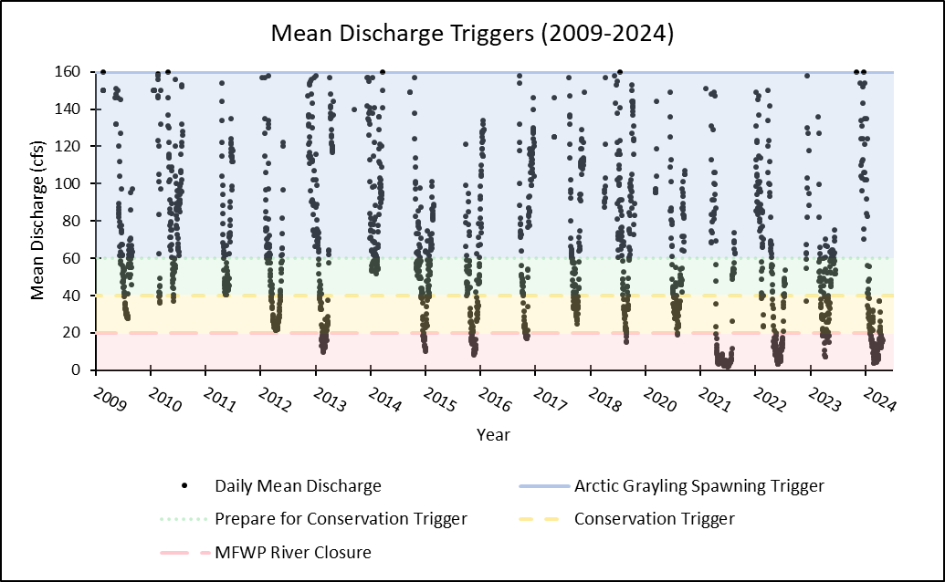
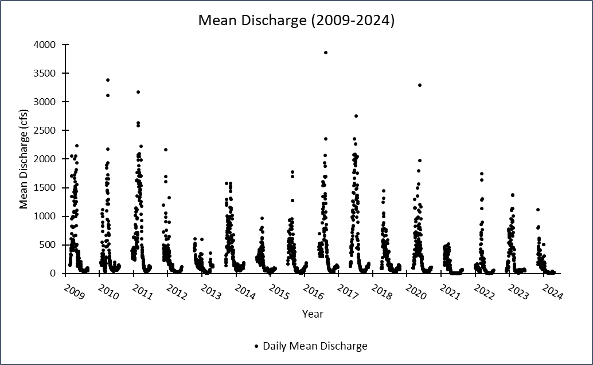
Figure B-1. Daily mean discharge at USGS gage #06024450. (a) Daily mean discharge from 2009-2024. (b) Daily mean discharge values that meet the mean discharge triggers outlined in the Big Hole River Drought Management Plan.
(a)
(b)
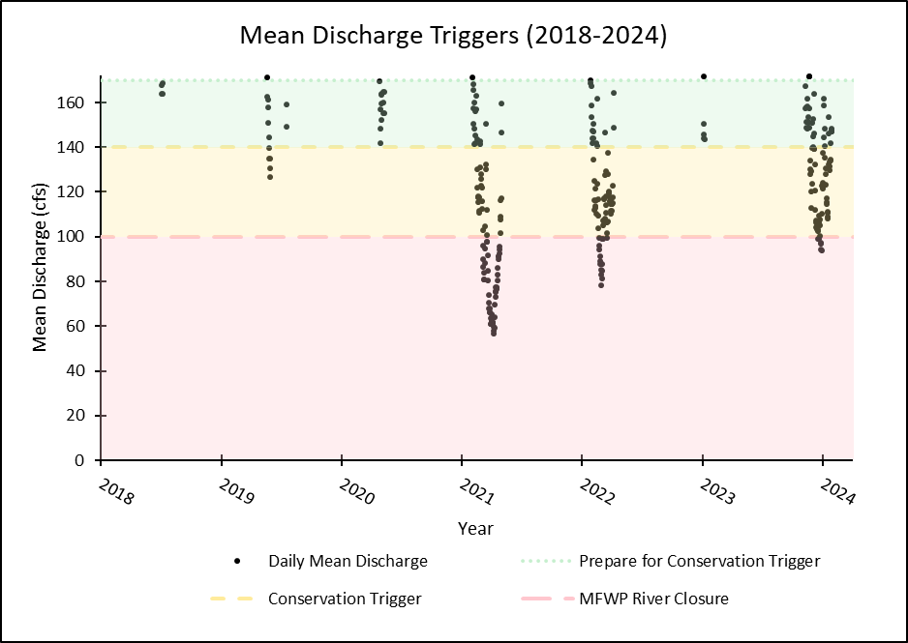
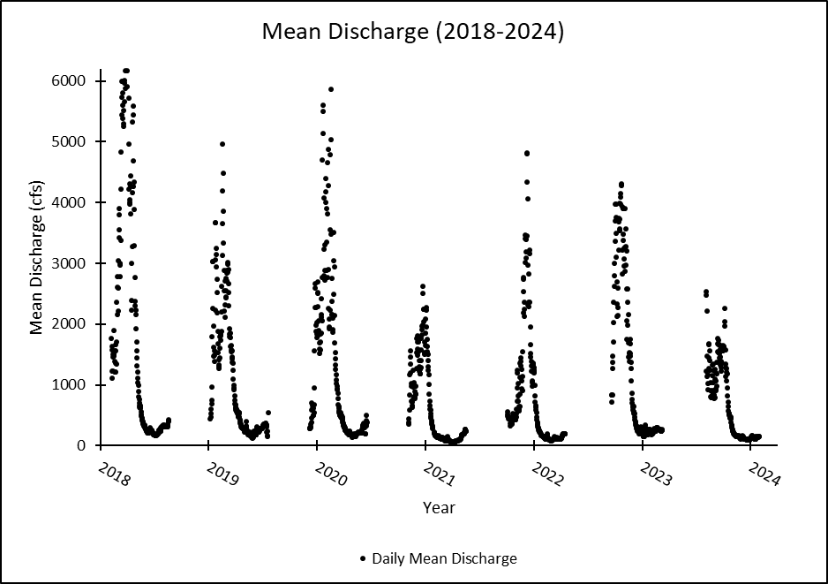
Figure B-2. Daily mean discharge at DNRC gage #41D 08000. (a) Daily mean discharge from 2018-2024 (b) Daily mean discharge values that meet the mean discharge triggers outlined in the Big Hole River Drought Management Plan.
(a)
(b)

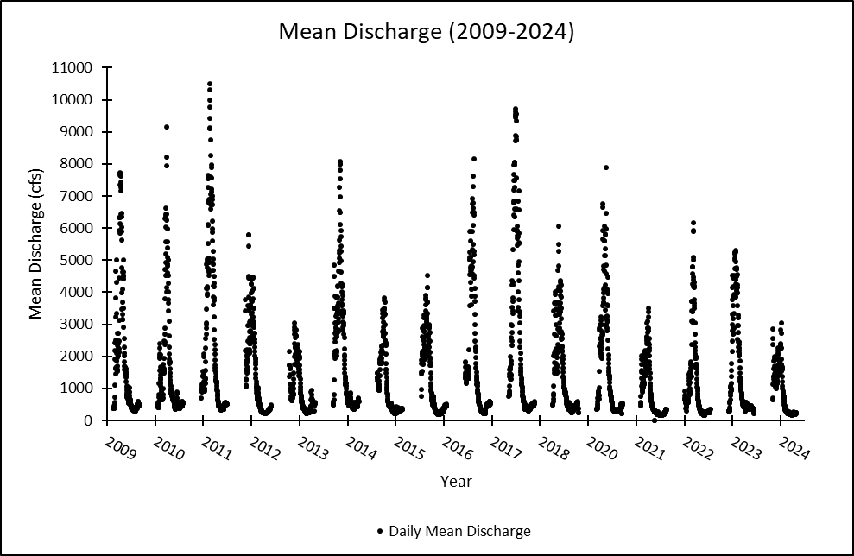
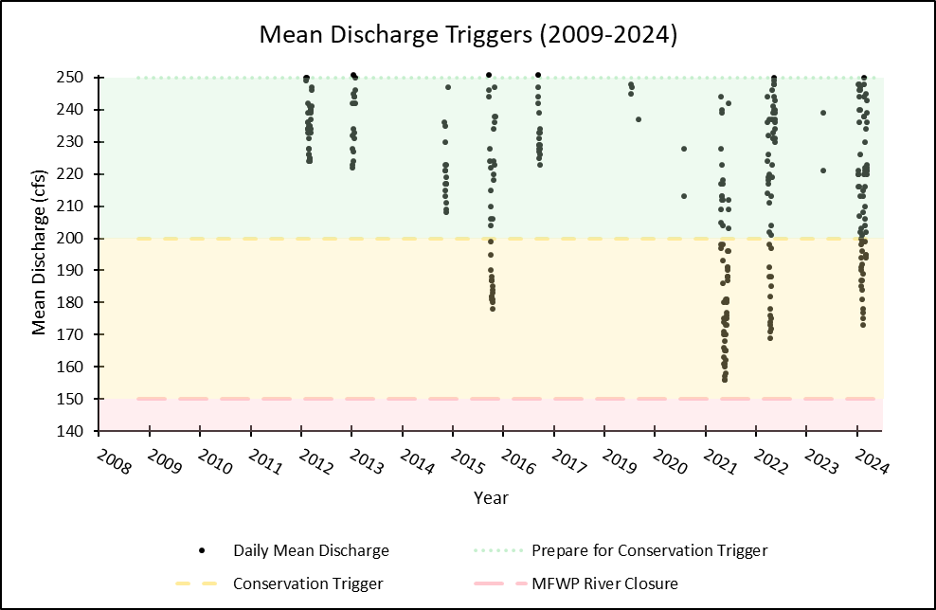
Figure B-3. Daily mean discharge at USGS gage #06025250. (a) Daily mean discharge from 2009-2024 (b) Daily mean discharge values that meet the mean discharge triggers outlined in the Big Hole River Drought Management Plan.
(a)
(b)

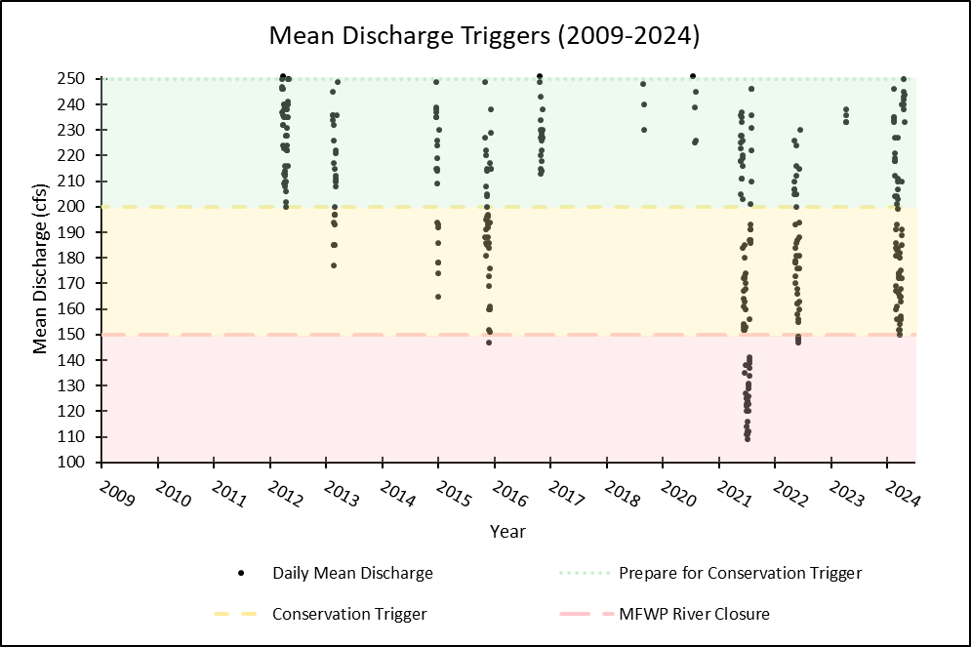
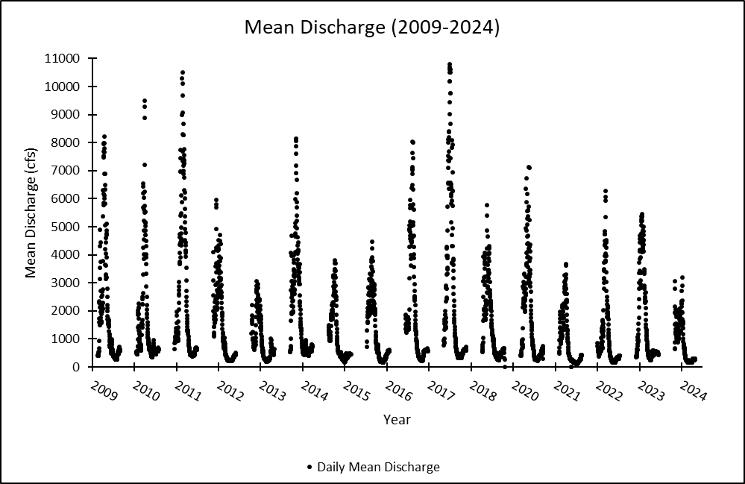
Figure B-4. Daily mean discharge at USGS gage #06026210. (a) Daily mean discharge from 2009-2024 (b) Daily mean discharge values that meet the mean discharge triggers outlined in the Big Hole River Drought Management Plan.
(a)
(b)

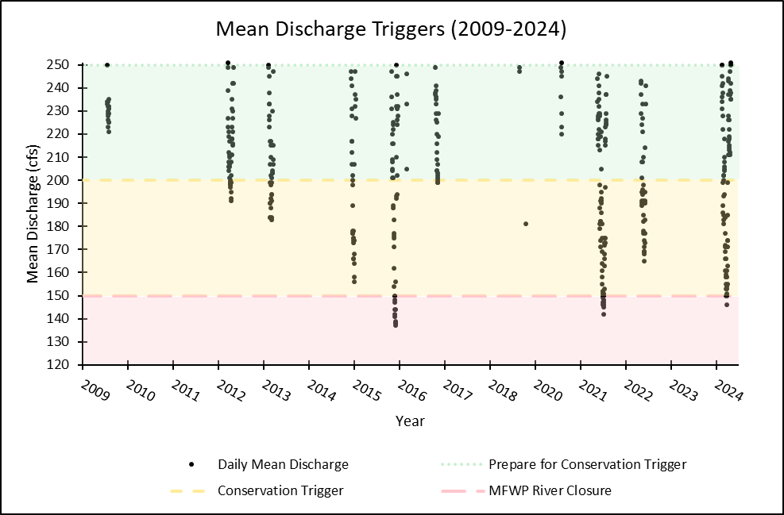
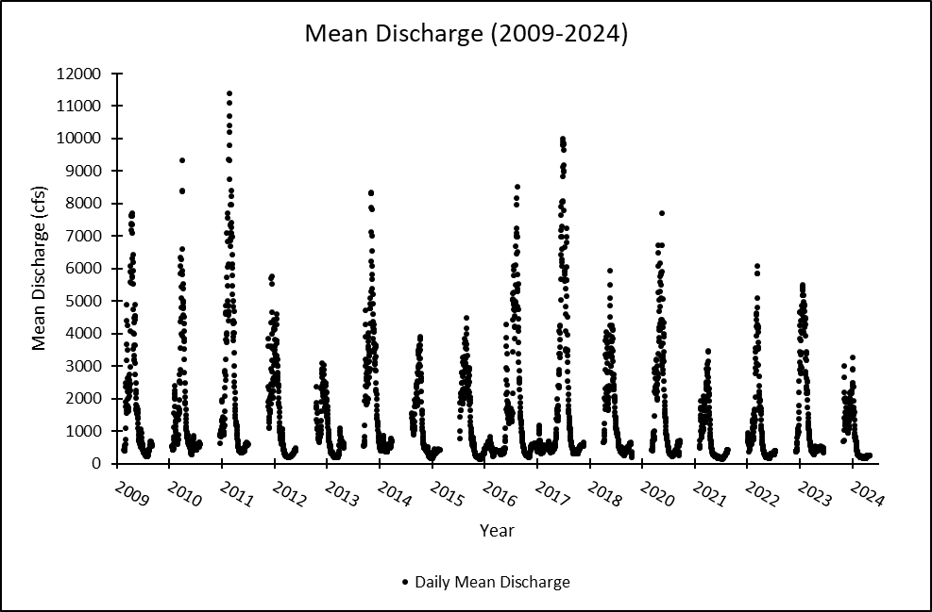
Figure B-5. Daily mean discharge at USGS gage #06025500. (a) Daily mean discharge from 2009-2024 (b) Daily mean discharge values that meet the mean discharge triggers outlined in the Big Hole River Drought Management Plan.
(a)
(b)

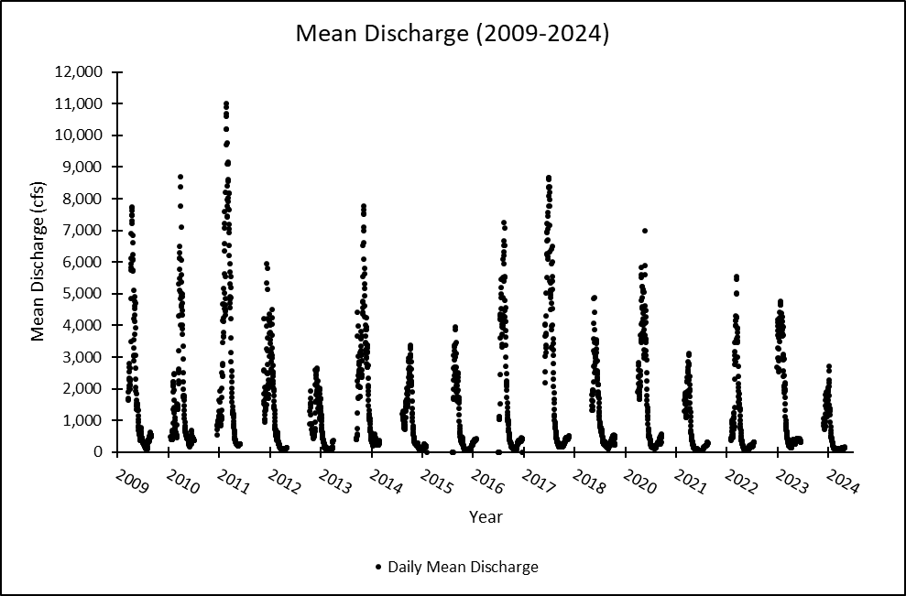
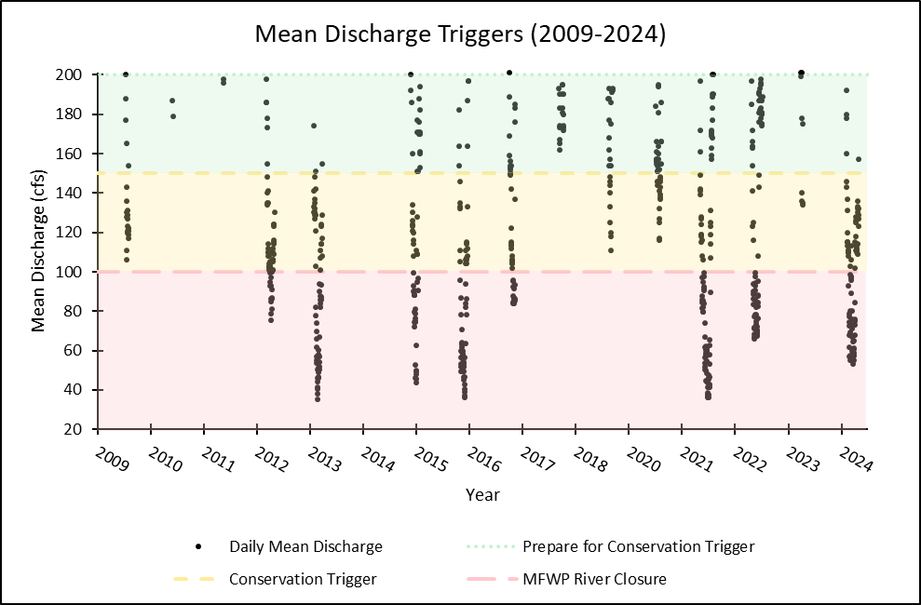
Figure B-6. Daily mean discharge at USGS gage #06026420. (a) Daily mean discharge from 2009-2024 (b) Daily mean discharge values that meet the mean discharge triggers outlined in the Big Hole River Drought Management Plan.
(a)
(b)

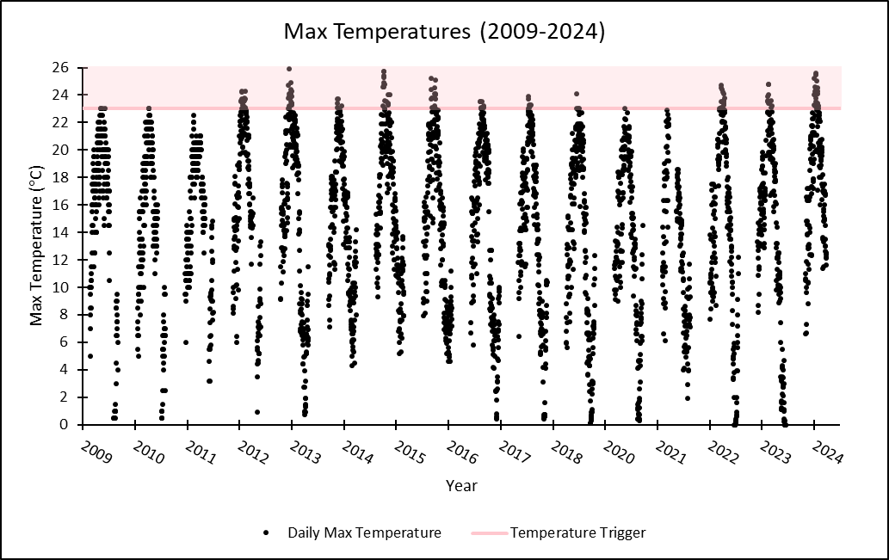
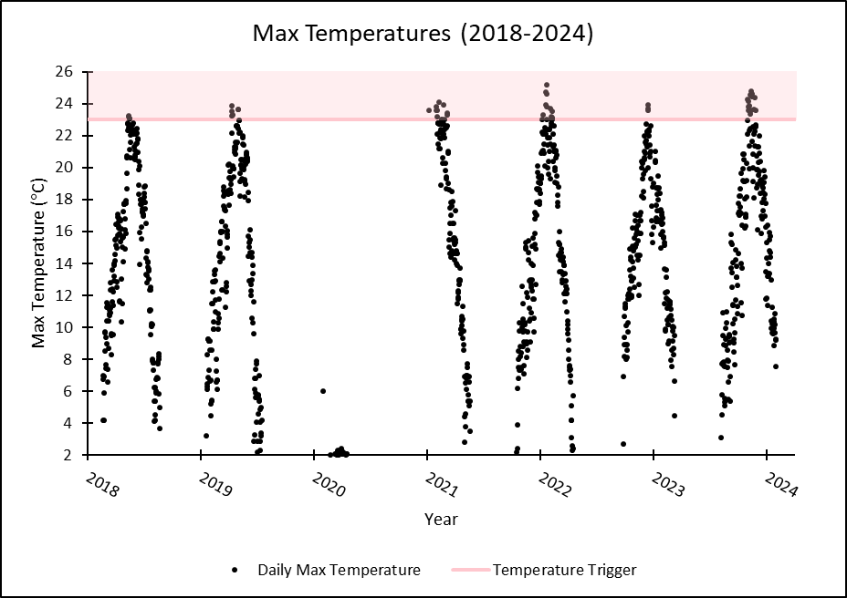
Figure B-7. Daily maximum temperatures at USGS gage #06024450.

Figure B-8. Daily maximum temperatures at DNRC gage #41D 08000.
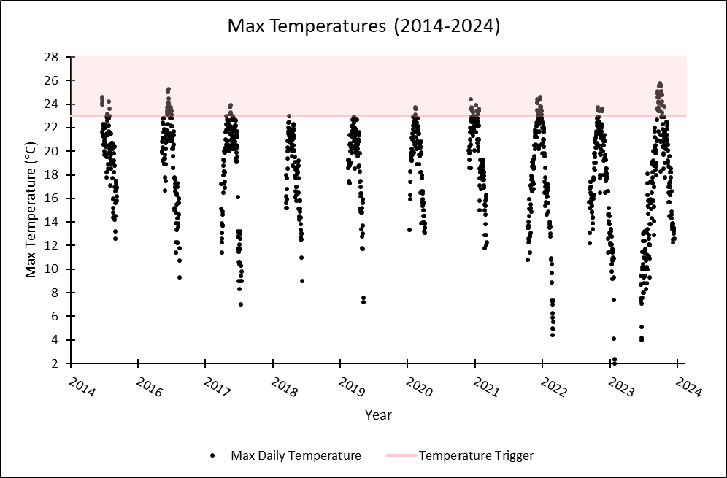
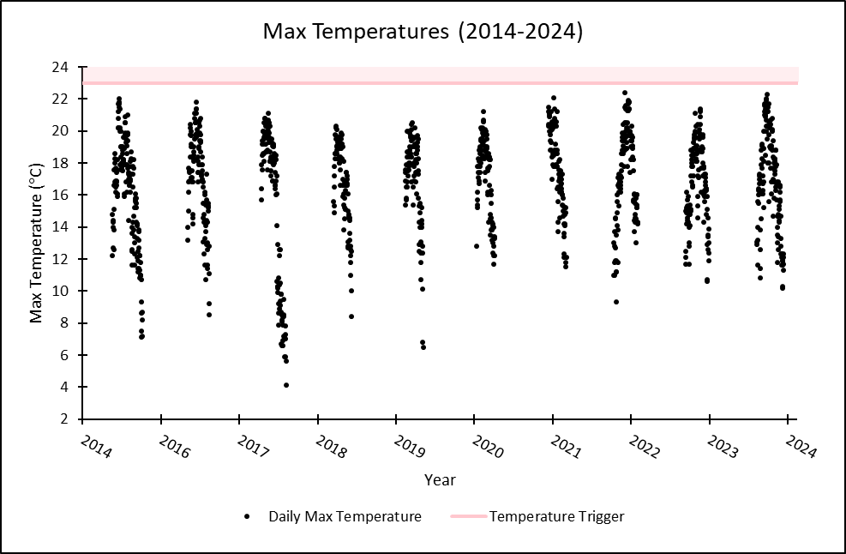
Figure B-9. Daily maximum temperatures at USGS gage #06025250.
Figure B-10. Daily maximum temperatures at USGS gage #06026210.
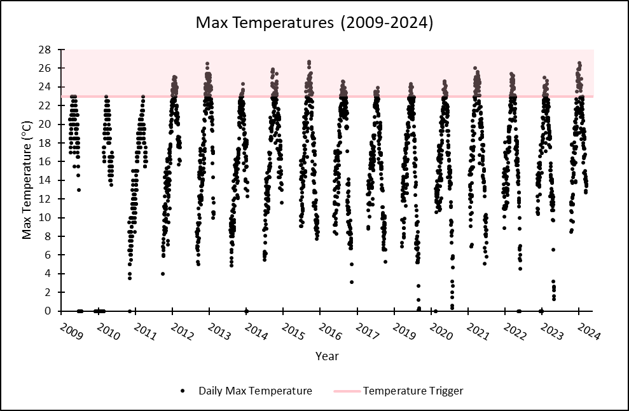
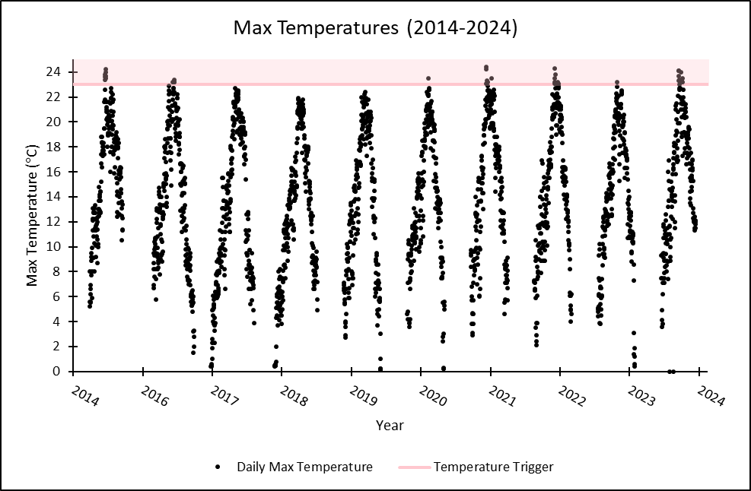
Figure B-11. Daily maximum temperatures at USGS gage #06025500.
Figure B-12. Daily maximum temperatures at USGS gage #06026420.
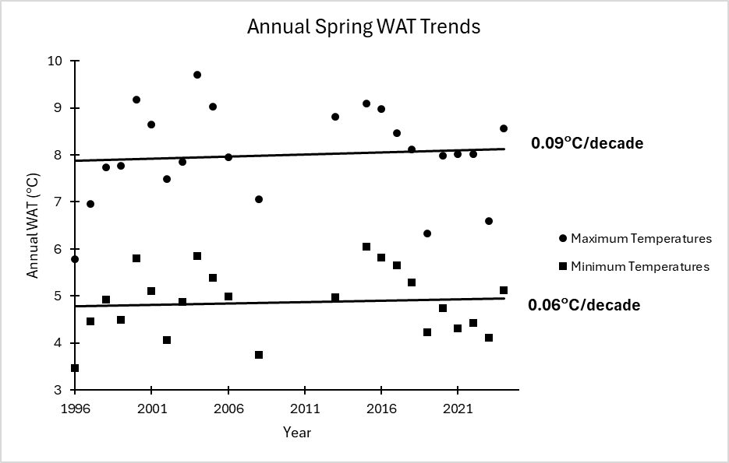
Figure B-13. Annual Spring weekly average temperature trends (1996-2024).

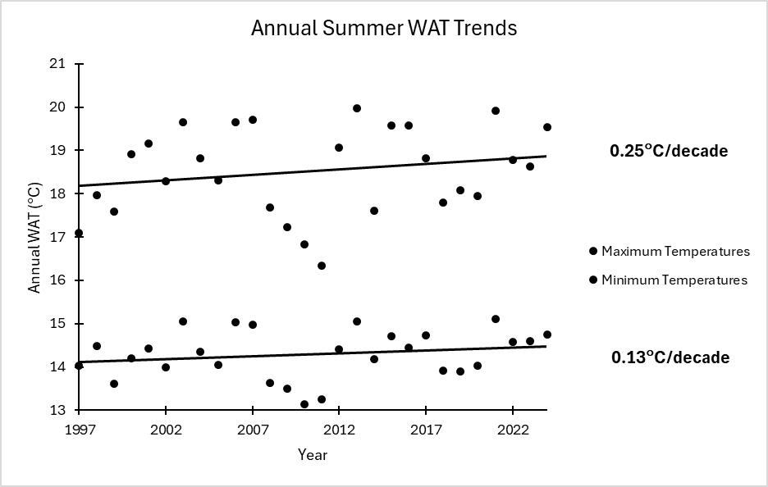
Figure B-14. Annual Summer weekly average temperature trends (1996-2024).
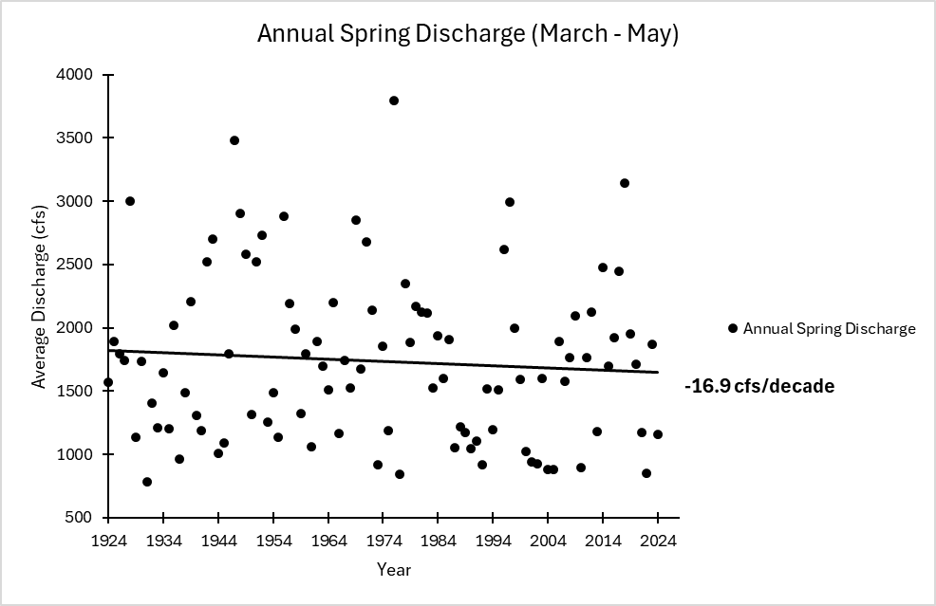
Figure B-15. Annual Spring discharge trends (1924-2024).

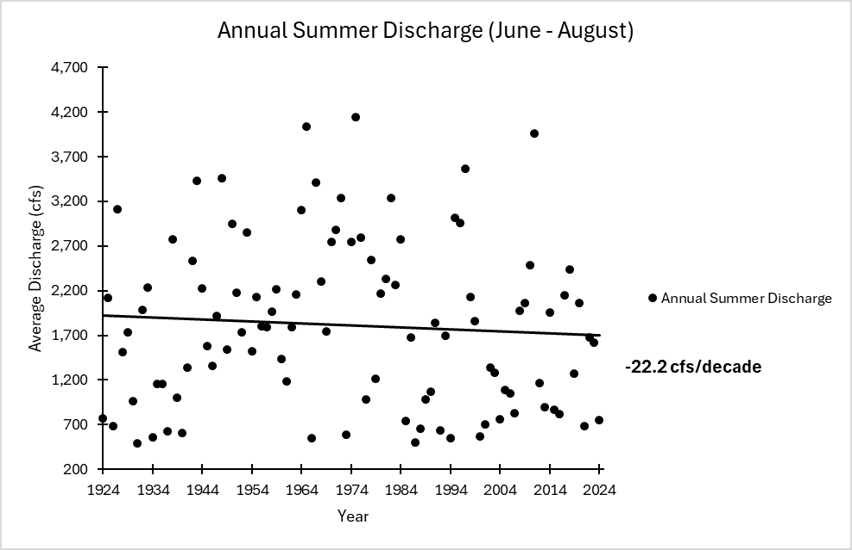
Figure B-16. Annual Summer discharge trends (1924-2024).

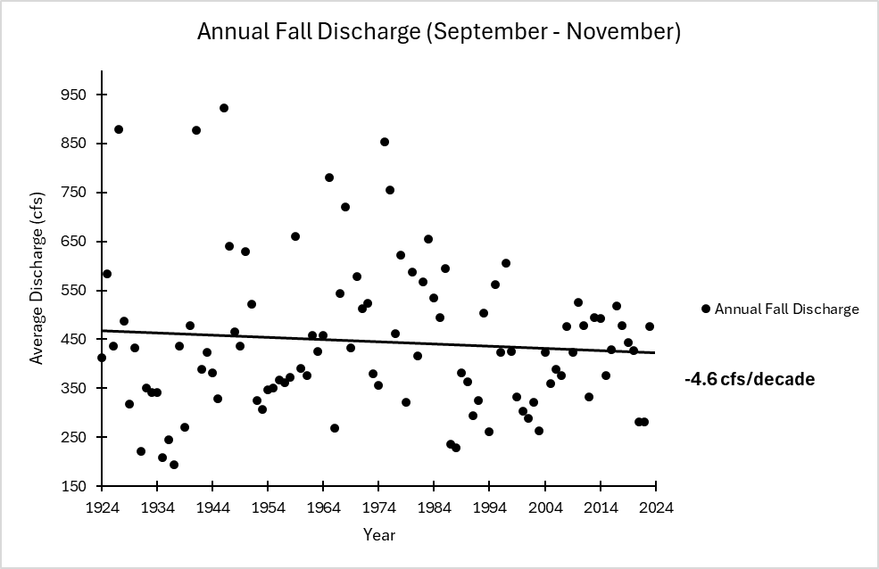
Figure B-17. Annual Fall discharge trends (1923-2023).

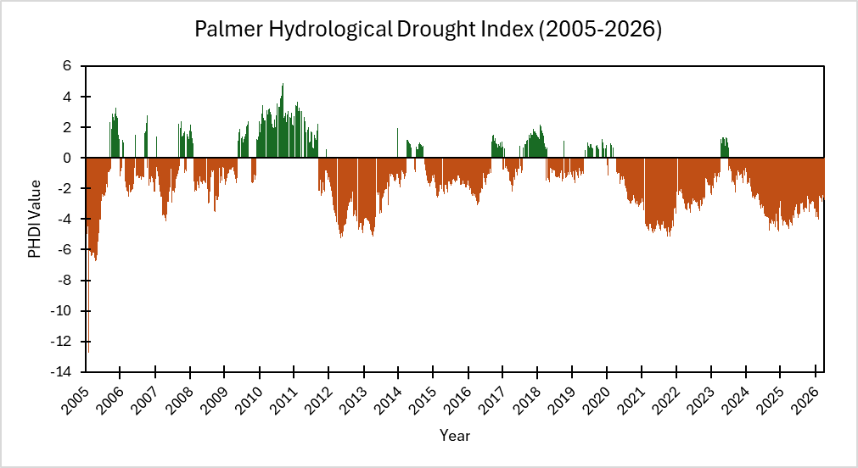

Figure B-18. Palmer Hydrological Drought Index for southwestern Montana (2005-2026).

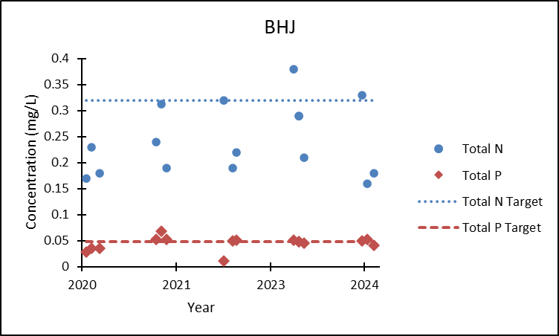
Figure B-19. Big Hole at Jackson nutrient concentrations compared to TMDL targets.

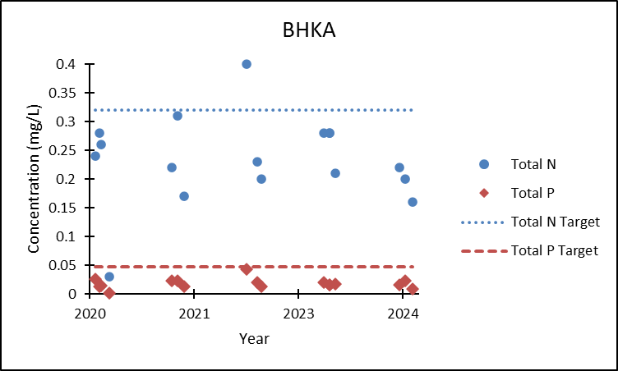
Figure B-20. Big Hole at Kalsta Bridge nutrient concentrations compared to TMDL targets.

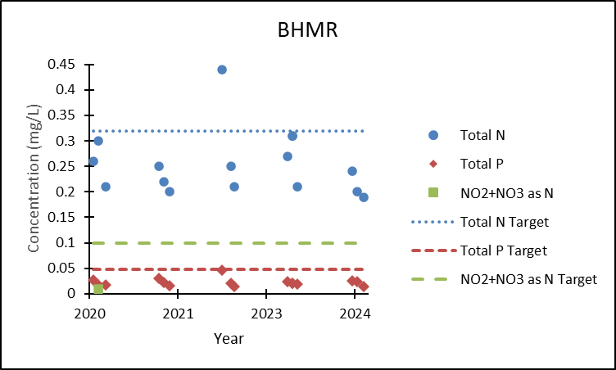
Figure B-21. Big Hole at Maiden Rock nutrient concentrations compared to TMDL targets.
¹All NO₂+NO₃ as N results < 0.01 mg/L were excluded from this analysis.

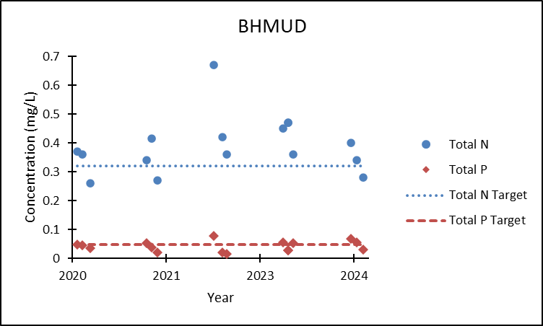
Figure B-22. Big Hole at Mudd Creek Bridge nutrient concentrations compared to TMDL targets.
¹All NO₂+NO₃ as N results < 0.01 mg/L were excluded from this analysis.

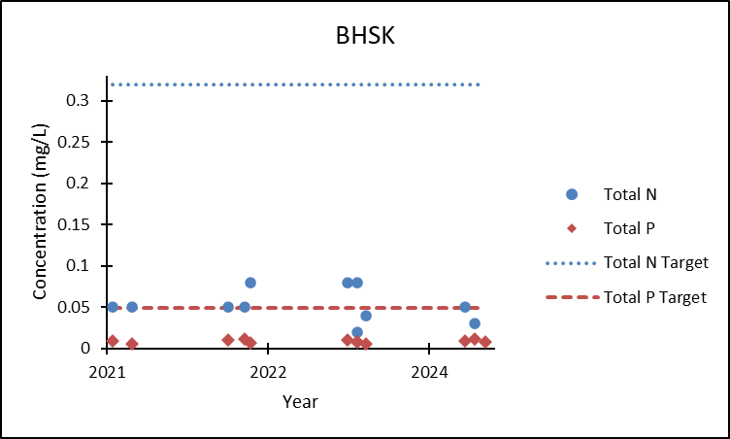
Figure B-23. Big Hole at Skinner Meadows nutrient concentrations compared to TMDL targets.
¹Total nitrogen results < 0.04 mg/L were excluded from this analysis.

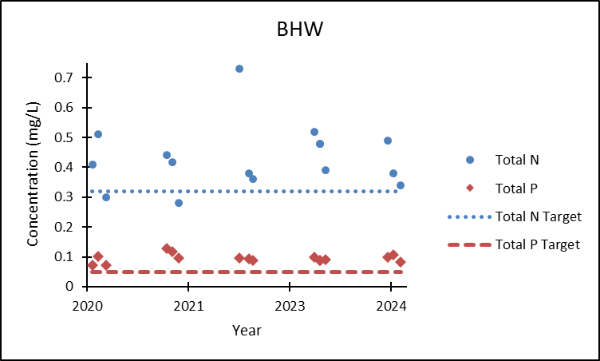
Figure B-24. Big Hole at Wisdom nutrient concentrations compared to TMDL targets.

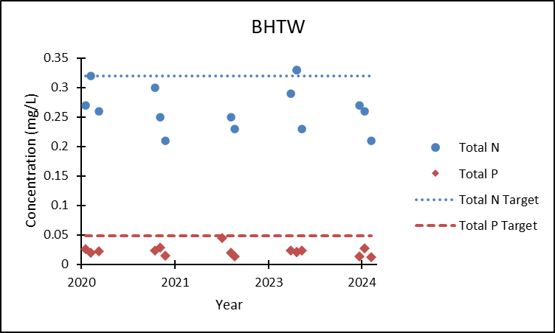
Figure B-25. Big Hole near Twin Bridges nutrient concentrations compared to TMDL targets.
¹All NO₂+NO₃ as N results < 0.01 mg/L were excluded from this analysis.

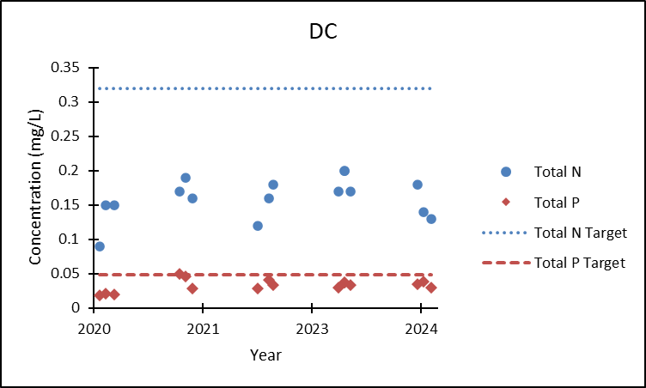
Figure B-26. Deep Creek on BLM land nutrient concentrations compared to TMDL targets.
¹All NO₂+NO₃ as N results < 0.01 mg/L were excluded from this analysis.

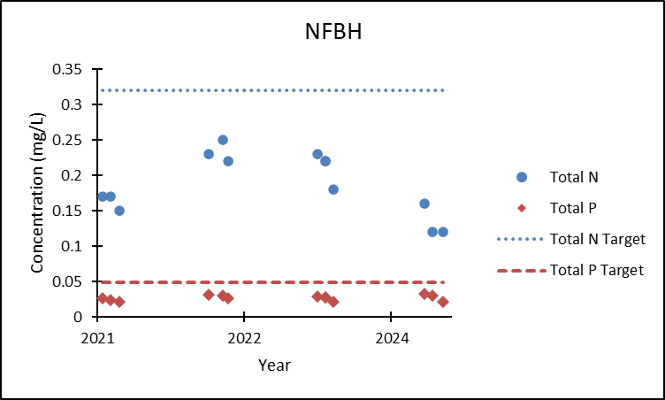
Figure B-27. North Fork Big Hole near Wisdom nutrient concentrations compared to TMDL targets.

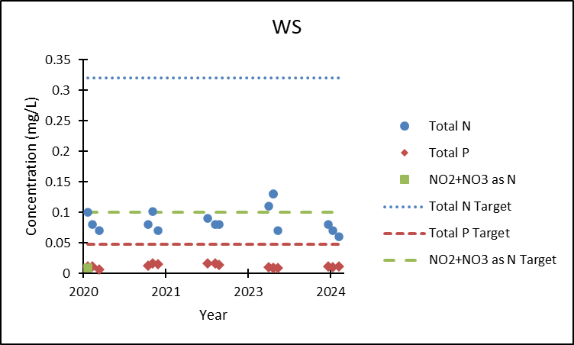
Figure B-28. Wise River near confluence nutrient concentrations compared to TMDL targets.
¹All NO₂+NO₃ as N results < 0.01 mg/L were excluded from this analysis.

Table B-1. USFS PIBO data
Waterbody/AU ID | FS PIBO Site ID | Year | % Pool Tail Fines < 6mm | W/D Ratio | Pool Frequency (pools/mile) | Macroinvertebrates
Birch Creek, headwaters to national forest boundary MT41D002_090 | 2619 | 2008 | 7.42 | 20.87 | NA² | 1.19
 | 2619 | 2013 | 10.67 | 17.96 | NA² | 0.74^{3d}
 | 2619 | 2018 | 10.33 | 67.1 | NA² | ND¹
 | 2619 | 2023 | ND¹ | 23.48 | NA² | ND¹
Doolittle Creek, headwaters to mouth (Big Hole River) MT41D004_220 | 2676 | 2008 | 33.23^{4a} | 14.4 | NA² | 1.17
 | 2676 | 2010 | 48.11^{4a} | 10.24 | NA² | 0.64⁶
 | 2676 | 2015 | ND¹ | 7.9 | NA² | 0.64⁶
 | 2676 | 2020 | 82.7^{4a} | 14.29 | NA² | ND¹
Fox Creek, headwaters to mouth (Governor Creek) MT41D004_170 | 1938 | 2006 | 23.37^{4a} | 14.77 | NA² | 0.90
Fox Creek, headwaters to mouth (Governor Creek) MT41D004_170 | 1938 | 2011 | 1.61 | 8.51 | NA² | 0.98
Fox Creek, headwaters to mouth (Governor Creek) MT41D004_170 | 1938 | 2016 | 3.3 | 8.19 | NA² | 0.75
Fox Creek, headwaters to mouth (Governor Creek) MT41D004_170 | 1938 | 2023 | 3.6 | 10.15 | NA² | ND¹
Jerry Creek, headwaters to mouth (Big Hole River ) MT41D003_020 | 2265 | 2007 | 5.93 | 25.29 | NA² | 0.63^{3d}
 | 2265 | 2012 | 2.33 | 16.48 | NA² | 0.98
 | 2265 | 2017 | 2.27 | 17.55 | NA² | 0.98
 | 2265 | 2022 | 4.67 | 21.59 | NA² | ND¹
Johnson Creek, headwaters to mouth (Big Hole River) MT41D001_020 | 2678 | 2008 | 3.89 | 21 | NA² | 1.00
 | 2678 | 2013 | 18.3^{5a} | 15.81 | NA² | 0.91
Moose Creek, headwaters to mouth (Big Hole at Maiden Rock) MT41D002_050 | 2973 | 2010 | 13.48 | 11.2 | NA² | 0.31^{3d}
 | 2973 | 2015 | 21.02^{3a} | 11.2 | NA² | 0.54^{3d}
Mussigbrod Creek, headwaters to mouth MT41D004_020 | 2989 | 2010 | 33.67^{5a} | 11.25 | 48.8^{3c} | ND¹
Mussigbrod Creek, headwaters to mouth MT41D004_020 | 2989 | 2015 | 18.47^{5a} | 12.23 | 106.7 | 0.59⁶
Rock Creek, headwaters to mouth (Big Hole River) MT41D004_120 | 2661 | 2008 | 89.79^{4a} | 12.97 | NA² | 1.06
 | 2661 | 2013 | 76.66^{4a} | 12.4 | NA² | 0.91
 | 2661 | 2018 | 63.88^{4a} | 11.88 | NA² | ND¹
 | 2661 | 2023 | 93.71^{4a} | 13.4 | NA² | ND¹
Ruby Creek, headwaters to mouth (North Fork Big Hole River) MT41D004_100 | 2655 | 2008 | 10.87 | 13.96 | NA² | 1.06
 | 2655 | 2013 | 23.38^{5a} | 12.72 | NA² | 0.66⁶
Trapper Creek, headwaters to mouth (Big Hole River) MT41D002_010 | 2196 | 2007 | 19.06^{3a} | 29.97 | NA² | 1.02
 | 2196 | 2012 | 6.38 | 20.28 | NA² | 0.73^{3d}
 | 2196 | 2017 | 14.21^{3a} | 15.29 | NA² | 1.24
 | 2196 | 2022 | 13.93 | 23.65 | NA² | ND¹
Wise River, headwaters to mouth (Big Hole River) MT41D003_200 | 2648 | 2008 | 25.42^{3a} | 14.94 | NA² | ND¹
 | 2648 | 2013 | 22.41^{3a} | 12.49 | NA² | 0.70^{3d}
 | 2648 | 2018 | ND¹ | 11.84 | NA² | ND¹
 | 2648 | 2023 | 66.64^{3a} | 10.65 | NA² | ND¹
¹ND indicates no data was available.
²NA indicates there was no target for comparison.
³Bolded results exceed the Middle and Lower Big Hole TPA water quality targets:
ª% pool tail fines < 6mm: <14%
^{b}W/D ratio: > 5.1
^{c}Pool frequency: 84 pools/mile
^{d}RIVPACS: >0.80
⁴Bolded results exceed the Upper Big Hole TPA water quality targets:
ª% pool tail fines < 6mm: < 22%
^{b}W/D ratio: < 26
⁵Bolded results exceed the North Fork Big Hole TPA water quality targets:
ª% pool tail fines < 6mm: < 11%
^{b}W/D ratio: < 28
⁶Bolded results exceed Upper and North Fork Big Hole TPA macroinvertebrate target of 1.2>RIVPACS>0.80
⁷Tributary to sediment impaired stream

Table B-2. French Gulch and Moose Creek riparian greenline assessment
Reach | Understory Shrubs Cover (%)¹
M1 | 25
M2 | 20
M3 | 0
FG1-1 | 0
FG1-2 | 0
FG1-3 | 10
FG2-1 | 0
FG2-2 | 10
FG2-3 | 5
FG3-1 | 20
FG3-2 | 5
FG4-1 | 10
FG4-2 | 5
FG4-3 | 0
FG5-1 | 5
FG5-2 | 15
FG5-3 | 20
¹Bolded results fall below the supplemental indicator target for understory shrub cover of > 48%.
²Table adapted from BHWC, 2018.

Table B-3. 2021 French Creek drainage sediment site data post-restoration
Site | Latitude | Longitude | Rosgen Stream Type | W/D Ratio² | Entrenchment Ratio³ | Riffle % < 2mm⁴
CALIO4_01 | 45.95808 | -113.03782 | C4 | 17.3 | 14.2 | 20.3
CALIO5_01 | 46.00044 | -112.96808 | B3/4 | 9.9 | 1.9 | 18.3
OREG04-01 | 45.98366 | -113.00733 | B3/4 | 14.8 | 3.5 | 23.5
SIXM06_03 | 45.99482 | -113.0349 | B3 | 13.3 | 2.0 | 16.3
SIXM06_01 | 45.97836 | -113.02627 | B3 | 10.2 | 23.0 | 30.2
FRNC06_06 | 45.926284 | -113.089666 | C3 | 19.5 | 12.0 | 21.9
AMER03_01 | 45.946 | -112.9542 | B4 | 14.2 | 64.0 | 22.0
AMER05_01 | 45.97563 | -113.0229 | B3 | 9.6 | 17.6 | 23.3
FRNC04_01 | 45.9579 | -113.01787 | B3 | 22.8 | 7.6 | 35.6
FRNC05_01 | 45.95388 | -113.03477 | B3 | 11.2 | 32.0 | 22.7
FRNC06_03 | 45.94759 | -113.05323 | C3 | 22.0 | 12.5 | 25.3
FRNC06_04 | 45.93952 | -113.07604 | C3 | 15.1 | 17.7 | 34.4
OREG02_01 | 46.01117 | -113.00124 | A4 | 7.9 | NA | 46.2
OREG04_02 | 45.99319 | -113.00161 | B3 | 9.4 | 11.3 | 45.5
SIXM03_01 | 46.00803 | -113.03873 | B4 | 11.2 | 11.3 | 18.1
¹Results in bold exceed the water quality target.
²Width-to-depth ratio targets: C4=20, B3=15, C3=31, B4=17, and A=10.
³Entrenchment ratio targets: C4=14.1, B=1.8, C3=5.1, A=NA
⁴Riffle % < 2mm targets: 13%
⁵Table adapted from Hanson, 2022.

Table B-4. 2017 French Gulch and Moose Creek post-restoration monitoring data
Site | W/D Ratio¹ | Pool Tail Fines <6mm (%)²
French Gulch 1 | 8.78 | 26
French Gulch 2 | 8.60 | 28
French Gulch 3 | 7.92 | 25
French Gulch 4 | 4.81 | 25
French Gulch 5 | 6.44 | 32
Moose Creek | 4.96 | 12
¹Bolded results do not meet the water quality target for W/D ratio: > 5.1
²Bolded results do not meet the water quality target for % pool tail fines < 6mm: <14%
³Table adapted from BHWC, 2018.

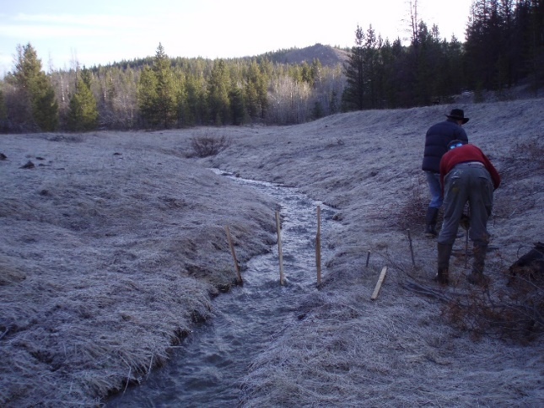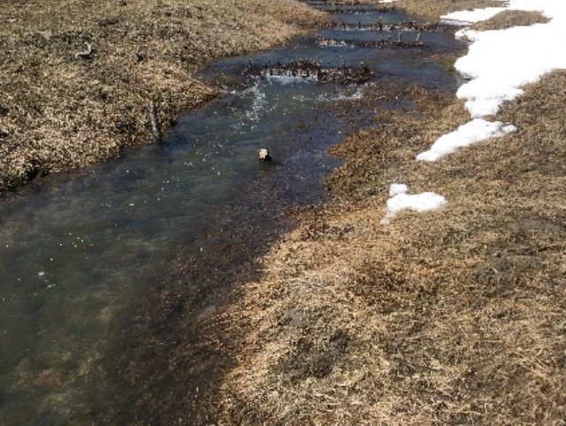
Figure B-29. California Creek pre- (2015) and post-restoration (2017) photos.

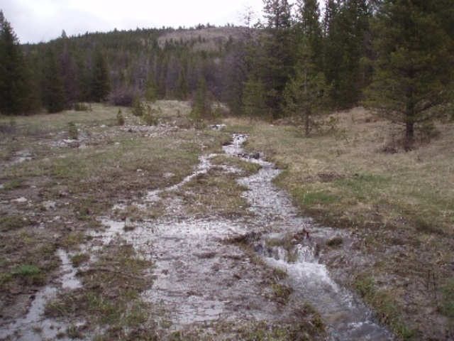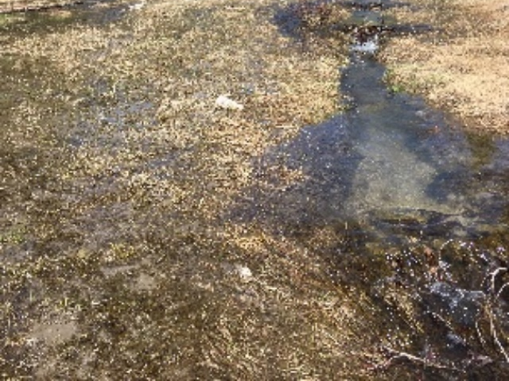
Figure B-30. California Creek pre- (2015) and post-restoration (2017) photos.

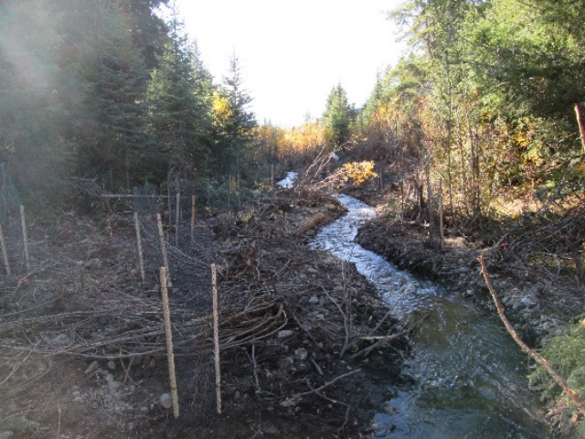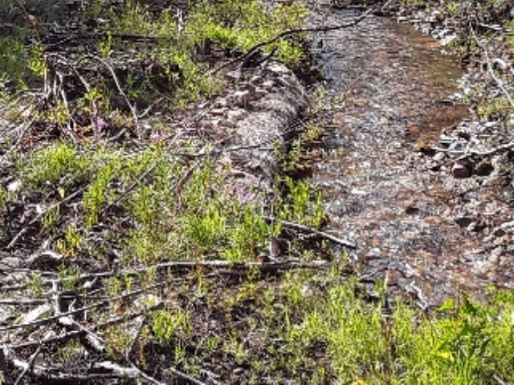
Figure B-31. French Gulch and Moose Creek pre- (2016) and post-restoration (2017) photos.

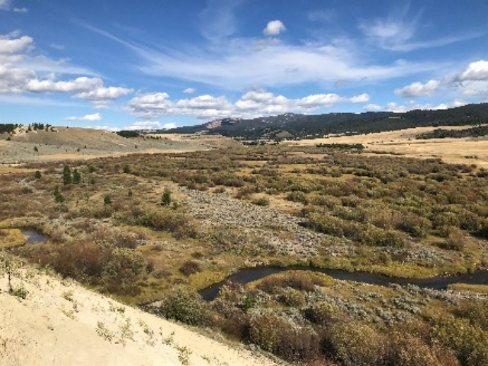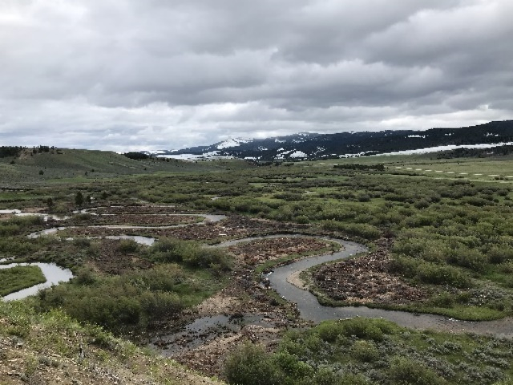
Figure B-32. French Creek pre- (2019) and post-restoration (2020) photos.

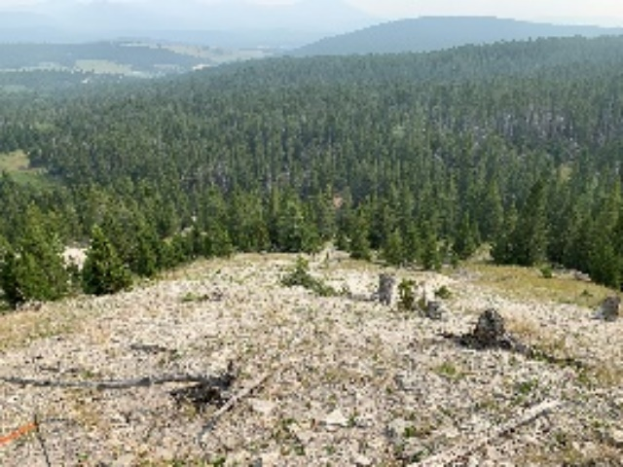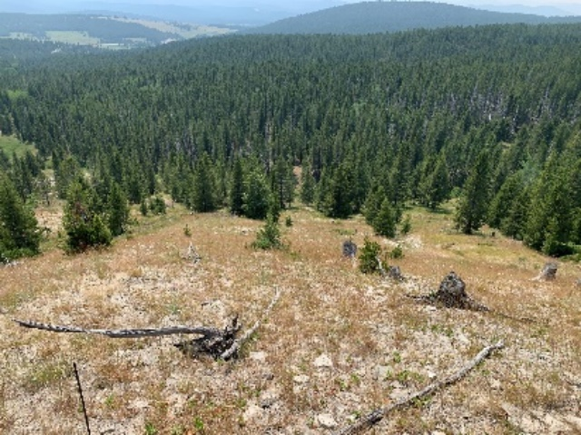
Figure B-33. Oregon Creek Uplands pre- and post-restoration photos.

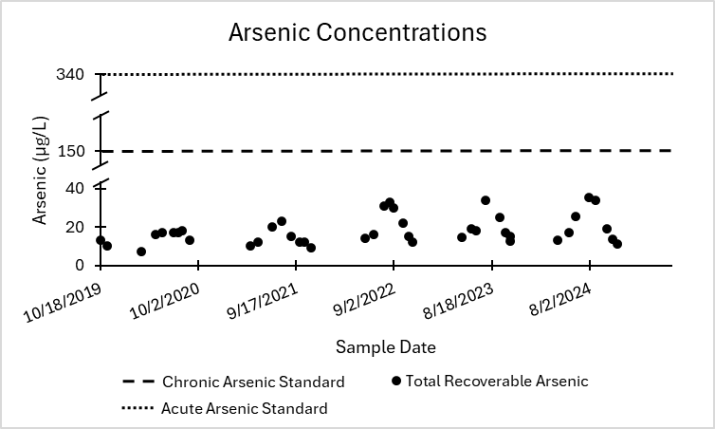

Figure B-34. 2019-2024 California Creek arsenic monitoring results.

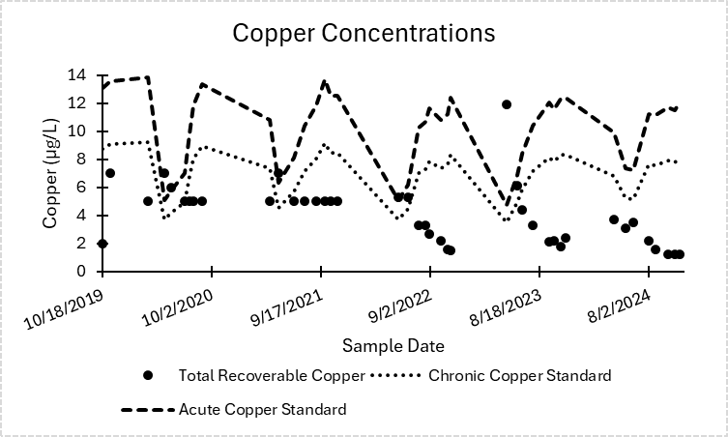

Figure B-35. 2019-2024 California Creek copper monitoring results.

Appendix C – Watershed Contacts

Table C-1. Big Hole River watershed contacts
Entity Name | Contact Name | Contact Title
Beaverhead Conservation District | Tom Miller | Supervisor
Big Hole Watershed Committee | Pedro Marques | Executive Director
Bureau of Land Management – Dillon Field Office | Currently vacant (Previously held by Alden Shallcross) | State Lead Montana / Dakotas Aquatic Habitat Management Program
Bureau of Land Management – Dillon Field Office | Dustin Crowe | Assistant Field Manager
Bureau of Land Management – Dillon Field Office | Helen Sladek | Hydrologist
Bureau of Land Management – Dillon Field Office | Currently vacant (Previously held by Paul Hutchinson) | Fishery Biologist
Bureau of Land Management – Miles City Field Office | Christina Stuart | Fish Biologist
George Grant Chapter of Trout Unlimited | Forrest Jay | President
Montana Association of Conservation Districts | N/A | N/A
Montana Department of Environmental Quality – Abandoned Mine Lands | Jason Rappe | Abandoned Mine Lands and Construction Section Supervisor
 | Jorri Dyer | Abandoned Mine Lands and Construction Section Supervisor
Montana Fish, Wildlife & Parks | Jarrett Payne | Plant Ecologist – Wildlife Division
Montana Fish, Wildlife & Parks | Jim Olsen | Big Hole Fisheries Biologist
Montana Fish, Wildlife & Parks | Katelin Killoy | Riparian Ecologist for the Arctic Grayling CCAA Programs
Montana Fish, Wildlife & Parks | Michael Duncan | Region 3 Fisheries Program Manager
Montana Fish, Wildlife & Parks | Michelle McGree | Future Fisheries Coordinator
Montana Department of Natural Resources and Conservation | Autumn Coleman | Resource Development Bureau Chief
Montana Department of Natural Resources and Conservation | Danika Holmes | Regional Water Planner – Upper Missouri River Basin
Montana Department of Natural Resources and Conservation | Heidi Folnagy-Anderson | Business Analyst
Montana Department of Natural Resources and Conservation | Kaitlin Boren | Hydrologist
Montana Department of Natural Resources and Conservation | Lindsay Volpe | Renewable Resource Grant and Loan Program Manager
Montana Department of Transportation | Larry Urban | Wetland Mitigation Specialist
Montana Natural Resources Conservation Service | Kyle Tackett | Acting State Conservationist
Montana Technological University | Christopher Gammons | Professor, Department of Geological Engineering
Montana Technological University | Paul Helfrich | PhD Student
Montana Technological University | Robert Pal | Professor - Ecology
Montana Watershed Coordination Council | Terri Nichols | Watershed Programs Manager
National Resource Damage Program | Ray Vinkey | Environmental Science Specialist
Ruby Valley Conservation District | Currently vacant (Previously held by Audra Bell) | Stewardship Director
Save Wild Trout | Brian Wheeler | Executive Director
United States Fish & Wildlife Service | Currently vacant (Previously held by James Magee) | Fish and Wildlife Biologist
United States Forest Service – Beaverhead-Deerlodge National Forest | Allison Landro | Environmental Coordinator
 | Kevin Weinner | Hydrologist
 | Jennifer Mickelson | Watershed Program Manager
 | Sonny Thornborrow | Physical Scientist

Appendix D – Maps

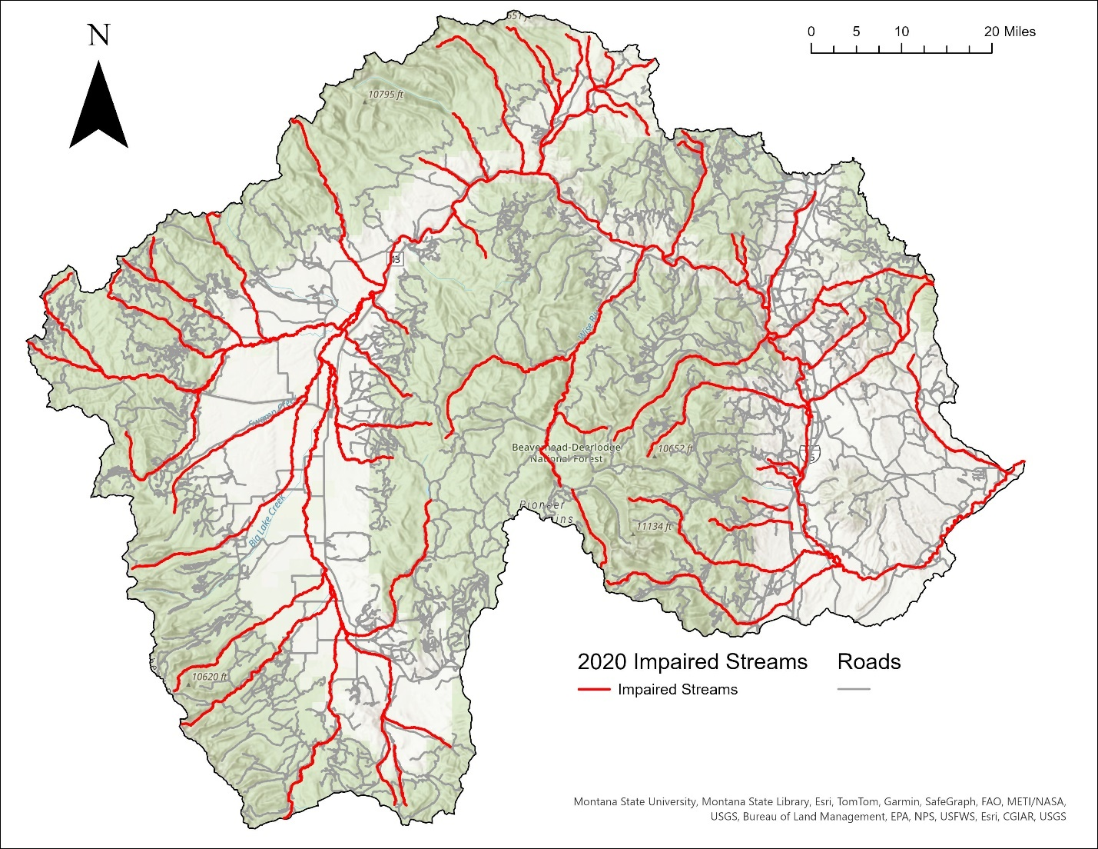

Figure D-1. Road systems in the Big Hole River watershed.

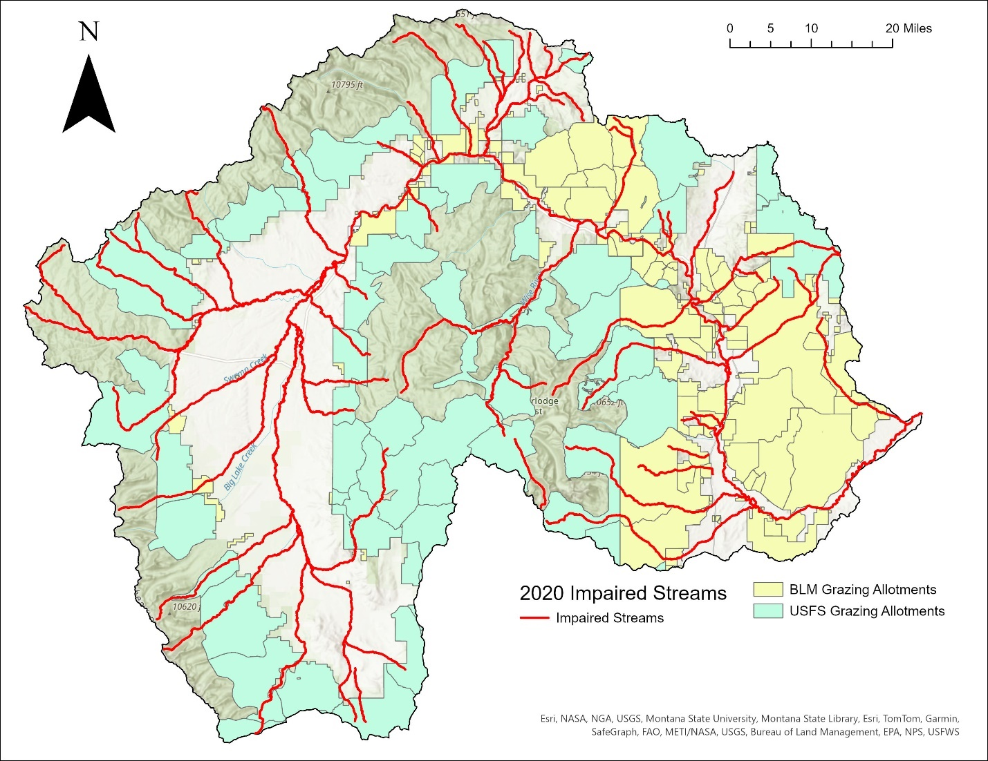
Figure D-2. Grazing allotments in the Big Hole River watershed.
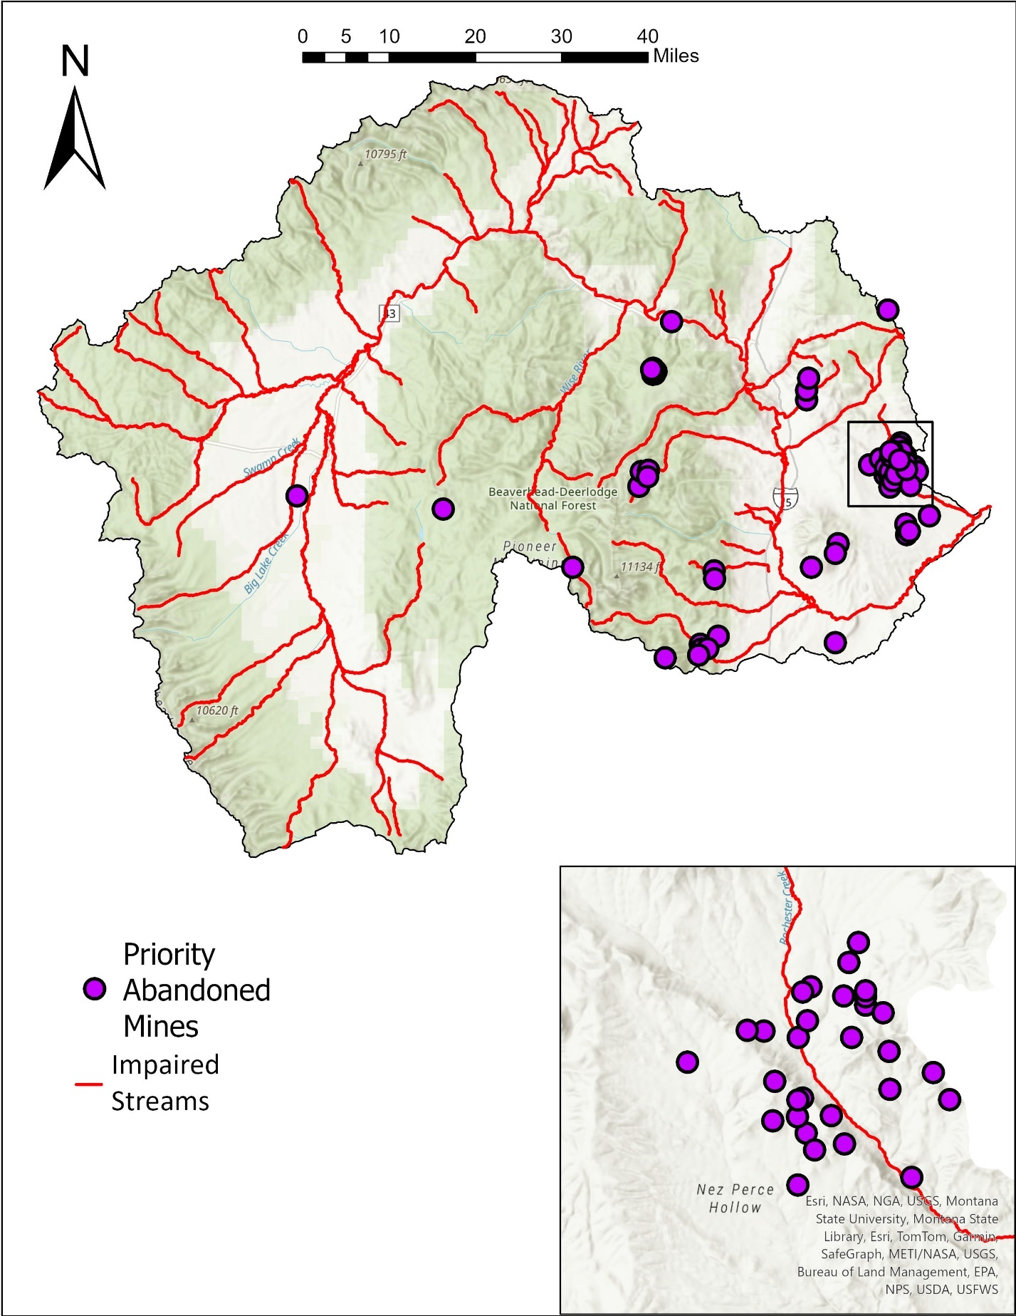

Figure D-3. Abandoned in the Big Hole River watershed.

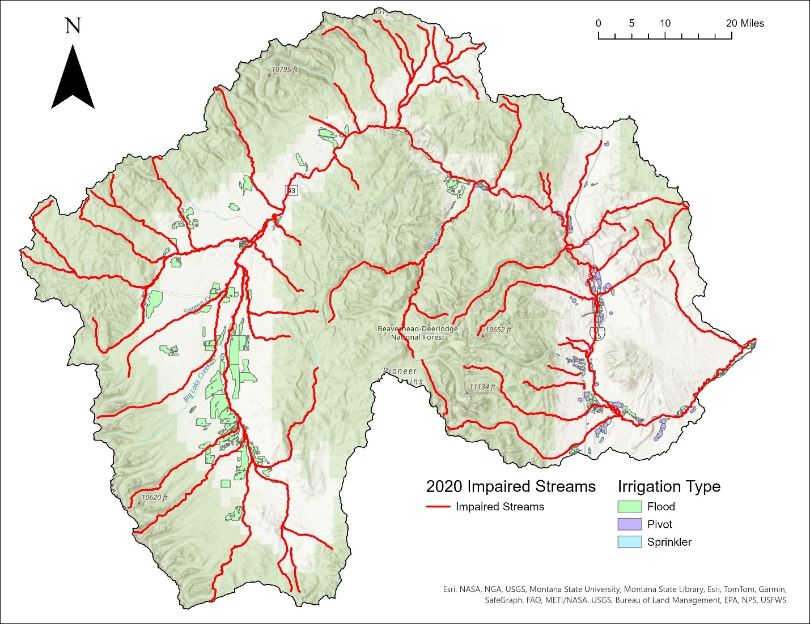

Figure D-4. Irrigation systems and types in the Big Hole River watershed.

